CU-Boulder CHEM-5181

Problem 5.1- Electrospray Ionization Charge States.

Below are two expanded views of an electrospray mass spectrum of an unknown biomolecule collected with the Orbitrap high-resolution mass spectrometer in the CU-Boulder Mass Spectrometry Facility. The first spectrum shows a charge envelope between m/z 650 and 1150.

(a) Using knowledge of the m/z values for the peaks of the envelope, assign charge states to all peaks having relative abundance > 15 and determine the mass of unknown compound (Da).

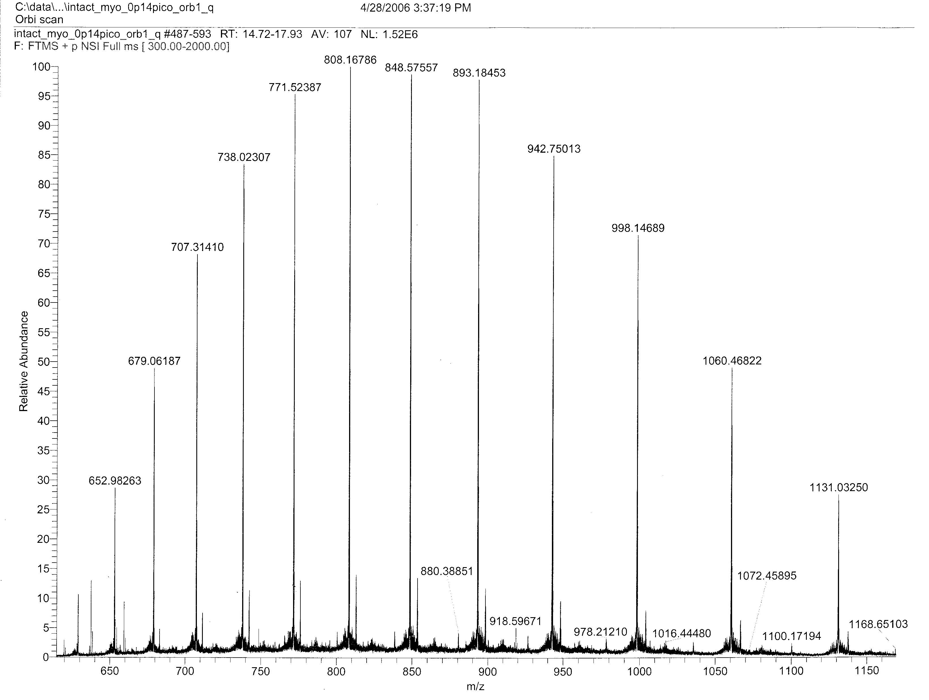

(d) Using data from the second mass spectrum, which is an expanded view of the region between m/z 737.2 and 738.8, re-calculate the charge of the peak at m/z 738.02307.
