Climate Change Unit Assessment: What have we learned together?

We have a chance now to put all of what we’ve learned together, to help answer the big questions we had at the beginning of the unit.

1. Is the fact that some cities are getting hotter part of a larger global trend in temperature or not? Support your answer with one or the two graphs below.

Graph A:
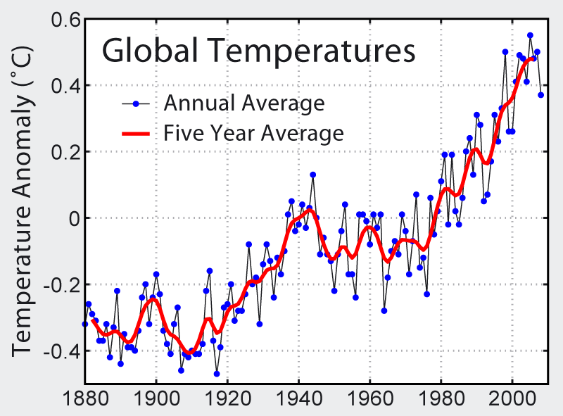

Graph B:
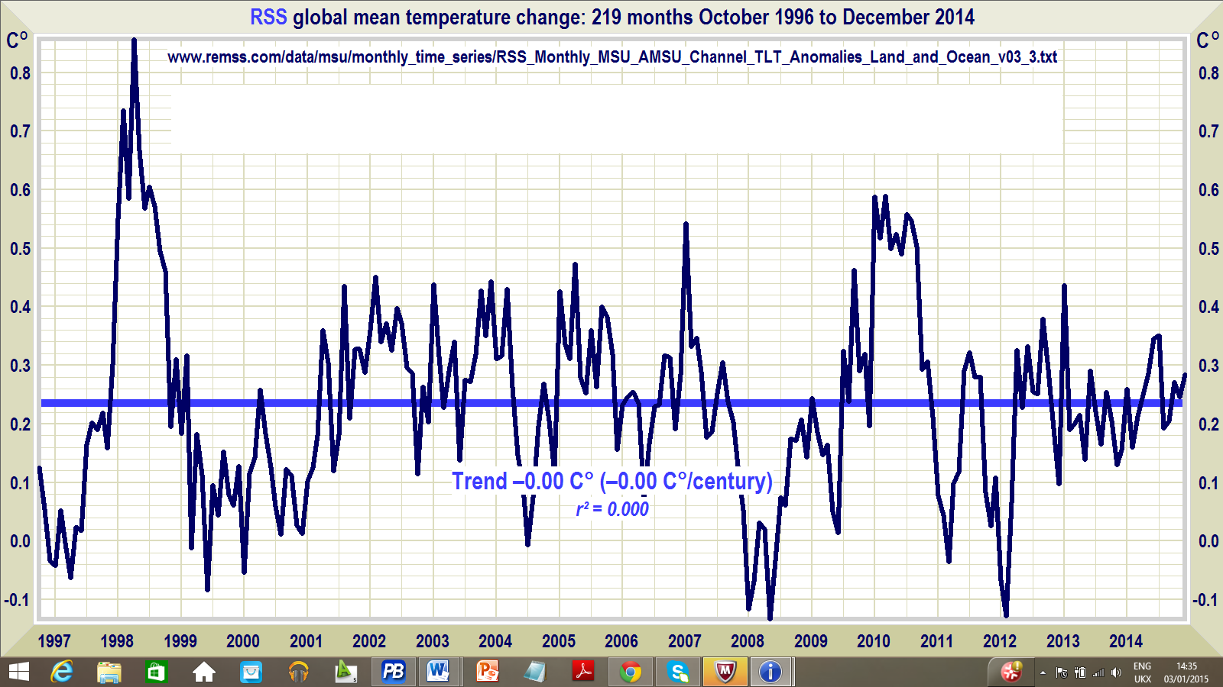
Sources: NASA, Climate Depot

Both graphs show the global temperature, as compared to just cities. The one on the left could support the claim that the hotter cities is part of a larger, global trend. The one on the right, showing temperatures in just the past 20 years or so, would not support that claim.

2. Which graph would be more likely to be used by someone who claims there is no evidence of global warming? Why?

The graph on the right, because the pattern shows variation around a mean global temperature that does not change.

3. How far back should we look at data on global temperatures, to decide whether global temperatures are rising or not? Support your answer with things you have learned so far in this unit.

We need to go back to at least before the Industrial Revolution, when the longer-term trend was that it was getting cooler, and when it reversed. The graph on the left shows a chart where a longer-term trend of rising temperature since 1910 at least, which is since the Industrial Revolution. We should also look farther back, where we have to rely on ice core data, to see if the trend is really long-term.

The graph below shows how world population, overall energy consumption, and energy consumption per capita are changing over time.
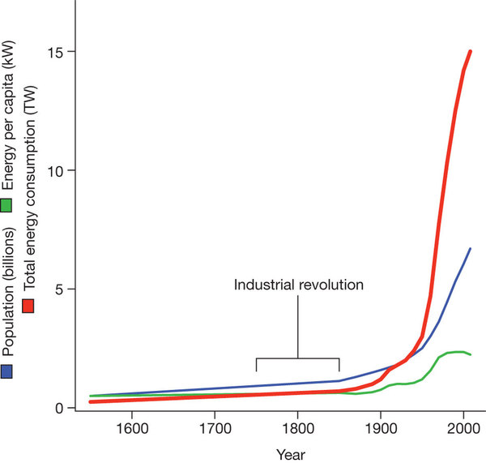
Source: Nature

4. What has been the pattern or trend in the consumption of energy since the Industrial Revolution?

The increase was slow at first but then became much bigger since 1900 or so.

5. What can you conclude about the relationship between population and total energy consumption? Support your answer with evidence from the graph.

There is a direct, positive relationship between the two. As population increases, total energy consumption does, too. The closeness of the two lines and the shape of those lines supports my conclusion (claim).

6. How might the graph change, if total population continued to grow, but each individual began using much less energy?

The total energy line would continue to grow, but at a slower rate. The line showing energy use per capita would go down, as per person use fell.

7. What changes in human activity during the Industrial Revolution could help explain the pattern of global temperature scientists have observed since that time? Draw on what you’ve learned from the unit to support your conclusions.

The changes are the burning of fossil fuels to power machines of all kinds. These weren’t burned before, and they put greenhouse gases in the air that are causing the global air temperature to get warmer.

8. What evidence have we developed so far that CO₂ can cause an increase in air temperature?

We conducted an experiment in class in which we observed the temperature in two bottles, one with more CO₂ created through a chemical reaction, one without. We saw that the temperature rose higher in the bottle with more CO₂.

9. Some people have argued that CO₂ rises in the atmosphere are due to increases in the total population of living organisms, since when they breathe, they release CO₂.

10. What specific questions would you need to answer the overall question, “What proportion of the CO₂ rise in the atmosphere is due to fossil fuel burning, as opposed to other sources, such as an increase in the population of organisms?”

Possible questions are:
Where does the CO₂ we breathe out come from?
Where does the O₂ we breathe in come from?
Where does carbon get stored, and for how long, on the planet?
Can there really be more CO₂ on the planet over time, or is it just a change in where it is stored?
What is the relative amount of CO₂ coming from fossil fuels buried in the earth to the amount of CO₂ we breathe out? How have those amounts changed over time?

11. What evidence would you need to gather, to answer these questions?

We need to map out where the carbon is cycling across Earth’s different spheres.
We’d need to know how long it stays in different places (i.e., carbon sinks)
We need data on how much CO₂ increase is due to organisms’ respiration, compared to burning of fossil fuels.

12. Explain what's happening to the temperature of the Earth, and what is causing the pattern. Use evidence that you have gathered throughout the unit to support your claims.

