Lesson 3: Graphs and Background Information
Adapted from: http://www.fao.org/docrep/018/ar429e/ar429e.pdf

Food wastage: any food that is lost by deterioration or waste.
Carbon footprint: the total amount of greenhouse gases a product emits during its life. This is expressed in kilograms of CO₂ equivalent and could be CO₂, CH₄ (methane) or N₂O (nitrous oxide). Methane and nitrous oxide are very powerful greenhouse gases. Methane (CH₄) traps between 25-100 times more heat energy than carbon dioxide.

Figure A
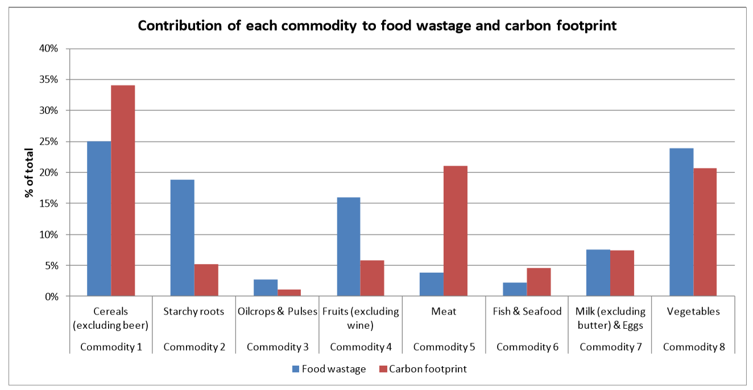
Figure B
