- / Science

SEP 25, 2015 @ 10:44 PM 10,064 
The Little Black Book of Billionaire Secrets

The Science Of Why Cities Are Warmer Than Rural Areas

Marshall Shepherd, CONTRIBUTOR
FULL BIO 

Opinions expressed by Forbes Contributors are their own.

If you watch the evening news, you may have noticed that cities are often warmer than the surrounding rural or suburban landscapes. For the first time in human history, more people live in cities than rural environments and this trend is likely to increase.

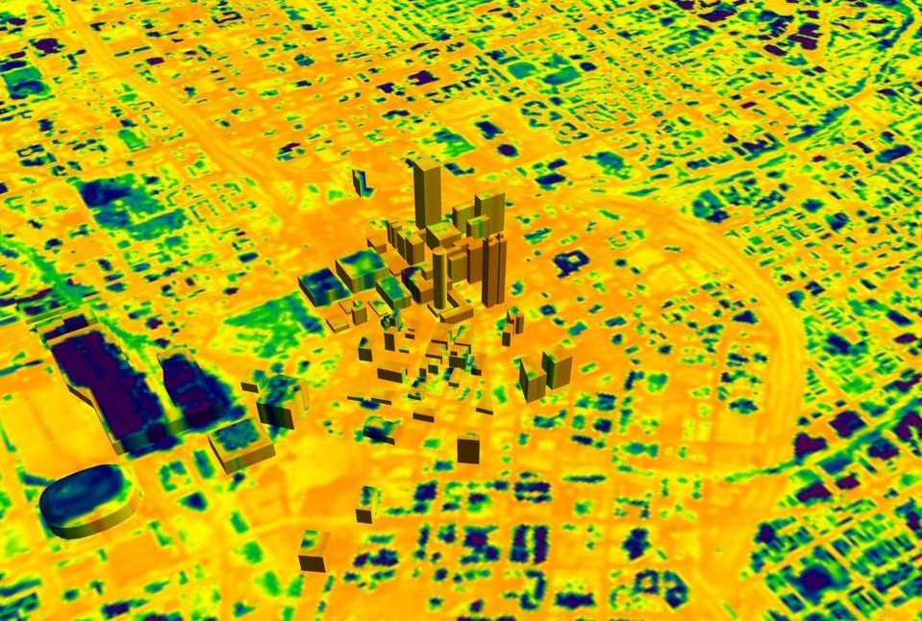
Atlanta thermal image at night showing the surface urban heat island. Courtesy of NASA. [+]

City regions can typically have air temperatures warmer than surrounding rural environments by anywhere from 1 to 15 degrees F. The difference is most noticeable in the evenings. During the daytime, skin or surface temperatures are even larger.
This difference is known as the Urban Heat Island. There are different types of Heat Islands: Surface, Canopy or Air Temperature, and Boundary Layer (roughly lowest 1 km of the atmosphere). Herein, I will write generically about them as one entity. The Urban Heat Island or UHI was first noted by Luke Howard in 1820. According to

Helmut Landsberg's classic textbook The Urban Climate, Howard speaking about London noted:

“ ...night is 2.1 degrees C warmer...in the city than in the country

Heat islands can lead to increases in heat related health issues and mortality, increased energy demand, higher air conditioning costs, and more air pollutions and greenhouse gas emissions. So why do UHIs happen? There are several factors that cause the Urban Heat Island.

Heat-absorbing surfaces. If you think about the materials in a city (asphalt, tar roofs, concrete), they are primarily of low albedo and have heat storing capacity.
Albedo is a measure of reflectivity of a material. Fresh snow has a very high albedo while dark asphalt has a low albedo. Lower albedo surfaces will absorb more solar energy than higher albedo surfaces. Therefore, roadways, rooftops, and buildings absorb heat throughout the day. These surfaces re-emit that absorbed energy at night, which maximizes the UHI during the hours after sunset. In cities with large buildings, the corridors between them are called urban canyons. Heat energy (longwave infrared) radiated from buildings can accumulate even more within these canyons. Highly reflective surfaces like "light" roadways and white roofing have been proposed as a way to reduce the urban heat island. Kanok Boriboonsomsin has referenced previous studies noting:

“ ...increasing the albedo of 1,250 sq km (483 sq mi) of roadways in Los Angeles by
0.25 would save cooling energy worth $15 million per year, and would reduce
smog-related medical and lost-work expenses by $76 million per year

Recommended by Forbes

MOST POPULAR
  - TRENDING ON FACEBOOK

The 10 Most Dangerous U.S. Cities
Farewell Toys R Us, We Will Miss You

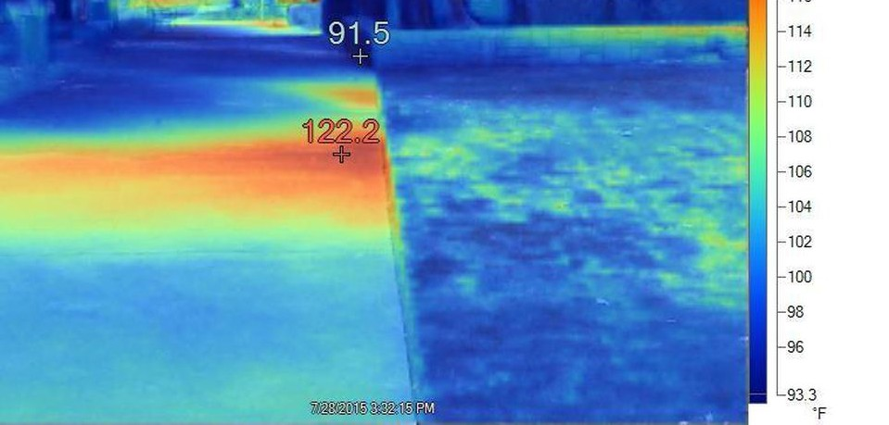
Temperatures of paved and natural surfaces at the University of Georgia. Courtesy of Marshall Shepherd and Jason [+]

Lack of trees. Cities also tend to have less trees and vegetation within the central business district or city center. Less vegetation means less evapotranspiration. Like evaporation of perspiration from our skin, evapotranspiration is a cooling process. In a recent University of Georgia study, the top 50 UHIs in the United States were ranked. Louisville, Kentucky ranked #3. One reason is that the city has been slow to adopt a tree ordinance. This very attribute is why strategic greening such as greenscapes or green roofs are recommended UHI mitigation strategies.

Anthropogenic Waste Heat. Cities are notorious for a by-product of society called anthropogenic waste heat. This term is represented by the heat from industry, passing transit buses, cars, or heating-cooling systems. A review of the the difference between the theoretical energy balance of typical rural and urban energy balance model reveals an anthropogenic heat term that is not present in the rural scenario.

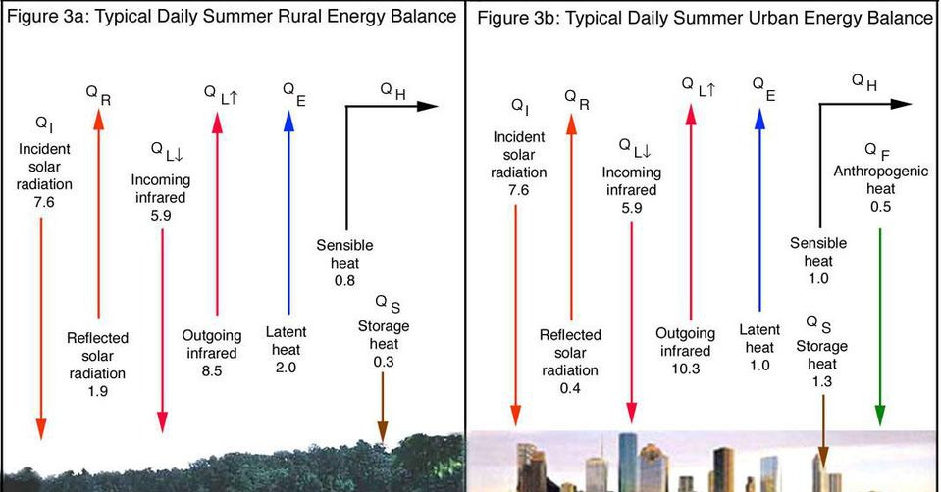
A diagram of the energy balance for a typical natural and urban landscape. Figure courtesy of Ronald Sass' website, [+]

The combination of heat-absorbing surfaces, lack of evapotranspirational cooling, and waste heat causes the Urban Heat Island.

