Name: ________________________________
Lesson 3: Why are cities and other regions of the world getting hotter?

Day 1
Prior Experiences: What are some similarities and differences in regions we categorize as “cities” versus regions we categorize as “states”? Use the Venn diagram below to organize your ideas.

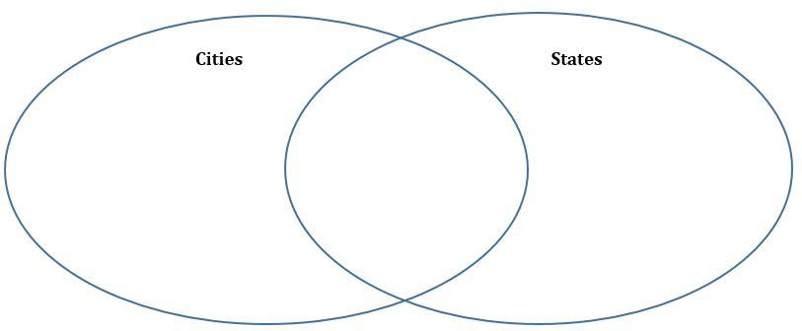

Exploration:
- Use the table below to organize your observations about the characteristics of the land surfaces in cities versus the land surfaces in states.

Characteristics | Characteristics of the land surfaces in cities (Denver, Colorado Springs, Greeley) | Characteristics of the land surfaces in states (like Colorado)
What features would you find in this location?
How is the land used?

If you were to look at this land from above, what colors would you expect to see a lot of?

Plan it out:
How can we investigate how these different land characteristics might affect temperature? Work with a partner to write a proposal for an experiment below…
- A procedure should be a step-by-step process that ANYONE should be able to clearly read, understand, and follow without having to ask any questions.
- Goal: Do land surfaces found in cities warm faster than land surfaces found in states?

Procedure

Day 2
Making Sense:

After you complete the investigation, record some questions you now have about how land surfaces affect temperature.
___________________________________________________________________________
___________________________________________________________________________
___________________________________________________________________________

What is the Urban Heat Island Effect?
___________________________________________________________________________
___________________________________________________________________________
___________________________________________________________________________

Colorado state temperature data

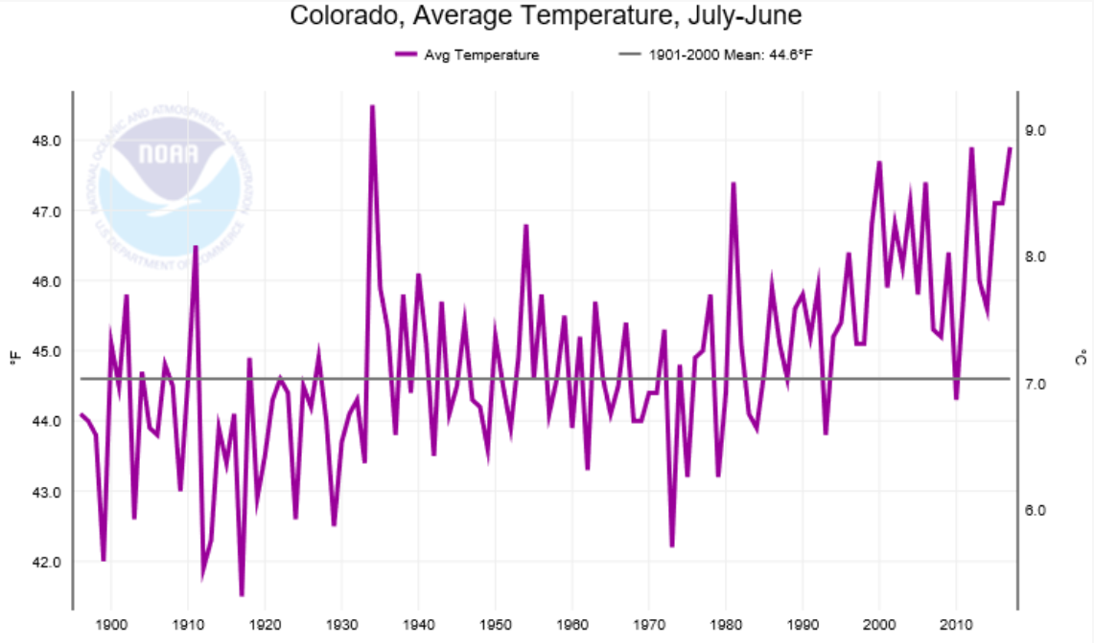
NOAA National Centers for Environmental Information

- Describe the temperature trend in the state of Colorado over the past 100 years.
___________________________________________________________________________
___________________________________________________________________________
___________________________________________________________________________

- Record some ideas or questions you have to explain the increase in statewide temperatures in Colorado.
___________________________________________________________________________
___________________________________________________________________________
___________________________________________________________________________
___________________________________________________________________________

Making Sense: A Thought Experiment

1. Based on what you figured out in your investigation, use the map below to imagine where on the global map you would expect to see low albedo areas and high albedo areas. Draw circles on the map showing at least one of each.
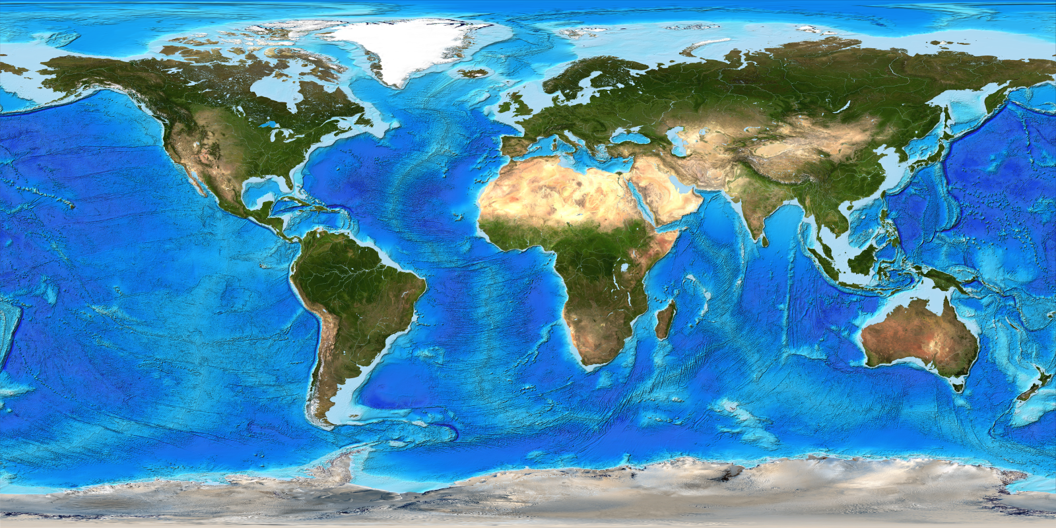

2. Explain why you think the high albedo region you picked should have overall cooler temperatures than places with low albedo. Use evidence from your investigation.

___________________________________________________________________________
___________________________________________________________________________
___________________________________________________________________________
___________________________________________________________________________
___________________________________________________________________________

3. Recall the map we looked at in Lesson 2 (see below). Does it match with your investigation results? Write down at least two things that make sense or don’t make sense when you compare your map in Question 1 with the temperature anomaly map below. Provide hypotheses as to why there are differences between your predictions and the map.

___________________________________________________________________________
___________________________________________________________________________
___________________________________________________________________________

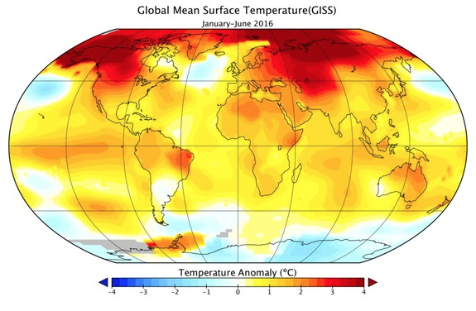
NASA GISS

