Name ___________________________________

Lesson 4: Are other parts of the world getting hotter?

Do Now: During our last couple of classes, we looked at how the surfaces in a place can make that place warmer or cooler.

What did we learn about the colors of surfaces and temperatures?
The darker the surface the warmer it will be because darker colors absorbs more light energy.
Lighter surfaces reflect more light energy so they will be less warm.
What does this tell us about the amount of light reflected and temperature?
Suggestion to review the term “albedo” to explain this phenomenon that lighter colored surfaces reflect more light energy and are cooler temperatures than darker surfaces that absorb more light energy and are warmer temperatures.
What did we decide to look at next?
We decide that we need to know if other parts of the world are getting hotter like cities are.

Reflecting Changes:
Look at the image below. Compare different parts of the world to see how the amount of light being reflected has changed from 2000-2011.
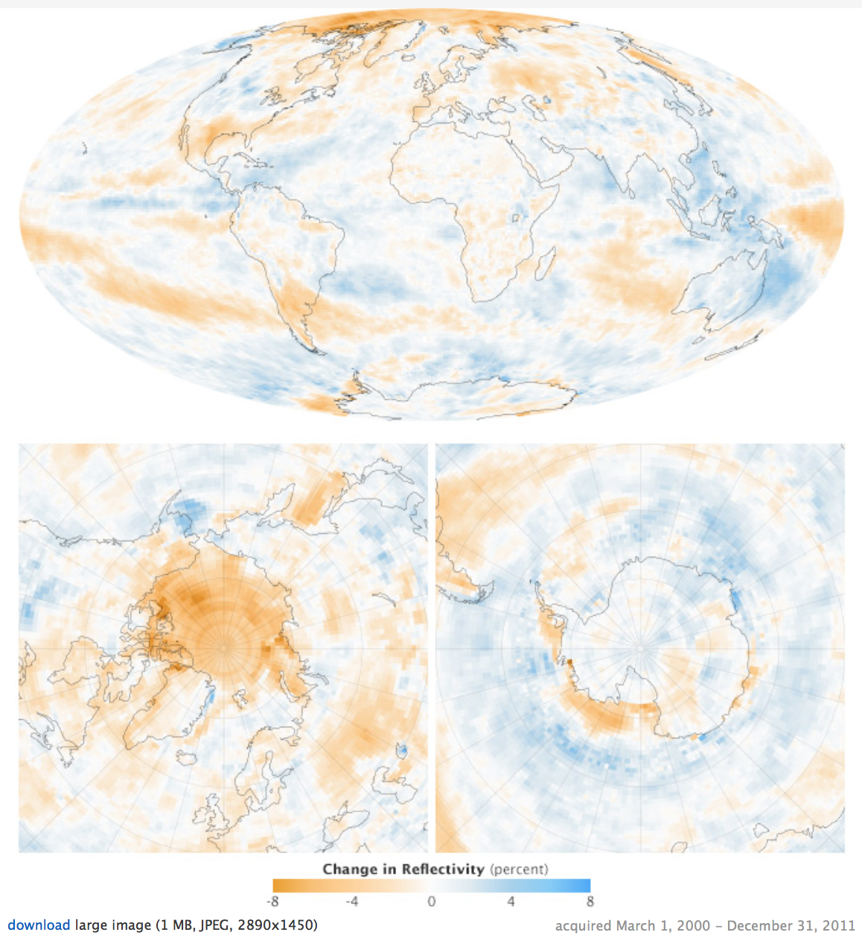

What do the colors on the map represent?
Red tones are decreases in reflective surfaces; blue tones are increases in reflective surfaces.

What patterns do you notice on the map? What does this tell us?
There are changes in reflectivity all over the world. The Arctic is less reflective than Antarctica.
The north pole must have a decrease in the amount of snow and ice that reflect light energy.
Other Parts of the US:
Look at the image below. Compare different parts of the country and how their temperatures have changed.

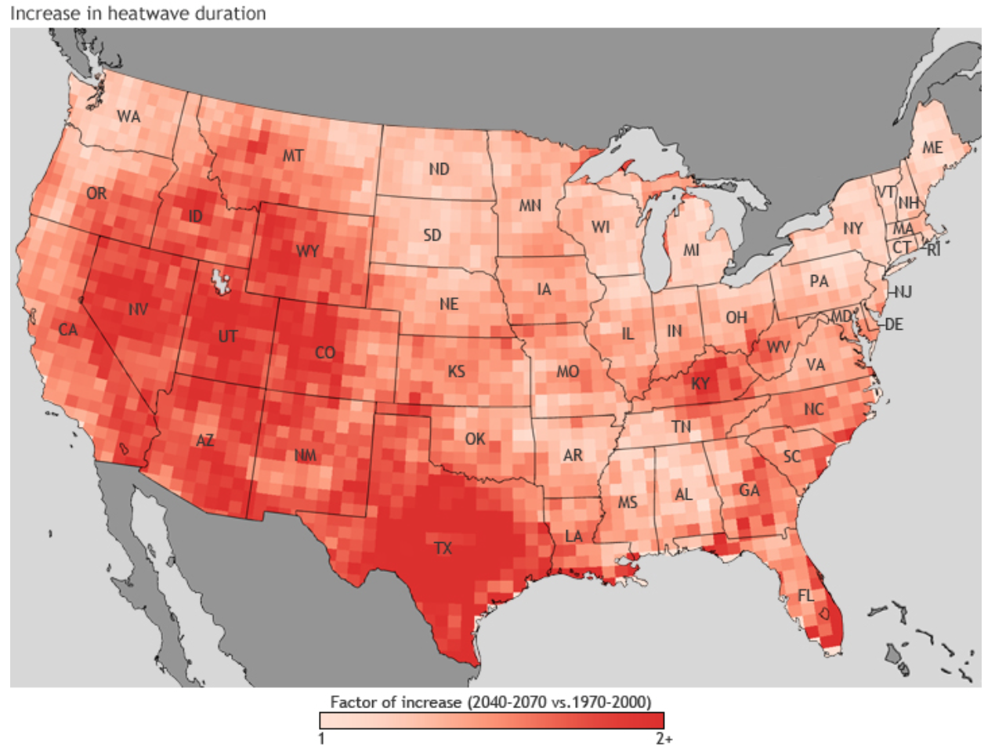

What patterns do you see on the map? What might explain these patterns?
Western states and Texas have the most increase in heat waves. Explanations vary.

Other Parts of the World:
Look at the following images to see the average temperatures around the world and over time. The image below shows the average surface temperatures around the world in 2016 compared to the average temperature between 1951-1980.
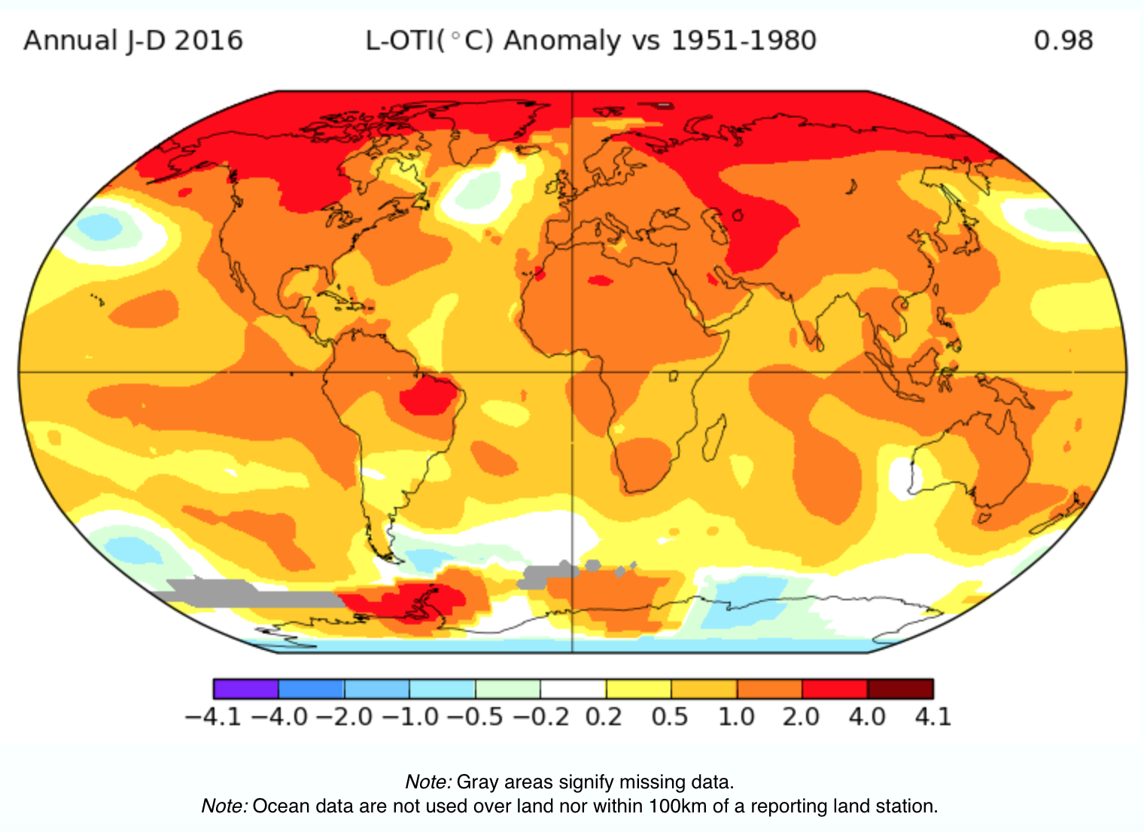

What do the colors represent on the map represent?
Warming temperatures are yellow to red, and cooling temperatures are green to purple.
White means temperatures have not changed.

What patterns do you notice on the map? What does this tell us?
Overall, temperatures around the world are warming more. Temperatures are warming the most in the Arctic and they are cooling the most in Antarctica.
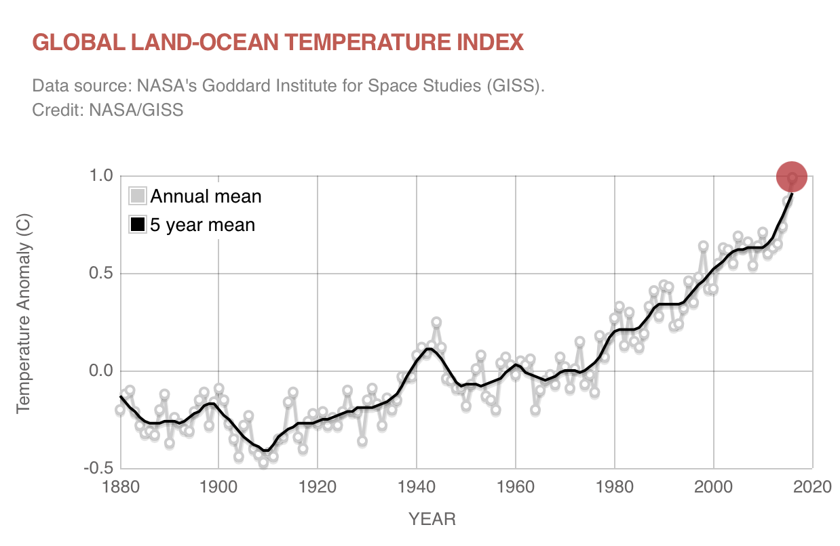What do the line graph colors represent? What do the graph axes tell us?
The gray line is the yearly average temperature of the world and the black line is the five year average temperature of the world. The x-axis is time in years; y-axis is the temperature difference from normal.

What patterns do you notice on the graph? What does this tell us?
The world’s average temperature has been increasing since the early 1900s.
Since the early 2000s, the temperature is increasing even faster.

Model: What do we know so far?
Use pictures and sentences to describe what is happening to temperatures around the world.
- What changes over time have we seen?
- How are those changes related to each other?
- What evidence do we have for those changes?

Student answers will vary:

What’s next?

What have we learned about temperatures in other parts of the world?
We learned that overall temperatures are increasing around the world and not just in certain cities.
What do we need to figure out next?
We decide that we need to find out what temperatures were like in the past. We also want to know what is causing temperatures throughout the world to increase nowadays.

