Name ___________________________________

Lesson 4: Are other parts of the world getting hotter?

Do Now: During our last couple of classes, we looked at how the surfaces in a place can make that place warmer or cooler.

What did we learn about the colors of surfaces and temperatures?
What does this tell us about the amount of light reflected and temperature?
What did we decide to figure out next?

Reflecting Changes:
Look at the image below. Compare different parts of the world to see how the amount of light being reflected has changed from 2000-2011.
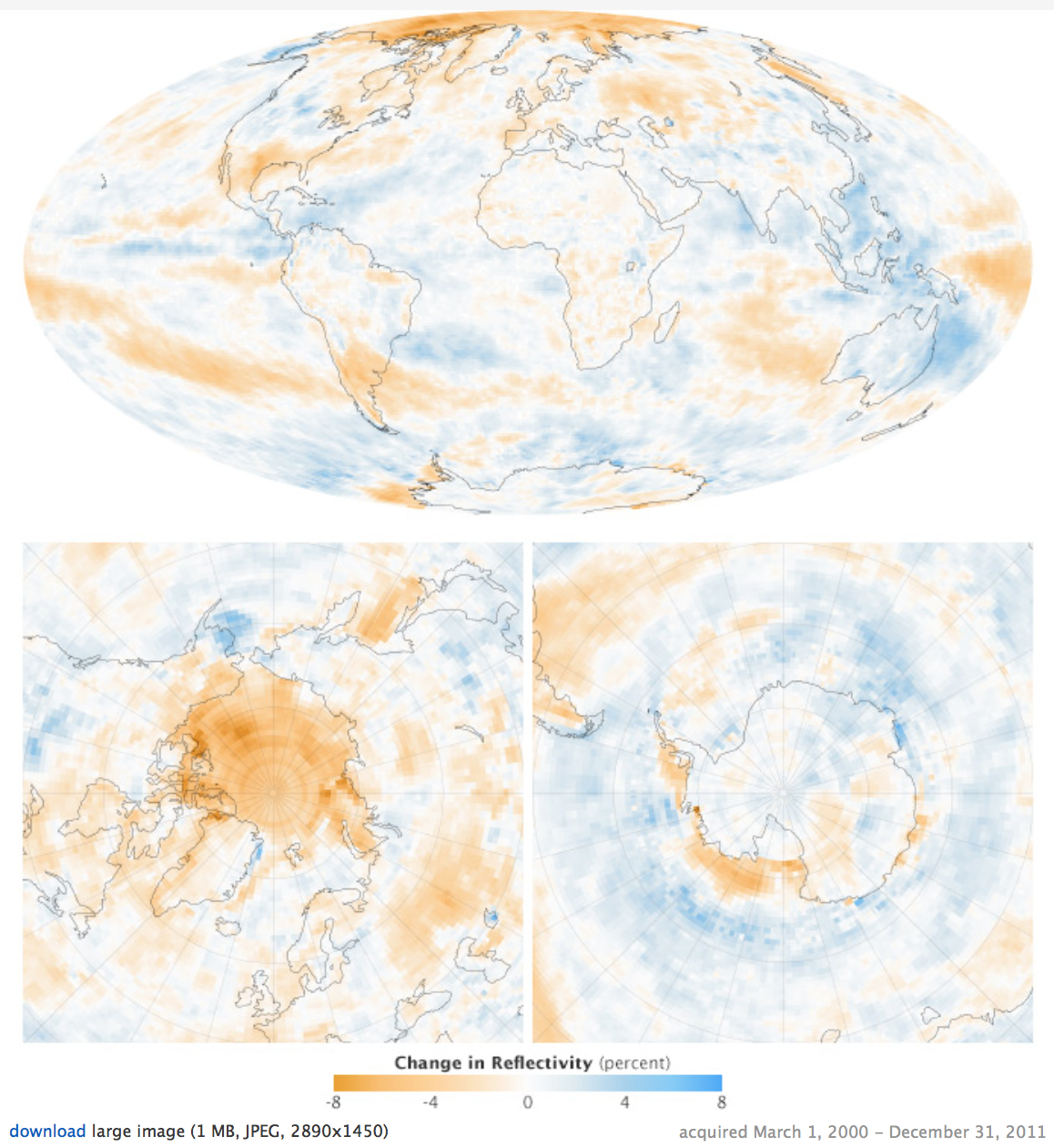

What do the colors on the map represent?
_________________________________________________________________________
_________________________________________________________________________
_________________________________________________________________________
What patterns do you notice on the map? What does this tell us about how albedo is changing on the planet?
_________________________________________________________________________
_________________________________________________________________________
_________________________________________________________________________

Other Parts of the US:
Look at the image below. Compare how temperature has changed in different parts of the country.

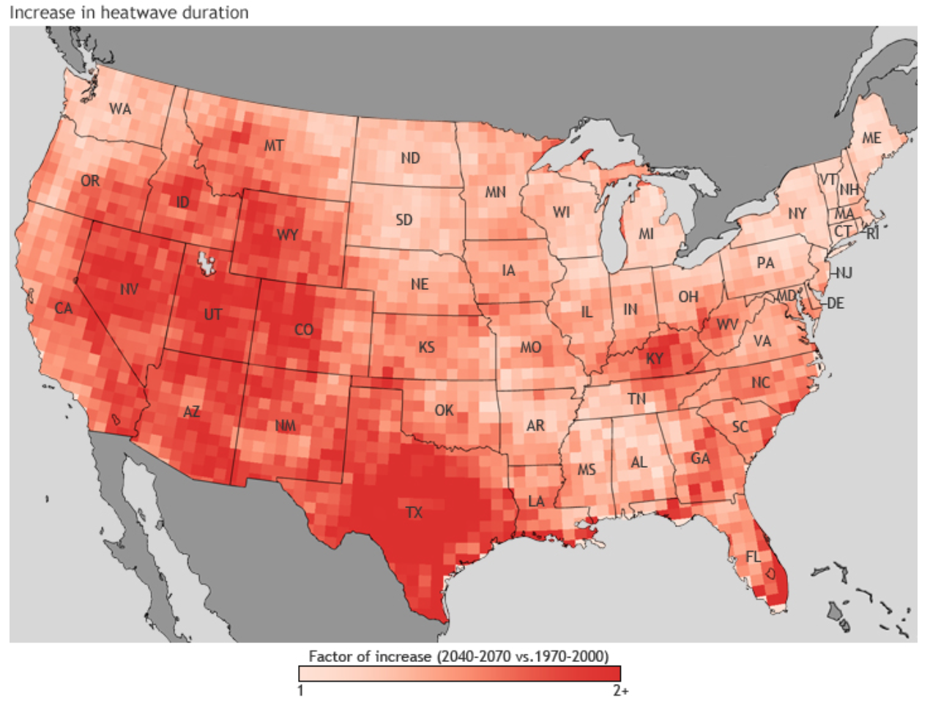

What patterns do you see on the map? What might explain these patterns?
_________________________________________________________________________
_________________________________________________________________________
_________________________________________________________________________

Other Parts of the World:
Look at the following images to see the average temperatures around the world and over time. The image below shows the average surface temperatures around the world in 2016 compared to the average temperature between 1951-1980.
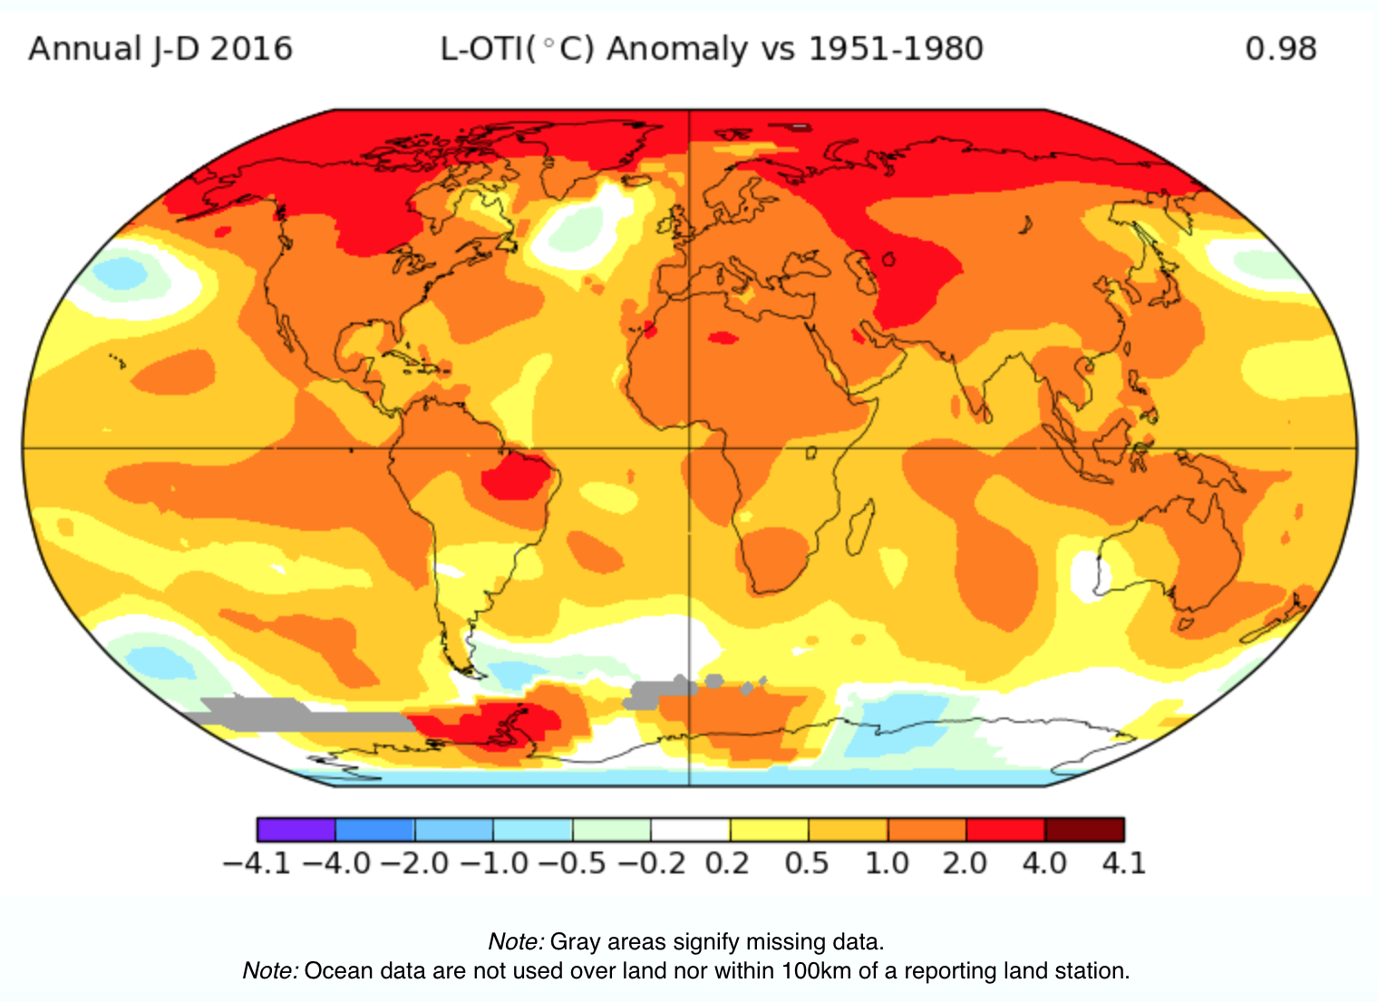
What do the colors represent on the map represent?
_________________________________________________________________________
_________________________________________________________________________
_________________________________________________________________________
What patterns do you notice on the map? What does this tell us?
_________________________________________________________________________
_________________________________________________________________________
_________________________________________________________________________
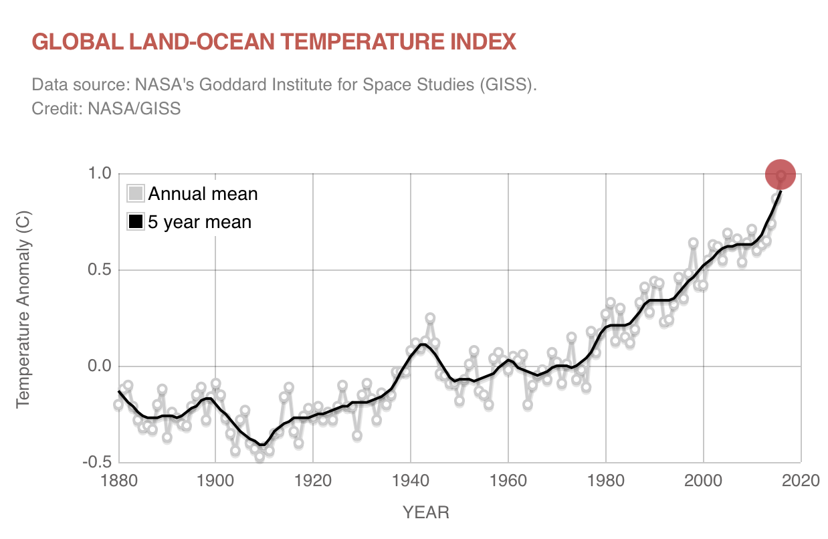What do the line graph colors represent? What do the graph axes tell us?
_________________________________________________________________________
_________________________________________________________________________
_________________________________________________________________________
_________________________________________________________________________
_________________________________________________________________________
What patterns do you notice on the graph? What does this tell us?
_________________________________________________________________________
_________________________________________________________________________
_________________________________________________________________________
_________________________________________________________________________
_________________________________________________________________________

Model: What do we know so far?
Use pictures and sentences to describe what is happening to temperatures around the world.
- What changes over time have we seen?
- How are those changes related to each other?
- What evidence do we have for those changes?

What’s next?

What have we learned about temperatures in other parts of the world?
What do we need to figure out next?

