Name ____________________________________

Lesson 6: How does human activity affect the trend of warming temperatures on Earth?

Do Now Prior Experiences:
In the last lesson, we investigated what the world’s temperature trend was in the distant past to find out if the recent increasing temperature is a trend or not. What do we now understand from the previous lesson?
We found out that Earth’s temperature was more stable and slowly warming in the past.
_________________________________________________________________________
The recent warming trend started around the time of the Industrial Revolution in the late
_________________________________________________________________________
1700s and that temperatures increased greatly and continues to increase now.
_________________________________________________________________________

Exploring Greenhouse Gases (GHGs):

- Use the PhET The Greenhouse Effect simulation to model the relationship between greenhouse gases, especially CO₂, and the temperature:
https://phet.colorado.edu/en/simulation/greenhouse
- Complete the data table and then investigate your own scenarios using the simulation.

Time | CO2 Concentration  (ppm=parts per million) | Temperature  (in °F and °C) | Amount of Infrared photons (heat) compared to other times  Circle one: | Amount of sunlight photons compared to other times  Circle one:
Ice Age  (2.6 million to 11,760 years ago) | Teacher to guide  Using simulation and confirm student responses |  | More  Same  Less | More  Same  Less
1750 (pre-industrial revolution) |  |  | More  Same  Less | More  Same  Less
Today  (post-industrial revolution) |  |  | More  Same  Less | More  Same  Less

Making Sense:
What patterns do you observe about the relationship between the concentration of CO_{2,} along with the other GHGs, and temperature?
As the level of CO₂ and other GHGs increases, temperature increases.
_________________________________________________________________________
As the level of CO₂ and other GHGs decrease, temperature decreases.
_________________________________________________________________________
CO₂ is the GHG that affects temperature the most.
_________________________________________________________________________

_________________________________________________________________________

_________________________________________________________________________

_________________________________________________________________________

_________________________________________________________________________

_________________________________________________________________________

Which time is the concentration of CO₂ in the atmosphere the highest? Where do you think the source of extra CO₂ came during this time?
Present day. Supporting ideas will vary.
_________________________________________________________________________

_________________________________________________________________________

_________________________________________________________________________

_________________________________________________________________________

_________________________________________________________________________

Which time is the concentration of CO₂ in the atmosphere the lowest? What do you think the reason is why CO₂ is not as high during this time?
Ice age. Supporting ideas will vary.
___________________________________________________________________________

___________________________________________________________________________

___________________________________________________________________________

___________________________________________________________________________

___________________________________________________________________________

Understanding GHGs and the Greenhouse Effect (GHE):
Watch “The Greenhouse Effect” video to connect CO₂ and its role in the warming Earth:
https://cleanet.org/resources/42808.html

In the space below, draw a diagram or write a brief explanation describing, what the GHE is and how it works. Use the following prompts, for ideas:
- Explain what the GHE is and why it’s important.
- How does the level of CO₂ in the atmosphere affect the Earth’s temperature?
- Describe how human activities affect the natural GHE.

Summary:
The GHE traps heat in the Earth’s atmosphere, which keeps temperatures at a habitable
________________________________________________________________________
level and allows liquid water to exist on the planet. GHGs trap infrared radiation (heat)
_________________________________________________________________________
which radiates from the Earth’s surface, which is warmed by incoming solar radiation.
_________________________________________________________________________
CO₂ is the most abundant GHG so it is able to trap the most heat. Humans burn fossil fuels,
_________________________________________________________________________
which give off CO₂ and this increases the amount in the atmosphere and warms it more.
_________________________________________________________________________

Human Activities that Emit CO₂ and Other GHGs:
Using the Data Sheet, work with a partner to analyze the U.S. GHG Emissions Flow Chart (Figure 6.1) to figure out details about the human activities that release GHGs.
http://cleanet.org/resources/47840.html

List the top three GHGs emitted the most from human activities and their percentages:
- Carbon dioxide (CO₂)
- Methane (CH₄)
- Nitrous oxide (N₂O)

List the top three sectors that release GHGs (e.g. Industry).
- ____________________________________________________________
- ____________________________________________________________
- ____________________________________________________________

Identify the top three end use/activities that release GHGs (e.g. Landfills).
- Electricity & heat
- Transportation
- Industry

Write one fact about human-caused GHG emissions that surprised you.
Student responses will vary.
_________________________________________________________________________

_________________________________________________________________________

_________________________________________________________________________

_________________________________________________________________________

Brainstorm:
Think, pair, share what do you think happens after CO₂ is released into the atmosphere?
- Watch the “Following Carbon Through the Atmosphere” visualization to see where CO₂ goes after it is emitted (released) into the air:
https://www.nasa.gov/feature/goddard/2016/eye-popping-view-of-CO2-critical-step-for-carbon-cycle-science
- On the world map, sketch the pattern that you observe of how CO2 travels:
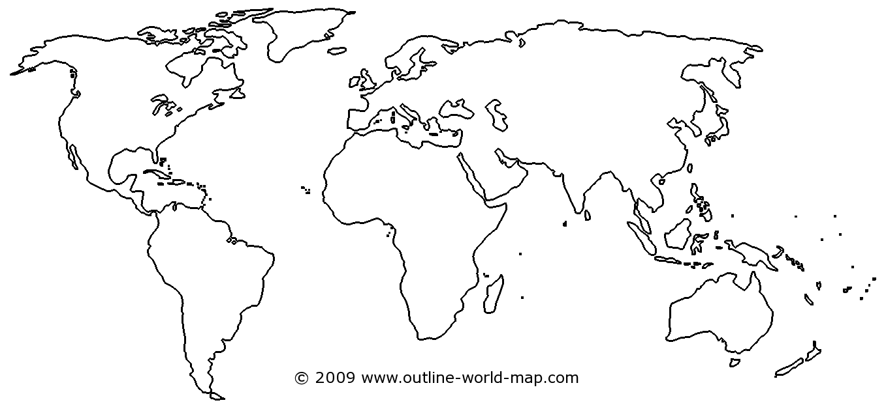
Source: http://www.outline-world-map.com/blank-thick-white-world-map-b3c

Summary:
Most CO₂ is emitted (released) in the Northern Hemisphere (more people and industry are
___________________________________________________________________________
located here) and most of it circulates here.
___________________________________________________________________________

___________________________________________________________________________

___________________________________________________________________________

___________________________________________________________________________

Connecting CO₂ and the Carbon Cycle:
Brainstorm:
Think, pair, share about where you think the CO₂ that is released into the atmosphere originally comes from and where it eventually goes?
- Using the Data Sheet, discuss the patterns modeled on The CO₂ and the Carbon Cycle diagrams (Figure 6.2 and Figure 6.3). Explain what you observe:

CO₂ and the Carbon Cycle Observations
Student answers from the diagram will vary.

Carbon Cycle Reservoirs:
- Launch and explore the online Carbon Dioxide and the Carbon Cycle interactive animation (or review the printed screenshots if computer access is unavailable):
https://rmpbs.pbslearningmedia.org/resource/pcep14.sci.ess.co2cycle/carbon-dioxide-carbon-cycle/#
- Using the interactive animation, observe each web page and read each informational link and summary to build understanding about CO₂ and the Carbon Cycle.
- Answer the questions on the following page.

As you go through each web page, record the main areas where carbon is stored (sinks) and which processes release CO₂ (sources) into the atmosphere:

List the main reservoirs (sinks) where carbon is stored on Earth from largest to smallest:
- Rocks
- Oceans
- Fossil fuels
- Biomass
- Atmosphere

What form is carbon stored in the atmosphere? CO₂
_________________________________________________________________________

_________________________________________________________________________

Which reservoir has the biggest direct impact on climate? Atmosphere
_________________________________________________________________________

_________________________________________________________________________

Which reservoir has the least impact on climate? Rocks
_________________________________________________________________________

_________________________________________________________________________

How do human activities affect the fossil fuel carbon reservoir?
When humans take fossil fuels from the ground and burn them, it releases CO₂ into the
_________________________________________________________________________ atmosphere and the atmosphere has the most impact on the climate.
_________________________________________________________________________

_________________________________________________________________________

CO₂ and the Atmosphere 300 Years Ago vs. CO₂ and the Atmosphere Present Day
Use the diagram and table to compare and contrast the sources of CO₂ in the atmosphere and how their amounts have changed over time: Student responses from the diagram will vary.
Past Present
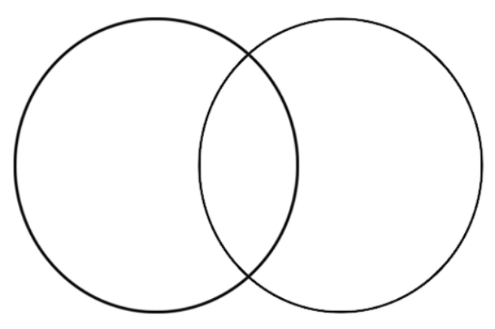
CO₂ and the Atmosphere 300 Years Ago | CO₂ and the Atmosphere Present Day

Temperature and CO₂:
Read each summary and analyze each graph about CO₂ in the atmosphere and temperature over the past 1000 years. Describe the patterns and trends you observe over time in the table:

 | Year  1000-1800 | Year  1800-Present
CO₂ Concentrations | CO₂ is fairly stable between 270 and 280 ppm | CO₂ is fairly stable between 270 and 280 ppm
Temperature Change | Temperature fairly stable and fluctuates between 0.0° to 0.6° below average temperature | Temperature warms rapidly from 0.5° below average to 0.7° above average temperatures
CO₂ and Temperature  Relationship | CO₂ do not appear to be following a similar pattern | CO₂ appear to be following a similar pattern

CO₂ and Climate Change Connections:
As a class, watch and then discuss the connections between GHGs, the GHE, and what adding more CO₂ to the atmosphere from burning fossil fuels does to the natural balance of Earth’s temperature.
Climate Change Basics video: http://cleanet.org/resources/45172.html

Next Steps:
What have we learned from this lesson and what should we investigate next?

Word Bank: atmosphere, carbon dioxide (CO2), Carbon Cycle, decrease, emissions, fossil fuels, greenhouse effect (GHE), greenhouse gases (GHGs), increase, sink(s), source(s), temperature.

Describe what we have learned about the connection between human activities, CO₂, and Earth’s temperature? You can use the word bank terms (above), if needed.
Student responses will vary but should focus on how human activities that burn fossil fuels are adding more CO₂ into the atmosphere and enhancing the greenhouse effect thus warming the Earth more.
What do we need to figure out next about why temperatures are getting hotter?
Student responses will vary but should focus on understanding how CO₂ increases temperature.

