Introduction

Earth-Sun Relationship

The Sun & its Energy

Earth & its Atmosphere

Solar Radiation in the Atmosphere
The Sun & its Energy

The sun's energy is the primary source of energy for all surface phenomena and life on Earth. Combined with the material of the Earth (including the molecules held close by the Earth's gravitational force called the atmosphere), this energy provides for the immense diversity of life forms that are found on the Earth. We will now look in detail at solar energy and its interplay with the constituents of the Earth's atmosphere.

Characteristics of the Sun

Atmospheric Environmental Concerns

Ozone Depletion

Global Climate Change

Regional Concerns

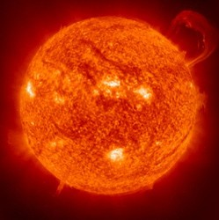
Image courtesy of NASA.
The sun is a medium, yellow star, consisting primarily of hydrogen at temperatures high enough to cause nuclear fusion. Nuclear fusion is a nuclear reaction in which hydrogen nuclei fuse together to form helium nuclei and release energy. In this state, some 120 million tons of matter-- mostly hydrogen--are converted into helium on the sun every minute, with some of the mass being converted into energy. The size of the sun determines its temperature and the amount of energy radiated.

Exercises

Internet Links

Other Resources

Atmospheric System PDF

Printer-Friendly Web Version
Electromagnetic energy from the sun comes to Earth in the form of radiation. The term "radiation" simply denotes the fact that the energy
travels as rays, that is, in straight lines. In general, the terms "solar energy" and "solar radiation" simply refer to energy from the sun. Electromagnetic energy is produced when electric charges change their potential energy. It is characterized by the property that it is pure energy, not requiring any
matter (or medium) for its existence or movement. Electromagnetic energy can therefore travel through space (which is a vacuum), traveling at a speed that is the same for all forms of electromagnetic energy and is equal to the speed of light, 3 x 108 m/sec (or 186,000 miles per second).

The sun radiates energy equally in all directions, and the Earth intercepts and receives part of this energy. The power flux reaching the top of the Earth's atmosphere is about 1400 Watts/m2. This measure simply means that on the average, one square meter on the side of the Earth facing the sun receives energy from the sun equal to that from fourteen 100 Watt light bulbs every second!

The sun is in a relatively stable state, and as far as we can tell, will continue to be so for about another three billion years. The sun and other stars do show periods of slightly higher than normal activity, detectable in our sun by an increase in sunspot activity. During sunspot activity, more energy
reaches the Earth. The sun spends about a quarter of its time in a state with very few sunspots. It is suspected that the sun dimmed about ten times in the last 100,000 years causing "Little Ice Ages" (extended periods of unusually cold temperatures) of about a couple of centuries each. The last such quiescent state occurred in the late seventeenth century. The sun has

also shone with considerable above-average brightness at least twice in our geological era: about 5,000 years ago, around the time of the beginning of the ancient civilizations of China, Minoa, Sumeria, and the Indus Valley; and about 1,000 years ago, when the temperatures of Northern England rose high enough to allow vineyards to flourish there.

Electromagnetic Spectrum - Basic Science

The entire region of electromagnetic energy distinguished by wavelength and frequency is called the electromagnetic spectrum. The propagation of the energy along the rays is in the form of a wave with the amount of energy alternating between high and low values, as in a water wave. Thus we say that light, heat, etc., travel in the form of waves. Wavelength can be defined as the distance between two successive peaks (or troughs) in waves of energy, while frequency is measured by counting the number of peaks
that pass a given point every second.

In the diagrams of the spectra in this section, we use two different scales in measuring wavelengths. The first is microns or micrometers (µm), which is equal to 10-6 meters. The other is nanometers (nm), equal to 10-9 meters. In discussing small ranges of the spectrum, we use units of nm, and in discussing the overall spectrum or larger regions, we revert to µm.

Frequency is measured in units of cycles per second, or hertz (Hz). One cycle per second is equal to one hertz.

In order of decreasing frequency (and increasing wavelength), the various regions of the electromagnetic spectrum are: gamma rays, x-rays, ultraviolet , visible light, infrared, microwaves, and radio waves. Electromagnetic energy from the sun consists mostly of a small amount of ultraviolet, all visible light, and some infrared.

The full electromagnetic spectrum is depicted in Figure 2. Table 1 gives the same information, as well as some technological applications.

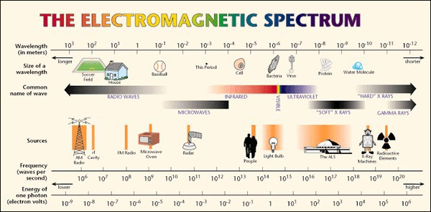
Figure 2: The electromagnetic spectrum. (from Lawrence Berkeley National Laboratory)

Name of
Region
Wavelength
Range (in m, µm, and nm)
Frequency Range
Gamma
Rays
3x1022 to 3x1018 Hz
Technological
Applications / Role in Nature
Radiation therapy

X - Rays
10-14 to 10-10 m
10-8 to 10-4 µm
10-5 to 10-1 nm
10-14 to 10-8 m
10-8 to 10-2 µm
10-5 to 10 nm

3x1022 to 3x1016 Hz

Radiation therapy; diagnosis (lower frequencies)

Ultraviolet
10-8
to 4x10-7 m

Tanning;

Rays
10-2
to 0.4 µm
3x1016
to 0.75x1016 Hz
Promotes production of
Vitamin D in human skin;

10-5 to 400 nm
photosynthesis in plants

Visible
4x10-7
to 8x10-7 m
16

Lamps for seeing
16

Light
0.4 to 0.8 µm
400 to 800 nm
8x10-7 to 10-3 m
0.75x10
to 0.375x10
Hz (Eyes respond to this range)

Infrared
0.8 to 103µm 800 to 106 nm
0.375x1016 to 3x1011 Hz Infrared photography

Radio

-4 6 12

Waves 10
to 10
m 3x10
to 300 Hz Communication devices

Table 1: Regions of the entire electromagnetic spectrum and general applications.
Note that the regions are not strictly delineated.

We have specialized sensory organs that only detect some parts of the spectrum. For example, the eye detects visible light, and even distinguishes different wavelengths within the spectrum of visible light as color! The skin perceives radiation from the infrared region of the spectrum as heat. Note that sound is not a form of electromagnetic energy. Because sound is really the energy of the motion of molecules through a medium (mechanical energy), it cannot travel through a vacuum. As we already noted, electromagnetic energy has no need for a medium through which to travel, and can therefore travel through space from the sun to reach the Earth.

Different molecules absorb different regions of electromagnetic energy preferentially. For example, the water molecule preferentially absorbs certain wavelengths in the microwave region of the electromagnetic spectrum. This preference is the basis of the efficient cooking of food by microwave ovens. Calcium, a primary constituent of bones, absorbs energy in the x-ray region more strongly than do the water or carbon in the cells of ordinary tissue, allowing for the use of x-rays to generate images that show unevenness such as broken bones or tumors. The chlorophyll molecule in green plants absorbs mostly ultraviolet (and also some blue violet, and red light) and uses this energy for photosynthesis. Most of the green light in sunlight is reflected by leaves, making them appear green to our eyes.

Solar Spectrum

The range of electromagnetic energy emitted by the sun is known as the solar spectrum, and lies mainly in three regions: ultraviolet, visible, and infrared. The solar spectrum extends from about 0.29 µm (or 290 nm) in the longer wavelengths of the ultraviolet region, to over 3.2 µm (3,200 nm) in the far infrared. Small amounts of radio waves are also given off by the sun and other stars. In fact, if the sun's image is made from its radio waves, it appears 10% larger than if its image is made from visible light. There are some "cooler" stars that give off mostly radio waves and no visible radiation.

The range of energy given off by a star depends upon the temperature and size of the star. Smaller, hotter stars (called "white dwarfs") give off more energy in the blue region and appear "whiter" than our yellow sun. Rigel, a star in the constellation Sirius, is a white dwarf. Larger, cooler stars, called "red giants," emit more light in the red region, and are exemplified by

Antares and Betelgeuse. Note that even a "cool" star still has a temperature of a million degrees or so.

While the sun does emit ultraviolet radiation, the majority of solar energy comes in the form of "light" and "heat," in the visible and infrared regions of the electromagnetic spectrum. As shown in Table 2, visible light spans the relatively narrow range of 0.4 to 0.9 µm (or 400 to 700 nm). Light is special to humans and many other animals due to the evolution of the eye, a sensory organ that detects this part of the solar spectrum. As noted earlier, our eyes even recognize parts of the visible light spectrum as the sensations of color. Thus 400 nm radiation is perceived by the eye as violet, and 600 nm radiation is perceived as red.

We are all familiar with the rainbow of colors--the range of different wavelengths that make up sunlight. The best way to visualize this concept, and the most common scientific demonstration, is the image of a glass prism splitting up white light into the colors. When raindrops act as prisms, we see a rainbow. Often, when the sun is bright, various transparent objects such
as beveled edges of glass windows or glass pieces of a chandelier transmit light as a spectrum. This phenomenon occurs because different wavelengths of light (or different colors) travel through glass at different speeds, causing them to bend at different angles. Figure 3 shows the spectrum (violet, blue, green, yellow, orange, and red) going from the shortest wavelengths (highest frequency) to the longest wavelengths (lowest frequency). On either side of the visible spectrum are the ultraviolet (shorter wavelength than violet) and infrared (longer wavelength than red). These wavelengths are mostly absorbed by the glass and are, of course, outside the range of wavelengths that our vision can detect.

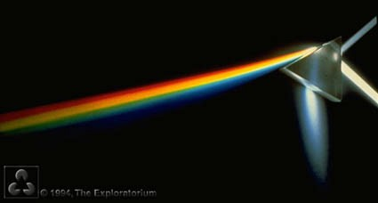

Figure 3: White light falling on a glass prism, dispersed into its constituent colors. (from Lawrence Berkeley National Laboratory)

While the eye effectively perceives and distinguishes visible light, infrared (wavelengths longer than red) is perceived as heat when it is absorbed by the skin and converted into energy of the molecules of the skin. Infrared plays an important role in the temperature of the Earth and its atmosphere, and in turn, the climate of the Earth. We will discuss this role in more detail in the section pertaining to the interaction solar energy with the atmosphere.

We will now discuss how much energy is available in the different wavelength regions of the solar spectrum.

Energy Distribution in the Solar Spectrum

Electromagnetic energy can be discussed in terms of its energy distribution, or the spread of energy over a range of wavelengths. This distribution of

energy is also known as the spectral distribution. The measure of radiation may be quantified in terms of the amount of energy falling per second (measured in Watts) per unit area (in square meters, m2) in each band of 1
µm wavelength.

The sun provides a broad range of energy, primarily concentrated around the visible and infrared regions. This energy is an important feature of the background conditions that led to the evolution of our life forms on Earth, and continue to support this life. There is a small amount of high-energy radiation like x-rays in the sun's energy but these do not penetrate below the topmost layer of the atmosphere, and we do not consider them here.

In the ultraviolet region of the solar spectrum around 0.28 µm wavelength, there is less than 100 W/m2 in a 1 µm band of radiation. In a 1 µm band around the red wavelength of 0.6 µm, however, there is over 2,000 W/m2. From 0.75 µm or so, there is infrared radiation ranging from about 1,000 W/m2/µm at 0.8 µm to about 100 W/m2/µm at 2.2 µm. This relatively low level of energy persists far into the infrared region.

The spectral distribution (or range of energies) of the solar radiation that falls on top of the Earth's atmosphere is represented in Figure 4. As this spectral distribution is close to what the sun emits, we can say that this is the sun's emission spectrum. The x-axis (or horizontal axis) represents the range of wavelengths in the solar spectrum (measured in nanometers), while the y-axis (or vertical axis) represents the amount of power (Watts) in each micron-wide band of wavelength falling on each square meter just outside of the Earth's atmosphere (measured in units of Watts/meter2/µm). This figure shows that most of the energy coming from the sun is in the visible region of the electromagnetic spectrum, making up what we call sunlight (white light).

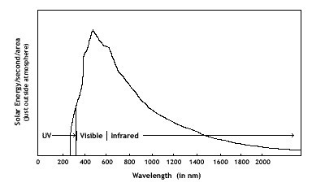
Figure 4: Solar spectral distribution entering the lower parts of the atmosphere.

Reflection and Absorption Spectra - Basic Science

When light falls on a surface, it can either be reflected, transmitted, absorbed, or varying degrees of all three. Different colored surfaces appear different to the eye because of differences in the way they reflect and absorb light. Stars are sources of radiation, giving off their own energy. Their color appears to us through the light they emit. So, a bluish star gives off more blue light than a yellow star like the sun. To see non-luminous objects, we need light from some other source to fall on them, and the reflected light reaches our eye. The colors of non-luminous objects are thus dependent on what wavelengths of energy they reflect and what wavelengths they absorb.

"White light" consists of the full spectrum of colors. If white light falls on a "perfectly" white surface, all of the light is reflected -causing all colors to reach the eye - and the reflecting surface is perceived as white. On the other hand, the perception of black is the absence of any color reaching the eye, meaning that all light is absorbed. In any case, the incident amount of energy (I), or the amount of energy falling on a particular surface, is equal
to the sum of the amount reflected (r) and the amount absorbed (a).

The following figures show schematically what happens when white light falls on a perfectly white surface, on a perfectly black surface, and on a green surface. In each case, Part A of the figure represents what happens when a ray or beam of white light falls on the surface. Part B of all the diagrams shows the spectrum of incident radiation and the spectrum of reflected radiation, with the x-axis representing wavelength and the y-axis representing energy intensity. The third part of each diagram set, labeled C, shows what is known as the absorption spectrum, showing what
wavelengths are absorbed. Note that in part C, while the x-axis still represents wavelength, the y-axis is now a measure of absorption and not energy. For simplicity we assume that all light not reflected is absorbed, although some might be transmitted. So what we label "absorption spectrum" below is actually an "absorption + transmission spectrum."

In the case of the white surface, almost all incident light is reflected. Thus the incident spectrum (I) and the reflected spectrum (r) are the same.
Because none of the light is absorbed, the absorption spectrum (a) may be shown as a flat line close to zero.

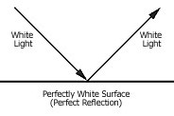
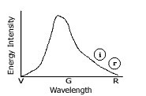
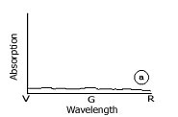
FIGURES 5.1: WHITE SURFACE

Figure 5.1A: Incident and reflected Figure 5.1B: Energy distribution in

beams.
incident and reflected beams. Figure 5.1C: Absorption spectrum.

When white light falls on a perfectly black surface, none of the incident light is reflected. Thus the same incident spectrum gives no reflected spectrum, represented by a flat line of almost zero energy. Because all incident light is absorbed, the absorption spectrum is the same as the incident spectrum.

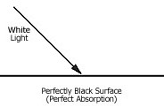
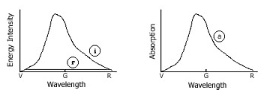
FIGURES 5.2: BLACK SURFACE

Figure 5.2A: Incident and reflected Figure 5.2B: Energy distribution in

beams.
incident and reflected beams. Figure 5.2C: Absorption spectrum.

In the example of a white light falling on a green surface, only green light is reflected. Once again using the same incident spectrum, the reflected spectrum this time centers around the wavelengths of green. The green surface also has a more complicated absorption spectrum: it absorbs both the violet-blue region and the red region as shown.

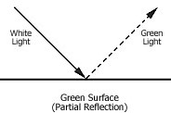
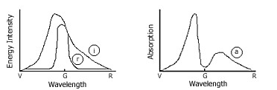
FIGURES 5.3: GREEN SURFACE

Figure 5.3A: Incident and reflected Figure 5.3B: Energy distribution in

beams.
incident and reflected beams. Figure 5.3C: Absorption spectrum.

Leaves appear green in sunlight (white light) because the chlorophyll molecules in the leaves preferentially absorb blue, violet, and red. Light from the green wavelengths is not absorbed; rather it is reflected and perceived by our eyes. The representation of this absorption is shown in Figures 6.1-6.3.

Figure 6.1 shows the absorption spectrum of the most common forms of plant chlorophylls. It shows that chlorophyll of plants has high absorption at 400 nm (violet and blue), low at 500 to 600 nm (green and yellow), and high again at around 680 nm (red). The absorption is a measure of the "appetite" of the chlorophyll for the ranges of wavelengths to which it is exposed.

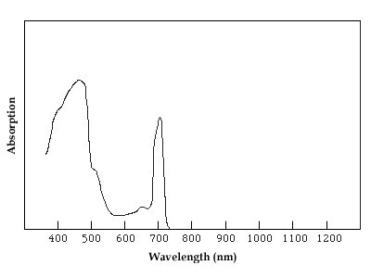
Figure 6.1: Absorption spectrum of chlorophyll.

Figure 6.2 shows this absorption spectrum (A) superimposed on a rough outline of the solar energy spectrum (B), which is an enlarged section of the solar spectrum shown in Figure 4. This figure demonstrates that when solar energy falls on leaves, the chlorophyll will absorb violet, blue, and red. The reflected spectrum therefore will have lost large portions of its energy around 400 nm and 800 nm, retaining energy mostly in the 500-600 nm (green) range, and in the infrared. The Ecological System describes photosynthesis in much greater detail.

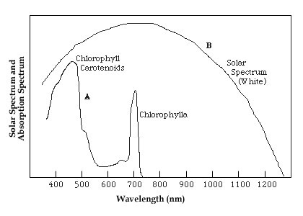
Figure 6.2: Solar spectrum of visible region juxtaposed with the absorption spectrum of chlorophyll.

Figure 6.3 shows the light that is left over after the absorption by chlorophyll occurs. This "reflected spectrum," then, actually represents the light (mostly green and yellow) that is reflected off the leaf. This is the detailed explanation of why leaves appear green in white light. The violet light absorbed by the chlorophyll is responsible for photosynthesis.

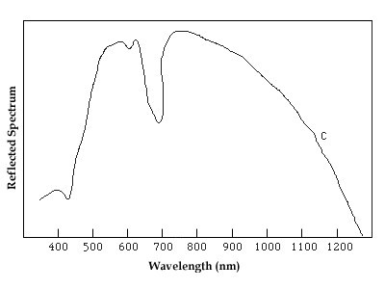

©Copyright 2003 Carnegie Mellon University

Figure 6.3: Reflected spectrum, or what is left of the solar spectrum after absorption by chlorophyll in a leaf. Our eyes
register this as the leaf surface being green.

PREV | NEXT

This material is based upon work supported by the National Science Foundation under Grant Number 9653194. Any opinions, findings, and conclusions or recommendations expressed in this material are those of the authors and do not necessarily reflect the views of the National Science Foundation.

