Scientists, Communication & Publics
CIRES ENGAGED SCIENTIST WORKSHOP
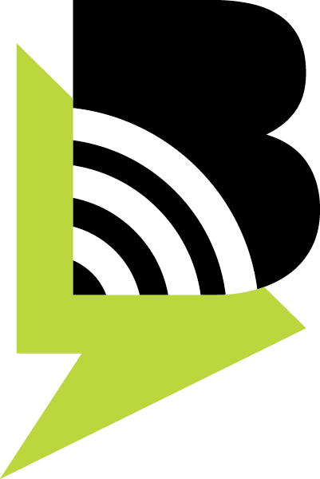
January 2017, Prepared by BoulderTalks
http://www.colorado.edu/bouldertalks/
Additional Resources:

Robert Cox and Phaedra C. Pezzullo. Environmental Communication and the Public Sphere, 4th Edition. Newbury Park, CA: Sage, 2016.

Leah Sprain, Martín Carcasson & Andy J. Merolla (2014). “Utilizing ‘On Tap’
Experts in Deliberative Forums: Implications for Design,” Journal of Applied Communication Research, 42:2, 150-167.

Websites:
The American Association for the Advancement of Science (AAAS): seeks to "advance science, engineering, and innovation throughout the world for the benefit of all people." To fulfill this mission, the AAAS goals include but are not limited to: “Enhanc[ing] communication among scientists, engineers, and the public.” Website: www.aaas.org

Bartlett Center at CU: A network for scientists and those invested in engagement for a sustainable world. Website: www.colorado.edu/bartlettcenter

ComSciCon: “Communicating Science is a workshop series organized by graduate students, for graduate students, focused on science communication skills. Our goal is to empower future leaders in technical communication to share the results from research in their field to broad and diverse audiences, not just practitioners in their fields. “ Website: www.comscicon.com

International Association for Public Participation: international organization promoting public participation. Website: http://www.iap2.org/

National Coalition for Dialogue and Deliberation: provides resources on dialogue, deliberation, and public engagement. Website: http://ncdd.org/rc/

Public Agenda: A New York City based organization promoting dialogue and collaboration. Website: http://www.publicagenda.org/blogs/deepening-public-participation-summary-and-resources

