Sea Ice, The Character - Teacher Guide
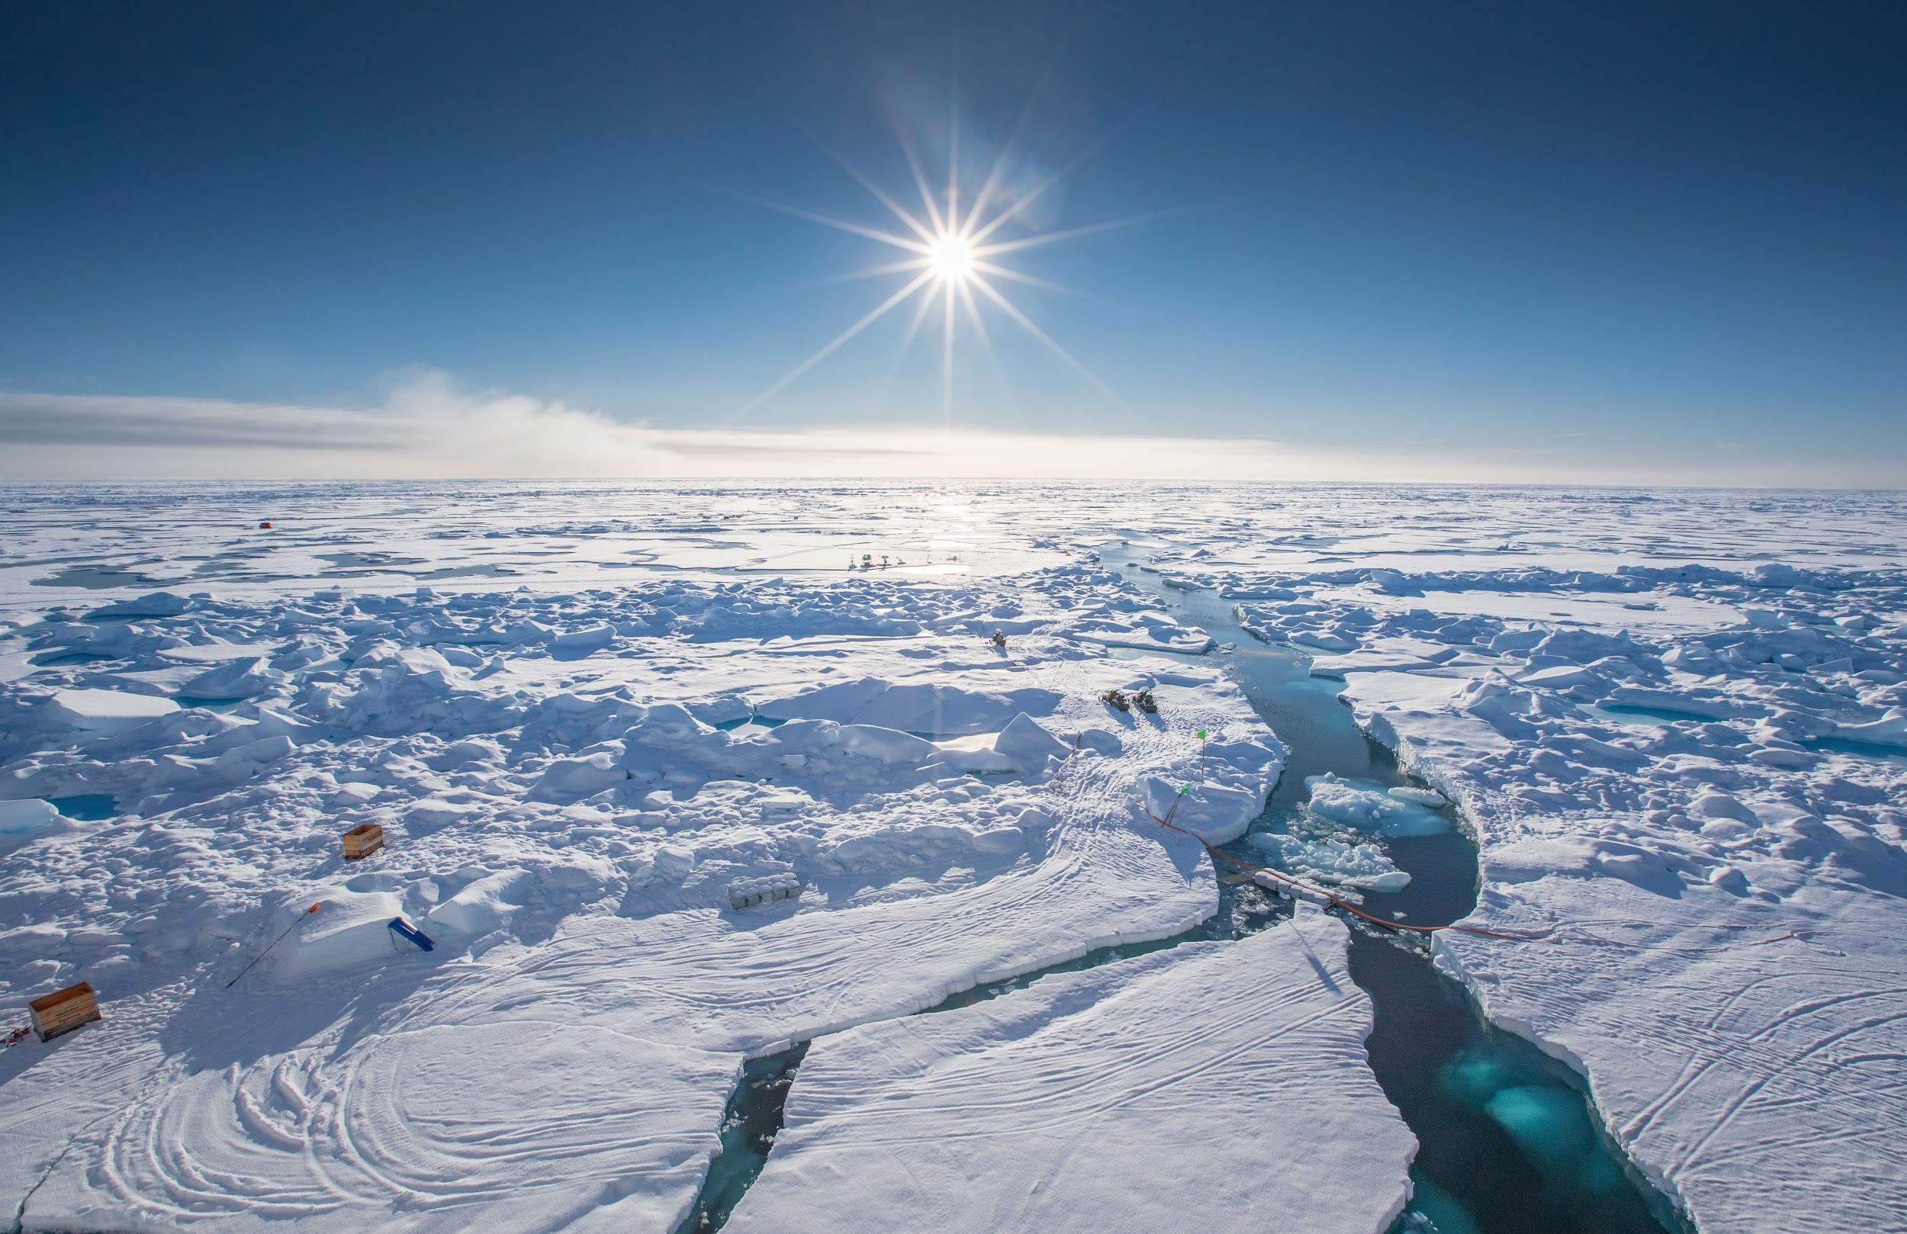
Setting the Stage
Sea ice plays an important role in the Arctic. It serves as one of the foundational pieces of the Arctic’s climate system. Local wildlife and human civilizations depend on healthy sea ice for travel, food, and their way of life. Globally, sea ice plays an important role in regulating our climate, serving as our world's “air conditioner.”

On the MOSAiC Expedition, the scientific team depended on sea ice for research. As the German Icebreaker Polarstern drifted with the sea ice, scientists and crew walked on the ice every day and studied it along with the Arctic’s atmosphere, ocean, ecosystem, and biogeochemistry. Throughout their time on the ice, many scientists and crew gained important knowledge and appreciation for the ice. Understanding sea ice allowed them to travel safely over it, assess its changes, and appreciate one of the most unique and extreme regions of our planet.

Instructional Overview
Grade Level | Middle/High School
Instructional Time | 60 minutes active student instruction (total time needed)  30 minutes active prep  2-4 hours passive prep (freezing water)
Lesson Driving Question | How does saltwater sea ice differ from freshwater ice? What is sea ice like in the Arctic? Why is sea ice important in the Arctic?
What Students Will Do | Students will look at different kinds of sea ice formations seen during the MOSAiC Expedition and be asked to compare saltwater and freshwater ice cores and their attributes.
Materials | - Sea Ice PPT  - Jessie Creamean talk (YouTube video)  - Pitcher or large container to prepare salt water  - 2 plastic containers per group (at least 10 ounces each) - example containers (Uline)  - Table salt  - Tap water  - Food coloring (preferably darker colors like blue and green)  - Spoons/stir sticks  - Labeling tape (or anything to label the containers)  - Optional: shallow bins for each group so it can capture melted water and evade messes
Material Preparation | - Test links to Sea Ice PPT  - Set up prior to main experiment:  - Pitchers  - Table Salt (recommended: Kosher Salt)  - Tap Water  - Measuring cup  - Food coloring  - Labeling tape (or anything to label the contains)  - Print out Sea Ice Worksheet

Set Up - Prepare the Ice Cores

For each group to learn about the quantitative and qualitative attributes of sea ice, saltwater must be made in advance. Be sure to make enough saltwater for each group to have 1 container. Tip: Consider how many students and groups you will have. We recommend groups of 4-5 students
- Label half of the containers “Freshwater” and half of the containers “Saltwater.”
- Make saltwater: for each cup of warm tap water, add 1.5 teaspoons for each cup of water.
- Distribute the saltwater and freshwater into the appropriately labeled containers. Make sure there is room in the container for ice to expand! Freeze until solid, do not disturb the ice while freezing.

Instructions
- As a class go through the Sea Ice PPT
- At the end of the presentation, introduce the melting ice core activity. Have students think about the differences between the freshwater and saltwater ice they are about to observe. Have them write down their hypotheses of what will happen as the ice cores melt on their worksheet.
- Divide students into groups and have each group write down their hypotheses on the worksheet.
- Take the ice out of containers and set them next to each other. When they melt they will make a mess so it is recommended to put them in a shallow tray or sink.
- Add five drops of food coloring on top of the frozen freshwater and frozen saltwater.
- Have students observe what happens for a few minutes
  - Students should observe brine channels that form on the saltwater, the dye should move through those brine channels, and the saltwater cube should melt quicker than freshwater
- Have students answer questions and watch Jessie Creamean’s talk (YouTube) in the PPT.

Citation:

This curriculum is funded by the National Science Foundation under award number OPP-13013589.
Kyle Kinzler. (2014, July 15). When Water Gets Icy. ASU - Ask A Biologist. Retrieved August 6, 2021 from https://askabiologist.asu.edu/experiments/when-water-gets-icy

