Name: ________________________________________ Period: _______ Date: ________

Lesson 1: How can we decrease our impact on the Earth’s climate at our school?

Observations and Inquiries: Fill in the table with any observations and questions as you watch the video.

Notices | Wonderings

Procedure: Read the Solid Waste Plan from DPS’ Department of Sustainability. Then, answer the questions.

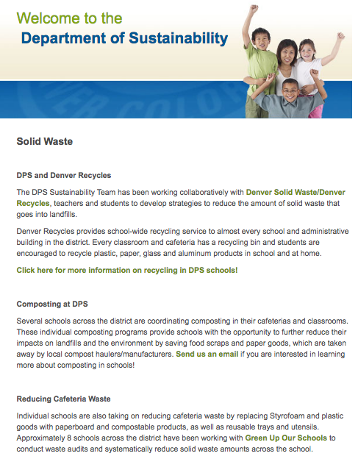

Making Sense: After reading the article, what are some ideas you have that we could do to make an impact on reducing the Greenhouse Gas emissions at our school? Use your understanding of climate change and information from the video in your answer.
___________________________________________________________________________
___________________________________________________________________________
___________________________________________________________________________
___________________________________________________________________________
___________________________________________________________________________
___________________________________________________________________________
___________________________________________________________________________

Initial Ideas: Share your ideas with your table group. What similarities did you notice between everyone’s ideas?
___________________________________________________________________________
___________________________________________________________________________
___________________________________________________________________________
___________________________________________________________________________
Generating Questions: What do we need to know in order to begin addressing food waste at school?
___________________________________________________________________________
___________________________________________________________________________
___________________________________________________________________________
___________________________________________________________________________
___________________________________________________________________________

Next Steps: Now that we have identified and grouped our questions, where should we start?

