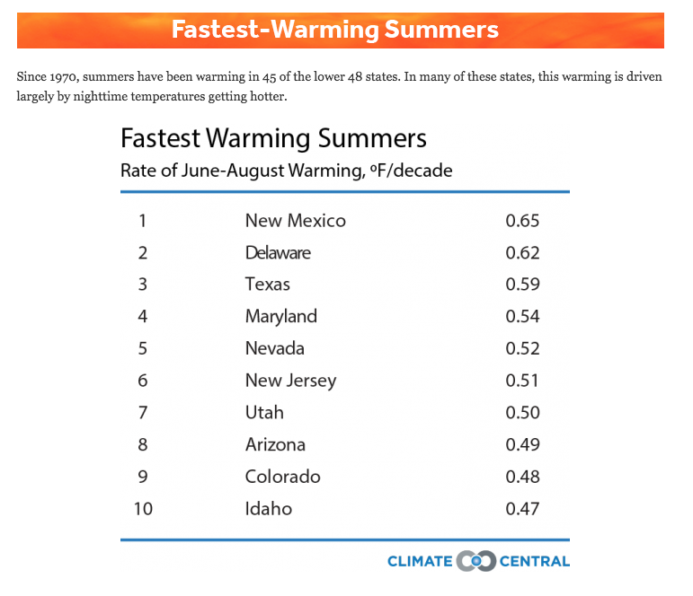
Name: ________________________________ Period:_____
Lesson 2: What is special about cities compared to rural places and other regions overall?
Part A
Questions:

1. What do you notice about the data?
________________________
________________________
________________________
________________________
________________________
________________________
________________________
________________________
________________________
________________________

2. The average summer temperature in Colorado is currently 82 degrees Fahrenheit. Using the rate of temperature change in Colorado in the table above, use the space below to calculate the average summer temperature in Colorado in 2100 (83 years from now or 8.3 decades).

3. Denver’s average summer temperature is currently 85.5 degrees Fahrenheit. In 2100, scientists predict the average summer temperature to be 10.9 degrees Fahrenheit hotter. What is the rate of change of the temperature per decade for Denver (Note: calculate the rate of change by dividing the average temperature increase by 8.3 decades)?
Write your answers, including units in the space below

4. Compare your data calculations as a group:
Predicted Average Summer Temperatures (℉) in 2100

Colorado: _____________

Denver: ______________
Rate of Increase in Temperature (℉) per Decade (10 years)

Colorado: _____________

Denver: ____________

5. Based on your calculations, write a claim about the difference in rates of summer temperature increase between Denver (city) and Colorado (state). Include evidence (measurements and units) and reasoning from your calculations.
___________________________________________________________________________
___________________________________________________________________________
___________________________________________________________________________
___________________________________________________________________________
___________________________________________________________________________
___________________________________________________________________________
___________________________________________________________________________

6. Write down all your ideas for why you think this difference in rates of temperature change is happening in Denver compared to Colorado.
___________________________________________________________________________
___________________________________________________________________________
___________________________________________________________________________

Part B: What’s going on in the world?

7. Look at the map of the world below. Temperature anomaly means the current difference from a long-term average temperature. What do you notice about the global temperature anomalies shown in the map? What differences do you see between regions? Specifically, where are the largest anomalies and where are the smallest anomalies? What is causing this?
___________________________________________________________________________
___________________________________________________________________________
___________________________________________________________________________
___________________________________________________________________________
___________________________________________________________________________
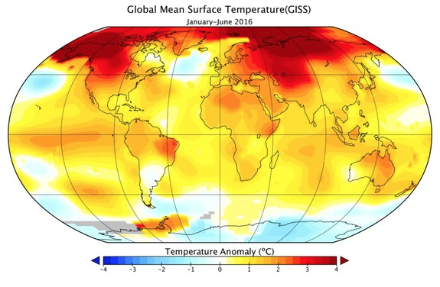

8. Look at the graph below that represents the global temperature from 1880 until 2017. What do you notice about the overall temperature trend globally? What do you notice about the rate of temperature change? Why do you think this is happening?







