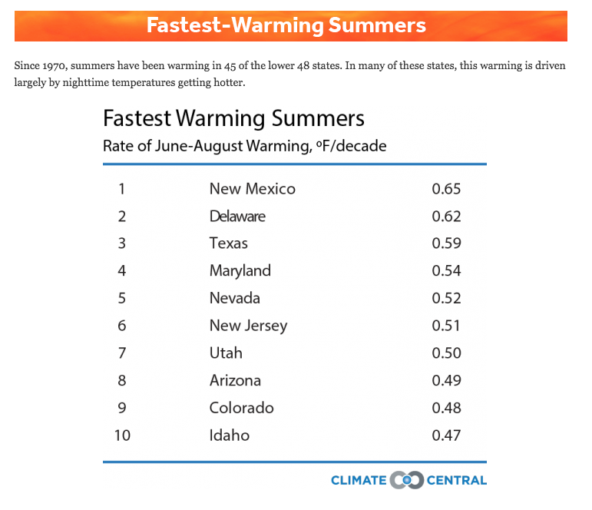
Name: ________________________________ Period:_____
Lesson 2: What is special about cities compared to rural places and other regions overall?
Part A

Questions:
1. What do you notice about the data?
________________________
________________________
________________________
________________________
________________________
________________________
________________________
________________________
________________________
________________________

2. The average summer temperature in Colorado is currently 82 degrees Fahrenheit. Using the rate of temperature change in Colorado in the table above, use the space below to calculate the average summer temperature in Colorado in 2100 (83 years from now or 8.3 decades).

To calculate the average summer temperature in Colorado in 2100, multiply the decadal rate of warming (0.48℉) by the number of decades (8.3), which is 86 ℉ (or 85.98℉).

3. Denver’s average summer temperature is currently 85.5 degrees Fahrenheit. In 2100, scientists predict the average summer temperature to be 10.9 degrees Fahrenheit hotter. What is the rate of change of the temperature per decade for Denver (Note: calculate the rate of change by dividing the average temperature increase by 8.3 decades)?
Write your answers, including units in the space below

10.9 ℉ / 8.3 decades = + 1.3 ℉/decade for Denver, CO

4. Compare your data calculations as a group:

Predicted Average Summer Temperatures (℉) in 2100

Colorado: 86 ℉

Denver: 96.4 ℉ (85.5 ℉ current temp. + 10.9 ℉ predicted increase in temp.)
Rate of Increase in Temperature (℉) per Decade (10 years)

Colorado: 0.48℉/decade (rate from data representation above Q.1)

Denver: 1.3℉/decade (10.9℉ ÷ 8.3 decades)

5. Based on your calculations, write a claim about the difference in rates of summer temperature increase between Denver (city) and Colorado (state). Include evidence (measurements and units) and reasoning from your calculations.

Answers should include evidence that Denver’s temperature is predicted to be 10.9℉ warmer than Colorado’s average temperature during the summer by 2100. The rate of temperature increase per decade is 0.82℉ (1.3℉ - 0.48℉) warmer for Denver (city) vs. Colorado (state), which is almost 3 times hotter (the average rate of summer temperature increase per decade for Denver is calculated to be 2.73 times warmer than the average rate of summer temperature increase per decade for Colorado (1.31℉ ÷ 0.48℉)).

6. Write down all your ideas for why you think this difference in rates of temperature change is happening in Denver compared to Colorado.

Answers may vary but should focus on urban vs. rural environmental differences
e.g.:
-cities have lower albedo than rural areas: built environment uses dark materials like asphalt and dark materials absorb heat compared to grass and vegetation, which reflect more heat. Albedo = reflectivity of a surface
- Lack of trees in urban areas. Trees undergo a process called evapotranspiration, which means that they ‘sweat’. The evaporating water absorbs heat from the surrounding air and thereby cools that air.
- Cities release heat! Think about the exhaust on a bus, air conditioners, etc.
The results are “heat islands” occurring in cities that have warmer temperatures than the surrounding rural areas.

Further Reading:

Shepherd, M., “The Science Of Why Cities Are Warmer Than Rural Areas”. Forbes. Dec. 25, 2015. https://www.forbes.com/sites/marshallshepherd/2015/09/25/the-science-of-why-cities-are-warmer-than-rural-areas/2/#139491851b42

Donegan, B., “Urban Heat Islands: Why Cities are Warmer than Rural Areas”. The Weather Channel. July 20, 2016. https://weather.com/science/weather-explainers/news/urban-heat-island-cities-warmer-suburbs-cooler

Part B: What’s going on in the world?

7. Look at the map of the world below. Temperature anomaly means the current difference from a long-term average temperature. What do you notice about the global temperature anomalies shown in the map? What differences do you see between regions? Specifically, where are the largest anomalies and where are the smallest anomalies? What is causing this?

There are larger temperature anomalies in the Arctic (northern polar regions), in some places up to 4 degrees Celsius. The majority of the world has temperature anomalies that are hotter than expected for normal temperatures (the temperature anomaly is positive).

Three things you also need to notice to talk about next class:
1) Notice that land tends to have larger anomalies than on water. Why? Think about specific heat of water vs specific heat of soil (water is higher, meaning that it takes more energy to warm it up).
2) The largest changes tend to happen near the poles. Think about that, why do you think that is? What is true in all the ‘red’ and ‘very blue’ regions? Hint: It has to do with how weather systems in the Arctic are changing which is a feedback loop!
3) Notice that the North Pole is getting warmer than the South pole. This has to do with the fact that the South Pole is shielded much more than the North Pole by circumpolar winds. The winds around the South Pole isolate it from changes all over the world
. 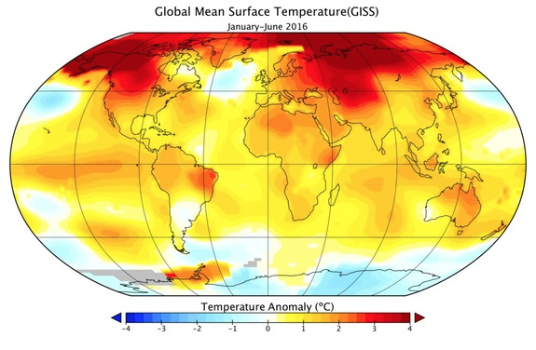
Taken from: NASA GISS
Further reading:
Lynch, P. 2016 Climate Trends Continue to Break Records. NASA TV. July 19, 2016.
https://www.nasa.gov/feature/goddard/2016/climate-trends-continue-to-break-records

Lewis, T. Polar Opposites: Why Climate Change Affects Arctic & Antarctic Differently. Oct 2, 2013. https://www.livescience.com/40125-climate-change-affecting-arctic-antarctic-differently.html

Kristyn Ecochard. What's causing the poles to warm faster than the rest of Earth?. Apr. 6, 2011. https://www.nasa.gov/topics/earth/features/warmingpoles.html

8. Look at the graph below that represents the global temperature from 1880 until 2017. What do you notice about the overall temperature trend globally? What do you notice about the rate of temperature change? Why do you think this is happening?

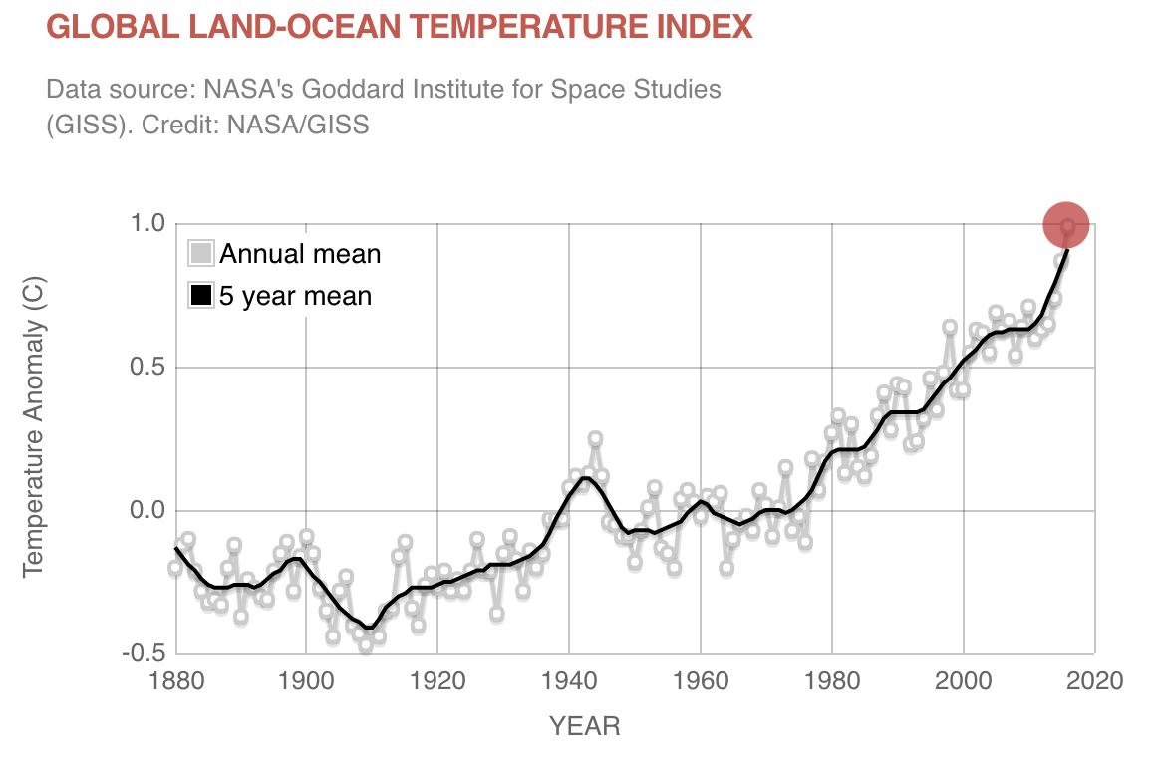
The global temperature is on a rising trend and it has been on this rising trend since the early
1900s. The rate of change is also increasing - we see a lower rate of change overall between 1880 and about 1930 and then there is a steeper slope (rate of change) especially starting around about 1970.

An important thing to note is that even though there are places where temperature is decreasing, the overall trend is positive temperature change.

Some reasons the slope is getting steeper:
- A lot of the processes creating these effects act as feedback loops. E.g., ice melting decreasing albedo, increasing temperatures, more ice is melting.
- It’s also because greenhouse gases are ‘reusable’. After it absorbs heat once, it doesn’t go away, it can absorb heat again. So if you double the amount of CO₂, you just double the warming happening at that point in time. As we keep increasing the amount of greenhouse gases, more warming will occur.

Further reading:
Hansen, J., R. Ruedy, M. Sato, and K. Lo, 2010: Global surface temperature change. Rev. Geophys., 48, RG4004, doi:10.1029/2010RG000345.
Shukman, David. What is Climate Change? Oct.4, 2017. http://www.bbc.com/news/science-environment-24021772

