Albedo Reading Guide
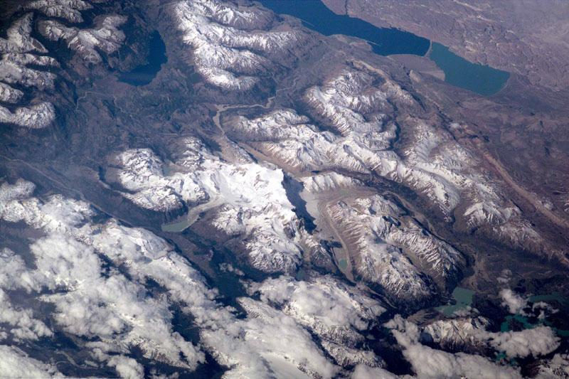
This picture of the Earth surface was taken from high above the planet in the International Space Station. In this view from above, we can see that there are lots of different things that cover the Earth. All those things - like soil, rocks, water, forests, snow, and sand - look different from above. Different materials like these have different ways of dealing with the solar energy that gets to our planet. Dark colored surfaces, like ocean and forests, reflect very little of the solar energy that gets to them. Light colored parts of the planet surface, like snow and ice, reflect almost all of the solar energy that gets to them.
The amount of energy reflected by a surface is called albedo. Albedo is measured on a scale from zero to one (or sometimes as a percent).
- Very dark colors have an albedo close to zero (or close to 0%).
- Very light colors have an albedo close to one (or close to 100%).
Because much of the land surface and oceans are dark in color, they have a low albedo. They absorb a large amount of the solar energy that gets to them, reflecting only a small fraction of it. Forests have low albedo, near 0.15. Snow and ice, on the other hand, are very light in color. They have very high albedo, as high as 0.8 or 0.9, and reflect most of the solar energy that gets to them, absorbing very little.
The albedo of all these different surfaces combined is called the planetary albedo. Earth's planetary albedo is about 0.31. That means that about a third of the solar energy that gets to Earth is reflected out to space and about two thirds is absorbed. The Moon's albedo is 0.07, meaning that only 7% of the energy that gets to it is reflected. The albedo of distant planets, so distant that they are difficult to study with telescopes can be a very helpful to scientists trying to figure out what a planet is made of.
Earth's climate depends on the amount of solar radiation that is reflected back out to space and the amount that is absorbed. If Earth's climate is colder and there is more snow and ice on the planet, more solar radiation is reflected back out to space and the climate gets even cooler. On the other hand, when warming causes snow and ice to melt, darker colored Earth surface and ocean are exposed and less solar energy is reflected out to space causing even more warming. This is known as the ice-albedo feedback.
Clouds have an important effect on albedo too. They have a high albedo and reflect a large amount of solar energy out to space. Different types of clouds reflect different amounts of solar energy. If there were no clouds, Earth's average albedo would drop by half.

Reading Comprehension Questions:
- When solar energy reaches Earth’s surface, what is the main characteristic of the surface that determines whether that light will be reflected or absorbed.
  - Texture
  - Area
  - Color
  - Altitude
- Complete the following tasks
  - Circle or underline or highlight the definition of albedo in the reading.
  - How is albedo measured?

  - Provide examples of 3 surfaces with low albedo. Write what their albedo value is if it is known.

  - Provide 3 examples of surfaces with high albedo. Write what their albedo value is if it is known.

- Describe: What is the difference between reflection and absorption? Which of these processes is responsible for increasing the temperature of a surface on this planet?

- What is the ice-albedo feedback?

- Is the average albedo of Earth going up or down based on what you know about the temperature change of Earth? Provide some evidence that your hypothesis is correct.

