Greenhouse Effect Simulation Help

Simulations
- Go to this website: http://phet.colorado.edu/en/simulation/greenhouse

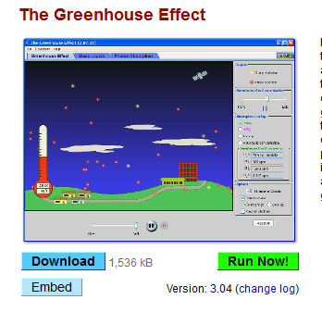Click “Run Now”

When the popup box appears, click “OK”. If you have a mac, you may need to go to your security settings and allow the program to run.
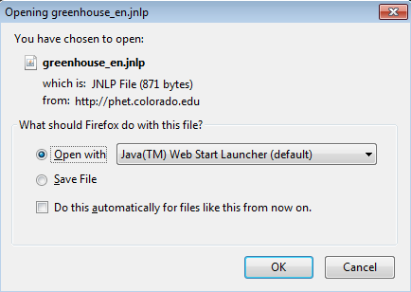

Once the box opens, click on the tab on top that says “Photon Absorption.” Click “Build Atmosphere” on the right hand side and add the molecules as shown in the image below.
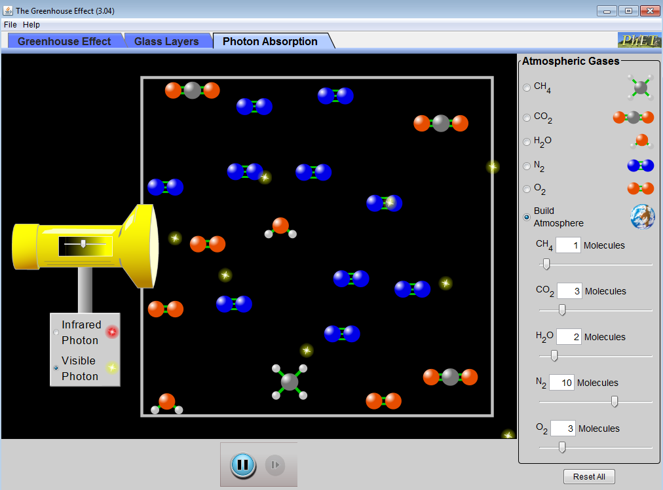

  - First use the “Visible Photon” light source (e.g. sunlight!). Move the slider in the middle of the flashlight until you start seeing photons coming out of the flashlight. Answer the questions in your Student Activity Sheet.

  - Now switch to the “Infrared Photo” light source (e.g. Earth’s heat!). Answer the questions in your Student Activity Sheet.
- Go to this website: http://concord.org/stem-resources/radiant-energy-flow
Click on the button that says “Download & Launch”.
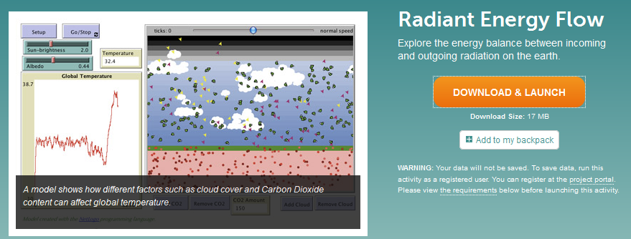
When the popup box appears, click “OK”.
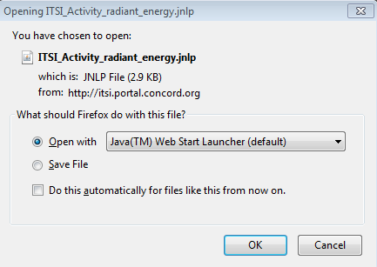
If you see any other boxes, just click “Run” or “OK”.
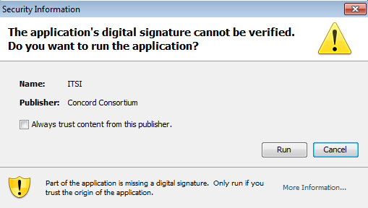

Scroll down until you see the “Procedures” box. Quickly look through the explanatory image.
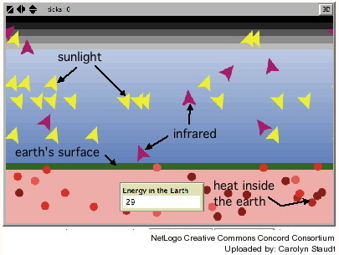
Scroll down a little farther until you get to the actual model. Click “Run” at the top. Then click “Add GGases” near the bottom. Click “Make 10 Sun Rays”.
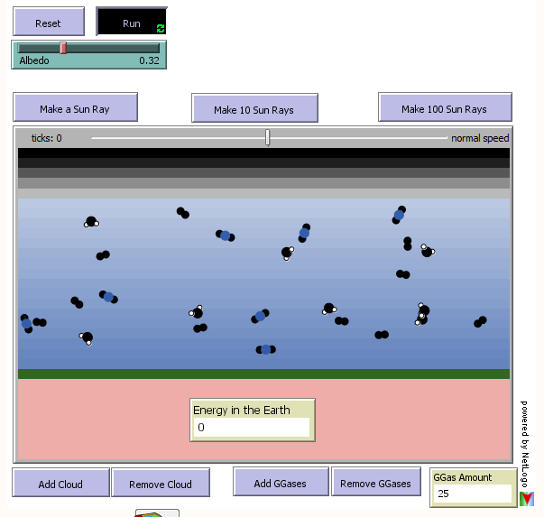

Answer the questions in your Student Activity Sheet.

If you are having trouble running the interactive model, please see https://phet.colorado.edu/en/help-center/running-sims/general for help.

