Name: _______________________________________
Lesson 4: How is human activity contributing to the increase in global temperatures?

Procedure:

The equation we are using comes from a model that assumes thermal equilibrium, where incoming energy to the surface is equal to outgoing energy. The model is an instructional "toy model," meaning it strips the process down to its essential elements so that the basic ideas are easy to convey. Models that are used to make predictions by climate experts are substantially more sophisticated, but at its root, the physics are similar to what is described below.

- READ: Satellites have directly measured the amount of energy arriving at Earth from the Sun as sunlight. Although this value varies slightly over time, it is usually very close to 1,361 watts of power per square meter. Scientists refer to the amount of incoming energy from sunlight as "insolation". The specific value at Earth of 1,361 W/m² is called the "solar constant" and is abbreviated as (K_{S}).
- DO: Identify where the “solar constant” is represented in the equation below and label it. Is it in the numerator or denominator? Does that mean the solar constant is directly or inversely proportional to T? Does that make sense? Why?
- READ: The Stefan-Boltzmann constant is part of a physical law that is necessary to involve in system heating equations. Symbolized by the lowercase Greek letter sigma (σ), it is a physical constant useful in calculating black body radiation. A black body, also called an ideal radiator, is an object that radiates or absorbs energy with perfect efficiency at all electromagnetic wavelengths. The value of the Stefan-Boltzmann’s constant is 5.7 x 10⁻⁸ watt / (m² x K⁴).
- DO: Find the Stefan-Boltzmann’s constant in the equation below and label it.
- READ: Since the values for the solar constant (K_{S}), Earth's albedo, and the Stefan-Boltzmann constant (σ) are all known, it is possible to solve this equation for temperature (T). Using a little algebra, we can write the expression
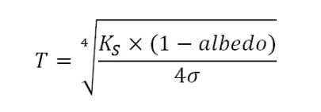
- DO: You can now use this equation to estimate temperature for the state of Colorado in a temperature unit known as Kelvins. Use the albedo assigned to your group to solve this equation, and put your answer on the board when finished IN FAHRENHEIT. Hint: Convert Kelvins to Fahrenheit using the following T_{(°F)} = T_{(K)} × 9/5 - 459.67

Record Data:
Albedo value (order lowest to highest) | Temperature in Fahrenheit

Conclusions:
What is the relationship between albedo value and temperature?
As albedo goes up, the temperature decreases, but it is not a linear relationship.

If albedo was decreasing in Colorado over time, could that result in an increase in temperature?
Yes, that could result in an increase in temperature.

Does albedo fully explain the temperature for Colorado? Why or why not?
No, it does not, because the albedo is not changing fast enough to cause the temperature change we are seeing.

How might increasing temperature impact Colorado’s albedo? Specifically why would “land cover” or surfaces change in response to temperature?

It forms a feedback loop. As the temperature goes up ice melts and the albedo decreases, which increases the temperature more, etc. There are other changes that can occur (some plants grow better in warmer temperatures, which have a higher albedo than dark soil), but the most impactful one is due to ice melting.

Gases
We determined that it’s not just albedo that affects temperature, but also the gases in Earth’s atmosphere. Name the gases that you know exist in Earth’s atmosphere and any information you know about these gases, as well as any questions you have about that gas. Try to list at least 4, but list as many as you can recall.

Name of gas in Earth’s atmosphere | Information you know about that gas, or a question you have about that gas

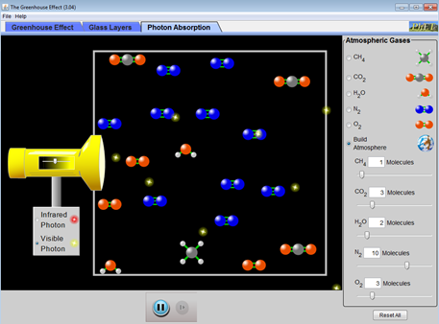
Investigating “Greenhouse Gases” – Photons Tab
Website #1 (http://phet.colorado.edu/en/simulation/greenhouse)
A) Using the “Visible Photon” light source (e.g. sunlight!), answer the following questions and explain your answer.

Do all the photons hit molecules?
No most don’t, sometimes they are absorbed, and sometimes they are reflected back, but most times they just pass through

If they hit a N₂ molecule, does anything special happen?
No

If they hit a CO₂ molecule, does anything special happen?
No
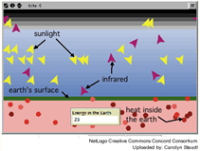
B) Now switch to the “Infrared Photo” light source (e.g. heat).

Do all the photons hit molecules?
No, most don’t

If they hit a N₂ molecule, does anything special happen?
No

If they hit a CO₂ molecule, does anything special happen?
The molecule vibrates

If they hit a H₂O or CH₄ (methane) molecule, does anything special happen?
Same vibrations

C) Website #2 (http://concord.org/stem-resources/radiant-energy-flow)

Do all the sunrays get absorbed by the Earth?
Depends on albedo. In mine, no, they don’t, but approximately 70% do (my albedo is 30%, you can imagine how changing the albedo will change the proportion of sunlight absorbed). If your albedo is 100%, then all the light is reflected. If it’s 0, then all the light is absorbed

How do you know if the ray of sunlight was absorbed in this simulation? (Be specific).
The ray of light becomes a red arrow when it is absorbed, and when it’s reradiated into space it becomes a red ball.

How would you describe sunrays that were not absorbed? What vocabulary word works here?
They are reflected back into space (versus re-radiated, which happens only after the energy is absorbed first and then ‘sent’ out, either at the same wavelength or a different wavelength)

What happens, if anything, when a visible light ray hits a Greenhouse Gas?
Nothing, GHG are invisible to visible light.

What happens, if anything, when an infrared (heat) ray hits a Greenhouse Gas?
The heat ray is absorbed and re-radiated (it looks like it’s being deflected, but that’s not what’s really happening).

Try increasing the amount of Greenhouse Gases. How does this affect the “Energy in the Earth” box?
The Energy of the Earth increases for a longer period of time. Eventually, you do lose the heat but Earth retains the heat for a longer period of time. The more GHG, the longer Earth has higher energy.

Putting it together
Create a model explaining how greenhouse gases influence temperature on planet Earth. The poster must include...
- A diagram of Earth’s surface and atmosphere, using the template shown below. You can use this packet for planning, but put your group’s final product on the blank sheet of paper provided.
- Step by step instructions of how the process works within the diagram, neatly labeled.
- All the vocabulary listed here: high albedo, low albedo, infrared energy (heat), visible energy (sunlight), absorption, reradiation, reflection, Greenhouse Gas, radiative inert gas.

Making Sense:

Write 2 questions you now have about greenhouse gases and how they influence temperature.
______________________________________________________________________________
______________________________________________________________________________
______________________________________________________________________________

Are Greenhouse Gases “bad”? Explain.
They are necessary to prevent Earth from being a block of ice, but like everything else, they are only good in moderation. Too many Greenhouse Gases and Earth becomes too hot; too little, and Earth becomes too cold.

Why are they called Greenhouse Gases? Why is this called the Greenhouse Effect?
The Greenhouse Gases absorb radiation in much of the same way that a greenhouse traps heat in to heat the inside of a greenhouse. The Greenhouse Gases serve as the glass on the greenhouse, trapping heat inside.

Conclusions:

What conclusions did your class draw about Greenhouse Gases and temperatures in Colorado, the United States, and in the world?
Greenhouse gases could explain the temperature change we are seeing.

