Name: _______________________________________
Lesson 4: How is human activity contributing to the increase in global temperatures?

Procedure:

The equation we are using comes from a model that assumes thermal equilibrium, where incoming energy to the surface is equal to outgoing energy. The model is an instructional "toy model," meaning it strips the process down to its essential elements so that the basic ideas are easy to convey. Models that are used to make predictions by climate experts are substantially more sophisticated, but at its root, the physics are similar to what is described below.

- READ: Satellites have directly measured the amount of energy arriving at Earth from the Sun as sunlight. Although this value varies slightly over time, it is usually very close to 1,361 watts of power per square meter. Scientists refer to the amount of incoming energy from sunlight as "insolation". The specific value at Earth of 1,361 W/m² is called the "solar constant" and is abbreviated as (K_{S}).
- DO: Identify where the “solar constant” is represented in the equation below and label it. Is it in the numerator or denominator? Does that mean the solar constant is directly or inversely proportional to T? Does that make sense? Why?
- READ: The Stefan-Boltzmann constant is part of a physical law that is necessary to involve in system heating equations. Symbolized by the lowercase Greek letter sigma (σ), it is a physical constant useful in calculating black body radiation. A black body, also called an ideal radiator, is an object that radiates or absorbs energy with perfect efficiency at all electromagnetic wavelengths. The value of the Stefan-Boltzmann’s constant is 5.7 x 10⁻⁸ watt / (m² x K⁴).
- DO: Find the Stefan-Boltzmanns constant in the equation below and label it.
- READ: Since the values for the solar constant (K_{S}), Earth's albedo, and the Stefan-Boltzmann constant (σ) are all known, it is possible to solve this equation for temperature (T). Using a little algebra, we can write the expression
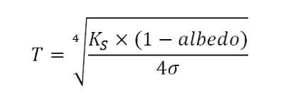
- DO: You can now use this equation to estimate temperature for the state of Colorado in a temperature unit known as Kelvins. Use the albedo assigned to your group to solve this equation, and put your answer on the board when finished IN FAHRENHEIT. Hint: Convert Kelvins to Fahrenheit using the following T_{(°F)} = T_{(K)} × 9/5 - 459.67

Record Data:
Albedo value (order lowest to highest) | Temperature in Fahrenheit

Conclusions:
What is the relationship between albedo value and temperature?

If albedo was decreasing in Colorado over time, could that result in an increase in temperature?

Does albedo fully explain the temperature for Colorado? Why or why not?

How might increasing temperature impact Colorado’s albedo? Specifically why would “land cover” or surfaces change in response to temperature?

Gases
We determined that it’s not just albedo that affects temperature, but also the gases in Earth’s atmosphere. Name the gases that you know exist in Earth’s atmosphere and any information you know about these gases, as well as any questions you have about that gas. Try to list at least 4, but list as many as you can recall.

Name of gas in Earth’s atmosphere | Information you know about that gas, or a question you have about that gas

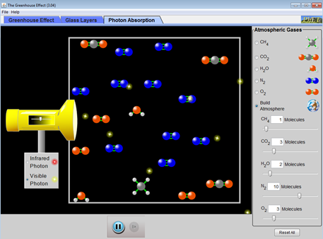
Investigating “Greenhouse Gases” – Photons Lab
Website #1 (http://phet.colorado.edu/en/simulation/greenhouse)

A) Using the “Visible Photon” light source (e.g. sunlight!), answer the following questions and explain your answer.

Do all the photons hit molecules?

If they hit a N₂ molecule, does anything special happen?

If they hit a CO₂ molecule, does anything special happen?

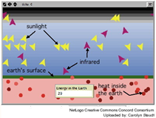
B) Now switch to the “Infrared Photo” light source (e.g. heat).

Do all the photons hit molecules?

If they hit a N₂ molecule, does anything special happen?

If they hit a CO₂ molecule, does anything special happen?

If they hit a H₂O or CH₄ (methane) molecule, does anything special happen?

C) Website #2 (http://concord.org/stem-resources/radiant-energy-flow)

Do all the sunrays get absorbed by the Earth?

How do you know if the ray of sunlight was absorbed in this simulation? (Be specific).

How would you describe sunrays that were not absorbed? What vocabulary word works here?

What happens, if anything, when a sunray hits a Greenhouse Gas?

What happens, if anything, when an infrared (heat) ray hits a Greenhouse Gas?

Try increasing the amount of Greenhouse Gases. How does this affect the “Energy in the Earth” box?

Putting it together
Create a model explaining how greenhouse gases influence temperature on planet Earth. The poster must include...
- A diagram of Earth’s surface and atmosphere, using the template shown below. You can use this packet for planning, but put your group’s final product on the blank sheet of paper provided.
- Step by step instructions of how the process works within the diagram, neatly labeled.
- All the vocabulary listed here: high albedo, low albedo, infrared energy (heat), visible energy (sunlight), absorption, reradiation, reflection, Greenhouse Gas, radiative inert gas.

Making Sense:

Write 2 questions you now have about Greenhouse Gases and how they influence temperature.
______________________________________________________________________________
______________________________________________________________________________
______________________________________________________________________________

Are greenhouse gases “bad”? Explain.
______________________________________________________________________________
____________________________________________________________________________________________________________________________________________________________

Why are they called Greenhouse Gases? Why this is called the Greenhouse Effect?
______________________________________________________________________________
______________________________________________________________________________
______________________________________________________________________________
______________________________________________________________________________
Conclusions:
What conclusions did your class draw about Greenhouse Gases and temperatures in Colorado, the United States, and the world?
______________________________________________________________________________
______________________________________________________________________________
______________________________________________________________________________

