Data Set #1
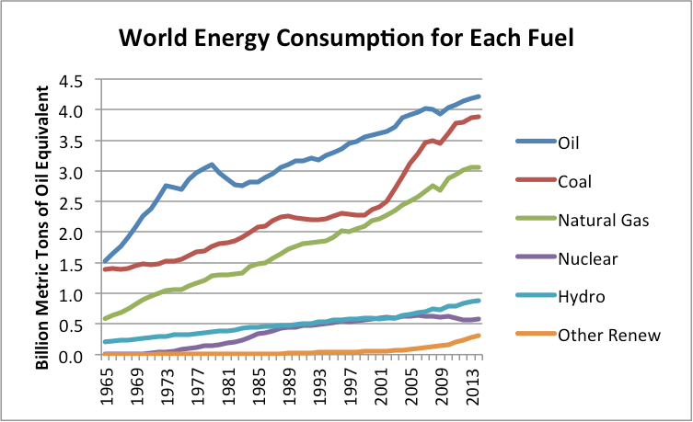
Source: https://ourfiniteworld.com/2015/06/23/bp-data-suggests-we-are-reaching-peak-energy-demand/

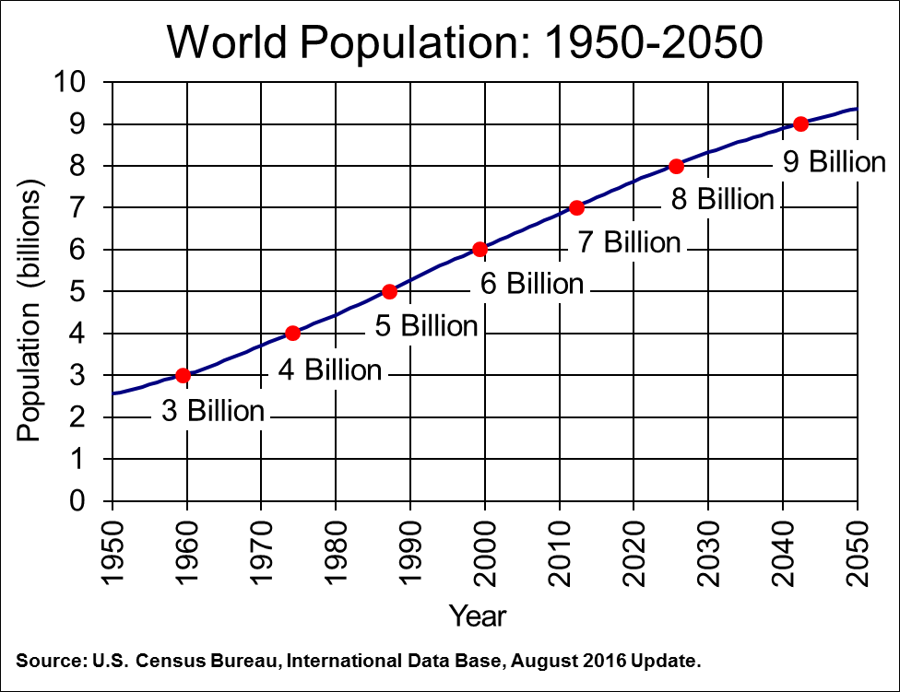
Source: https://www.census.gov/library/visualizations/2011/demo/world-population--1950-2050.html

Data Set #2
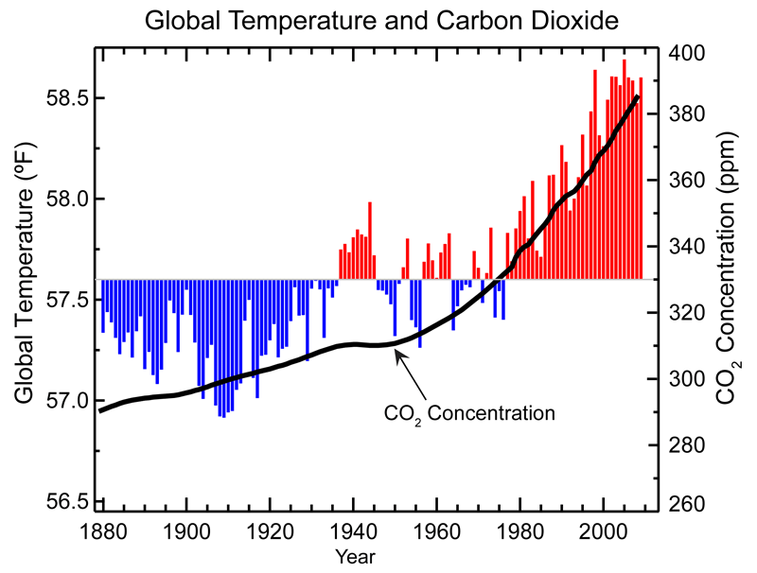
Source: https://www.ncdc.noaa.gov/monitoring-references/faq/indicators.php

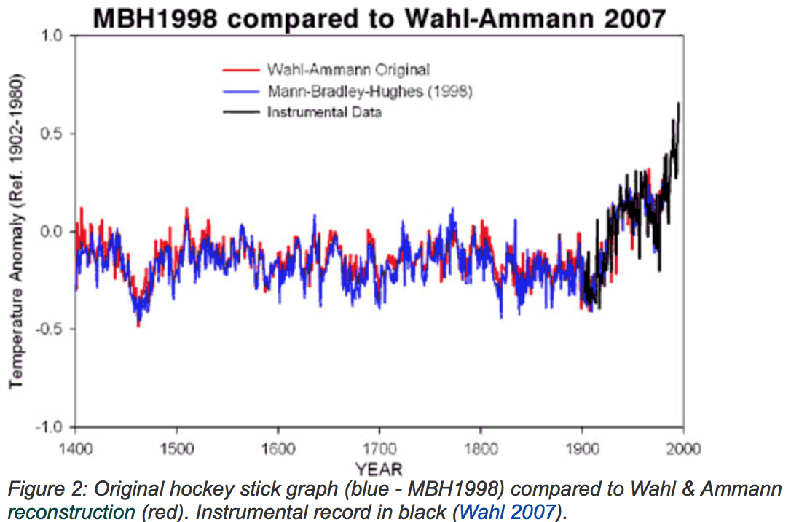

Source: https://www.skepticalscience.com/broken-hockey-stick.htm

Data Set #3

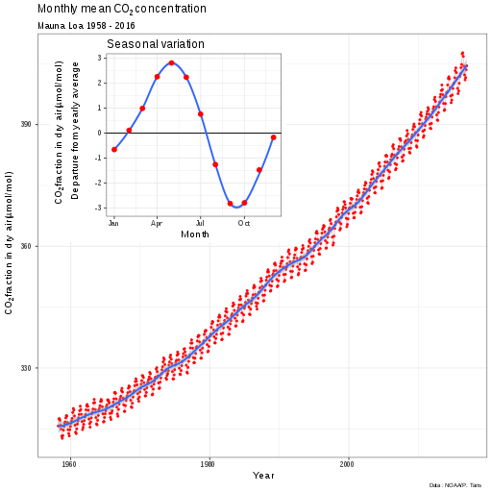
Source: https://scripps.ucsd.edu/programs/keelingcurve/

Data Set #4

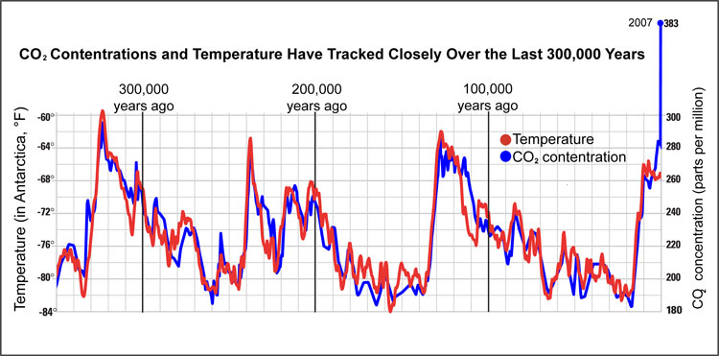
Source: https://www.ncdc.noaa.gov/global-warming/temperature-change

Data Set #5
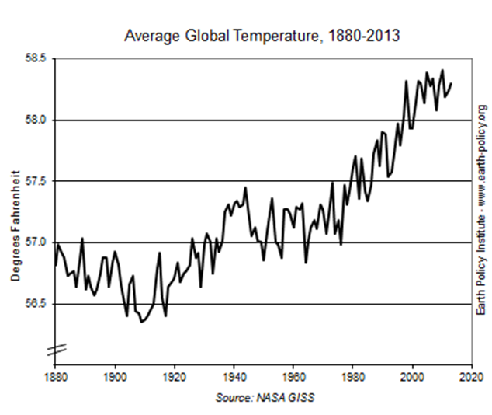
Source: http://www.earth-policy.org/indicators/C51/

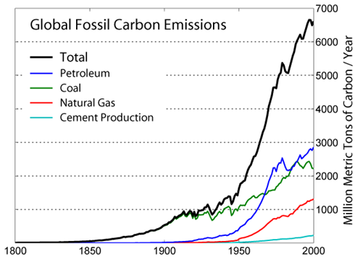
Source: https://cdiac.ess-dive.lbl.gov/trends/emis/glo_2014.html
Data Set #6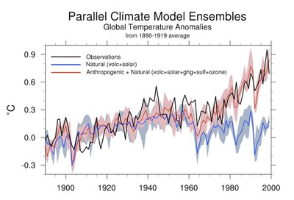
Source: http://ossfoundation.us/projects/environment/global-warming/milankovitch-cycles
Data Set #7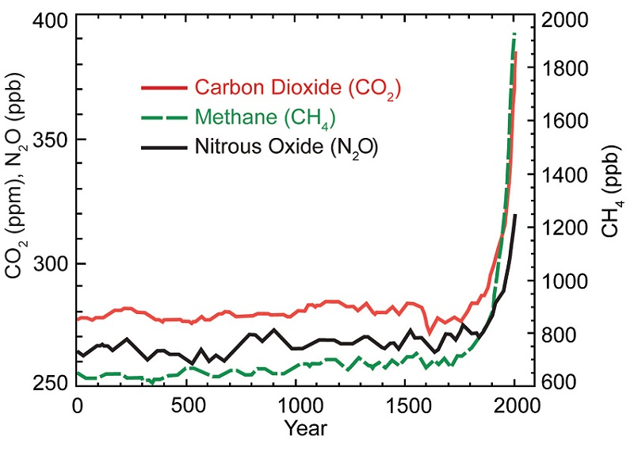
Source: https://19january2017snapshot.epa.gov/climatechange_.html

Data Set #8
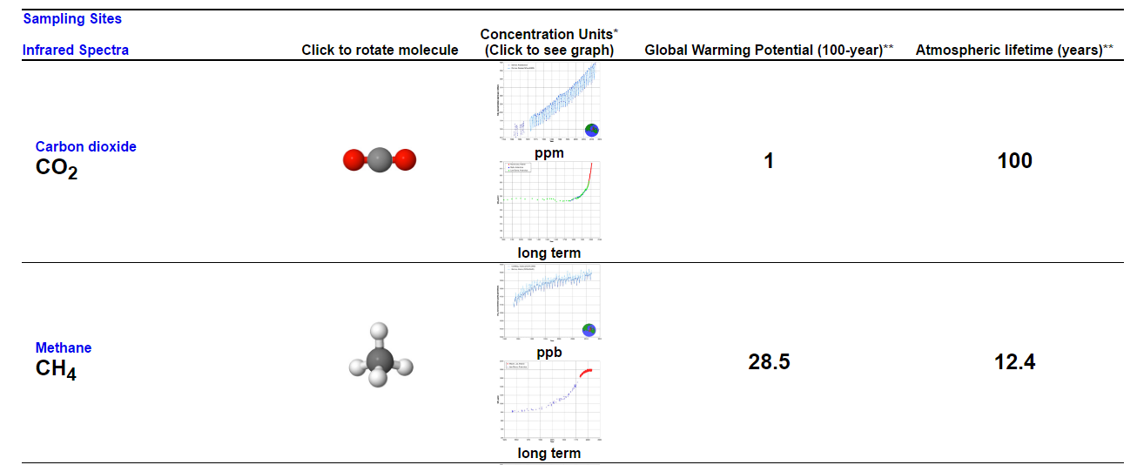
Source: http://chemistry.beloit.edu/Warming/pages/molecule4.html

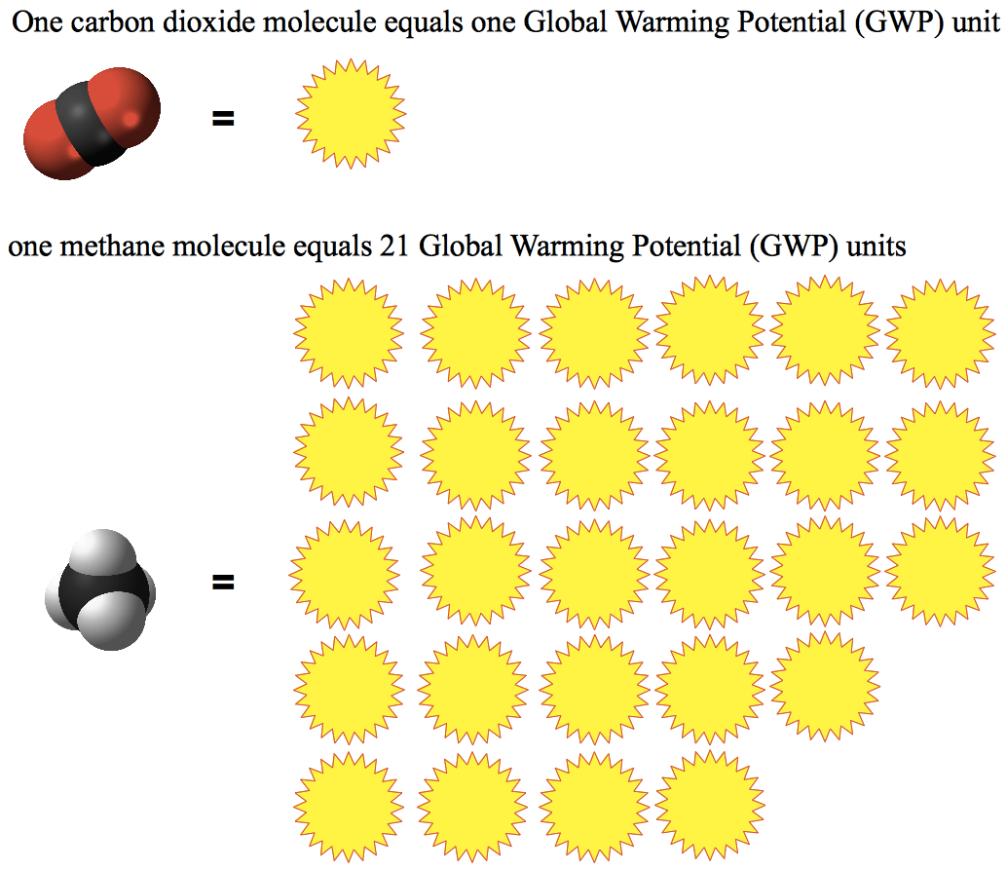
Source: https://infiniteinterconnections.wordpress.com/2014/07/31/the-secrete-life-of-waste-an-in-n-out-burger-beverage-cup/

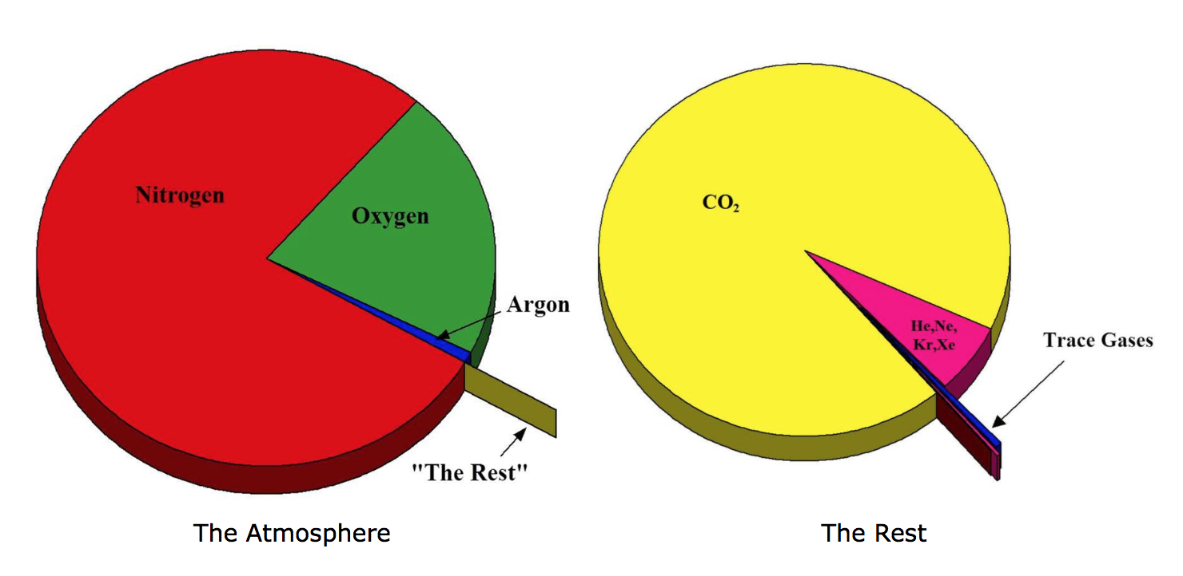
Source: https://science-edu.larc.nasa.gov/ozonegarden/ozone.html

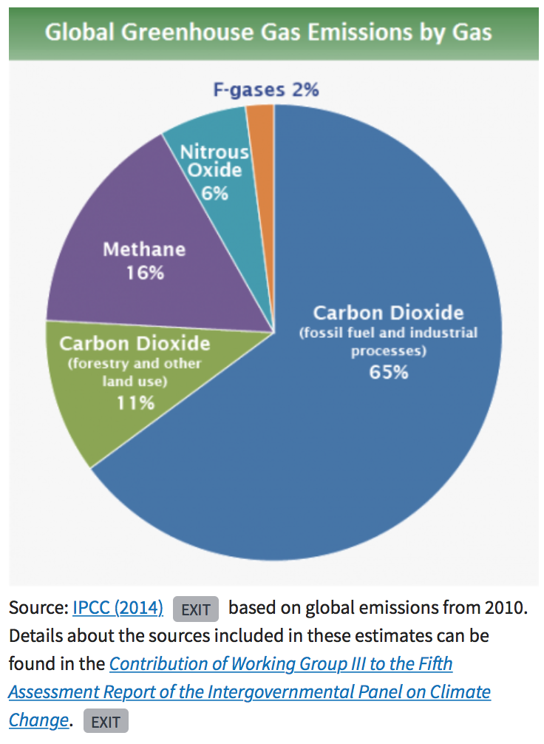

Source: https://www.epa.gov/ghgemissions/global-greenhouse-gas-emissions-data

