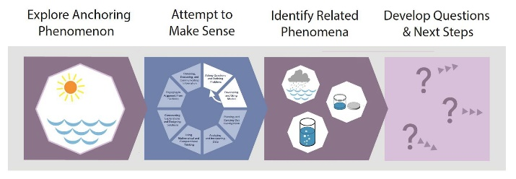
Storyline Tool #1: Anchoring Phenomenon Routine

 | Select your context for using this tool:  Analyzing Existing Curriculum Materials  - Planning to Teach With Existing Curriculum Materials  - Adapting or Designing New Curriculum Materials | What materials are you working with?

Does the launch of the unit include these elements of the Anchoring Phenomenon Routine? |  | Yes | No | ➤ Analyzing: If you found evidence of this, what did it look like?  ➤ Planning: What will you do when you teach this lesson to accomplish this?  Is there anything you need to add to the lesson?  ➤ Adapting: How can you enhance these elements in the materials?
Element 1  Explore Anchoring Phenomenon  What do we notice? | 1A: Students explore an anchoring phenomenon and notice aspects that require key pieces of target DCIs to explain.
 | 1B: Students go public with what they noticed.
 | 1C: The class builds a record of what everyone noticed.
Element 2  Attempt to Make Sense  How can we explain this?  Do our explanations agree? | 2A: Students generate initial explanations that elicit competing ideas about key pieces of the target DCIs.
 | 2B: Students go public with their explanations.
 | 2C: The class builds a record of areas of consensus and disagreement across everyone’s explanations.

Does the launch of the unit include these elements of the Anchoring Phenomenon Routine? |  | Yes | No | ➤ Analyzing: If you found evidence of this, what did it look like?  ➤ Planning: What will you do when you teach this lesson to accomplish this?  Is there anything you need to add to the lesson?  ➤ Adapting: How can you enhance these elements in the materials?
Element 3  Identify Related Phenomena  Where else does something like this happen? | 3A: Students generate examples of related phenomena they have experienced.
 | 3B: Students go public with related phenomena.
 | 3C: The class builds a record of related phenomena.
Element 4  Develop Questions & Next Steps  What do we need to figure out  to explain all of this? | 4A: Students generate questions that could lead to uncovering important ideas in the target DCIs.
 | 4B: Students go public with their questions.
 | 4C: The class builds a record of everyone’s questions.
 | 4D: Students generate ideas for investigations that could lead to uncovering important ideas in the target DCIs.
 | 4E: Students go public with their ideas for investigations.
 | 4F: The class builds a record of everyone’s ideas for investigations.

