Name ___________________________________

Lesson 5: What was Earth’s temperature like in the past?

Do Now Prior Experiences: After the last lesson, it is clear that we need to look at more data over time to determine if warming temperatures are a trend.

1. In your own words, what is a trend?
Students will give the responses that trends are patterns, or something that goes up or down. The teacher will accept all ideas during this portion and not let on if any students are right or wrong

2. Where have you seen trends before in your life?
Accept all answers here again just to get students thinking about trends.

3. At this point in our investigation, do you think that the rising temperatures are a trend? Explain your thinking in at least two complete sentences.
Students should say that it is an increasing trend. Look for students pulling in data from any of the previous lessons. Even if they reference the video where it is getting hotter, that is an increasing trend.

Procedure:
Analyze the series of pictures below of the man and his dog. Which one do you watch as you follow the pictures in order?
A.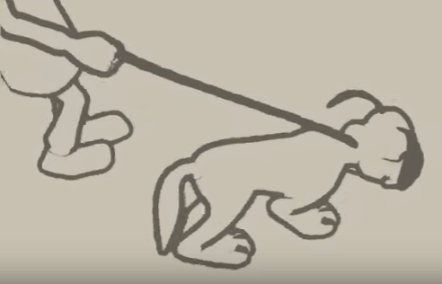 B. 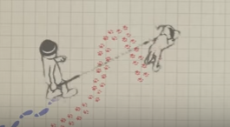 C.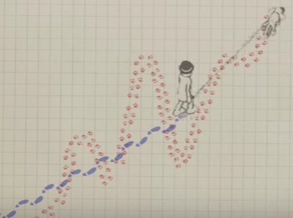

4. Continue to analyze. Which direction is the dog moving (up, down, or diagonal)? Which direction is the man moving? Compare the relationship between the two paths.

The dog is moving up and down. The man is angling upward. Both are moving in the similar direction.

5. Which character (dog or man) shows the path of a trend? Why?

The man shows the path of the trend because he is moving in the general direction of movement (change).

6. Now look at the final image below. The man is the climate and the dog is the weather. The man shows the trend. How can this example be used to explain the definition of a trend?

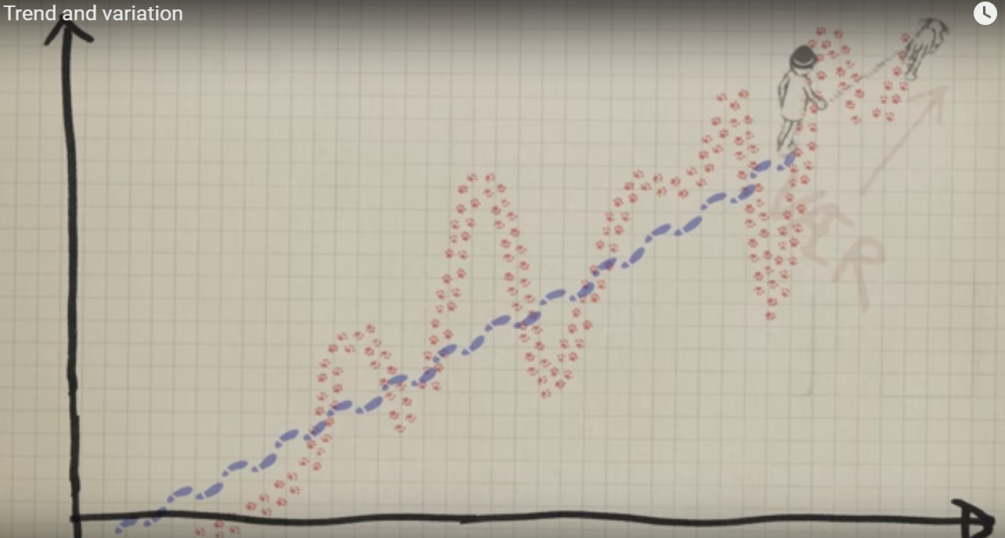

Application:
7. Summarize the four types of trends with sketches and descriptions.

8. Describe the trend of the world’s human population.
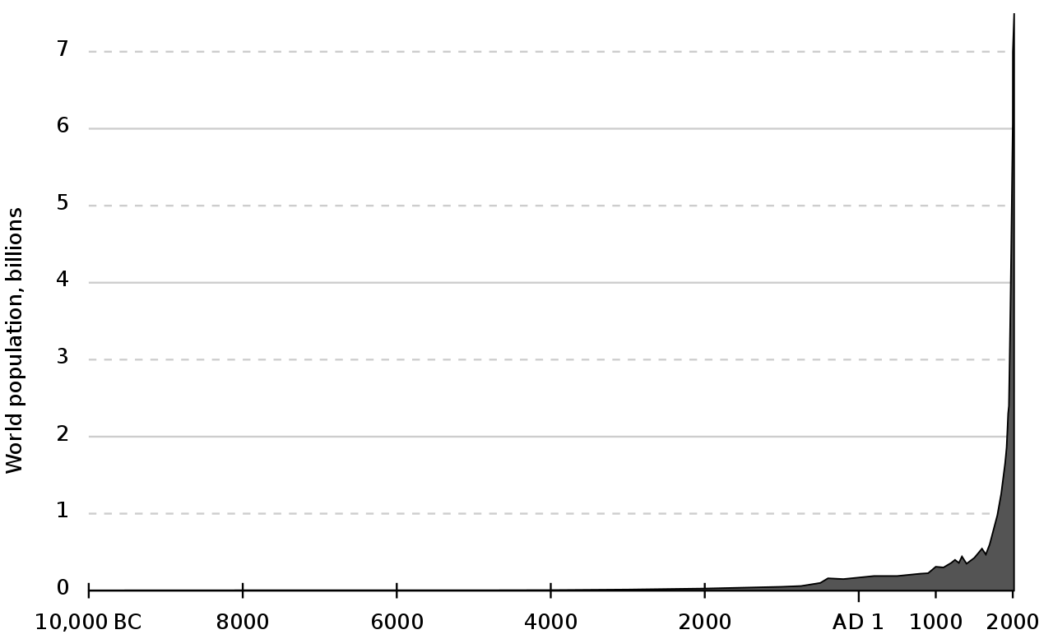

Source: Wikimedia Commons

Observations
Answers should reflect the definition: “A trend is the pattern of gradual change in a condition, output, or process, or an average or general tendency of a series of data points to move in a certain direction over time, represented by a line or curve on a graph.”

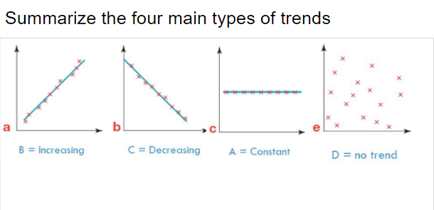
Students will have different things here, but we want them to know the different types of trends. Also, the population graph information can be compared to the following graph of the world’s temperature.

Now let’s look at global temperature data over a LONG span of time!
You will look at a time line from 20,000 BC to today. The timeline is long and requires you to scroll down. As you scroll, look for trends and when the trend changes.

Scroll down through the entire graph and make some general observations about the design of the timeline, the highest points and the lowest points along with the text. Answer the questions below as you look at the time line.

A Timeline of Earth’s Temperature Average Temperature: online https://xkcd.com/1732/ or download image (click to zoom in) https://imgs.xkcd.com/comics/earth_temperature_timeline.png

9. Look at the flow of the line from beginning to end. What is the overall trend from beginning to end?

Increasing trend

10. Carefully locate three trends within the timeline. State the start point (e.g. 10000 BC) and the end point (e.g. 500 BC) of the trend you see. Which direction is the trend (increasing, decreasing and at what rate: fast, slow)?
Answers will vary depending on the start and end points used in the timeline.

11. What are your thoughts now about the trend of last 200 years and the last 22,000 years? At what point does the overall trend change (look at the text - what is happening)?

The trend in the last 200 years shows a slow increasing rate until the early 1900’s when the trend starts to increase at a much faster rate due to fossil fuel use and carbon dioxide emissions. Before then, the trend varied between gradual and steady increasing and decreasing rates over 1000s of years.

Where is this data coming from?
Before people had thermometers, indeed before any temperatures were recorded, the Earth itself recorded clues about temperature, precipitation, atmospheric gases, and other aspects of the environment in the thick layers of ice that have accumulated in places like Greenland and Antarctica. To reveal these clues to the past, researchers drill into glaciers and ice sheets and remove cylinder-shaped samples of ice called ice cores. Back in the laboratory, scientists can use chemical sampling techniques to determine the age of each layer of ice and the concentrations of different gases trapped in tiny air bubbles within the ice, which reveals what the atmosphere was made of in the past. They can also examine the water molecules in the ice itself to get information about historical temperatures. Trapped pollen and dust provide additional clues about the climate. Ice core records can go back hundreds of thousands of years, and they help scientists find out whether the rapid increase in CO₂ levels and temperature we are currently observing fits a natural pattern or not.

Write a summary of how scientists know what the atmosphere was like before we had thermometers.
Students read and answer the questions in five minutes then have a share out discussion. We are wondering how scientists know what the temperature was before scientists could record temperatures. We read that scientists use ice cores to look at samples from where there’s been ice for 400,000 years or more in Antarctica. The lower they go down the older the ice. We call this superposition.

From the Industrial Revolution to Automobiles: Read to Learn

From Revolution to Reconstruction
During the 1800’s, business and industry developed in America in different ways. From the late 1700s onward, factory work gradually replaced the system of home-based production. Rural, water-powered mills, were replaced by urban (city), steam-driven factories, filled to the roof with chugging, hissing, clunking machines. A task once accomplished by a group of skilled craftsmen became a thoughtless chore completed by, and depending on, faceless, nameless machines in an assembly line. During this time of industrial growth, the world’s population reached 1 billion people in 1804.

Following the Civil War, industrialization in the United States advanced rapidly. One reason for the dramatic economic transformation was that rural workers and immigrants moved into the cities at an amazing rate. By 1880, over 25% of the entire population lived in cities.

Employers (bosses) soon realized that if factories were built in cities, there would be a larger supply of workers available. With more people willing to do the work, employers felt that they could cut wages, and put more money into their own pockets. Naturally, employers wanted to maximize their profits. That meant that men, women and children were hired for very low wages, usually worked in dangerous or unhealthy conditions, and often worked for twelve or more hours a day.

Industry in America developed far more rapidly than it had in Europe. Factories and mills spread quickly throughout New England (northeast US) prior to the Civil War due to good supplies of natural resources such as iron and coal, and the ease of transporting finished goods along the many navigable rivers. This in turn lead to the building of more railroads and canals to handle the increased shipping of supplies.

Turn of the Century
The Industrial Revolution had lasting effects. The people of the early 20th century (1900s) had access to many more luxuries than any people before. Cities were transformed by the ever growing skyscrapers that seemed to dominate architecture. This was made possible due to better methods of production of steel and the increasing use of energy sources such as electricity and coal. Electricity changed life as people began to use electric lights and appliances in their homes. For entertainment, new technologies such as the radio and moving pictures became popular. In 1908, the first mass-produced fossil-fuel powered automobiles were made. By 1927, there were 15 million Ford Model T cars on the roads and the world’s population reached 2 billion people in 1930. This spirit of invention and growth continued throughout the 20th century.

Notices and Wonderings
Write at least four facts you learned from the article. Write them in your own words.

Give students six minutes to read and answer the questions, then do a four minute debrief conversation about how the industrial revolution may have contributed to the increased temperature. You are looking for answers that relate the temperature increase to human activity such as the building of factories and railroads, the invention of cars and electricity. Push student thinking that this sharp increase really did start with humans increasing their production in cities.

What did you notice or learn from the reading?  Be specific. | Wonderings

Conclusions - Answer each question within a paragraph.

- What did you find out after you analyzed the trend cartoon?
- What kind of trend did we decide is happening to our temperatures compared to the Earth’s history?
- What other questions do we have about the increase in temperature on Earth?
- How did the industrial revolution change life for people?
Students write their responses and then discuss them as a class.

Next Steps:

What we should investigate in our next lesson?
Hint: Think about the impact of the Industrial Revolution on the global temperature.
But now we are wondering is the human activity the cause of this trend? Or is something else the cause? Lots of stuff in the past caused trends to change.

