Lesson 6 Data Sheet:

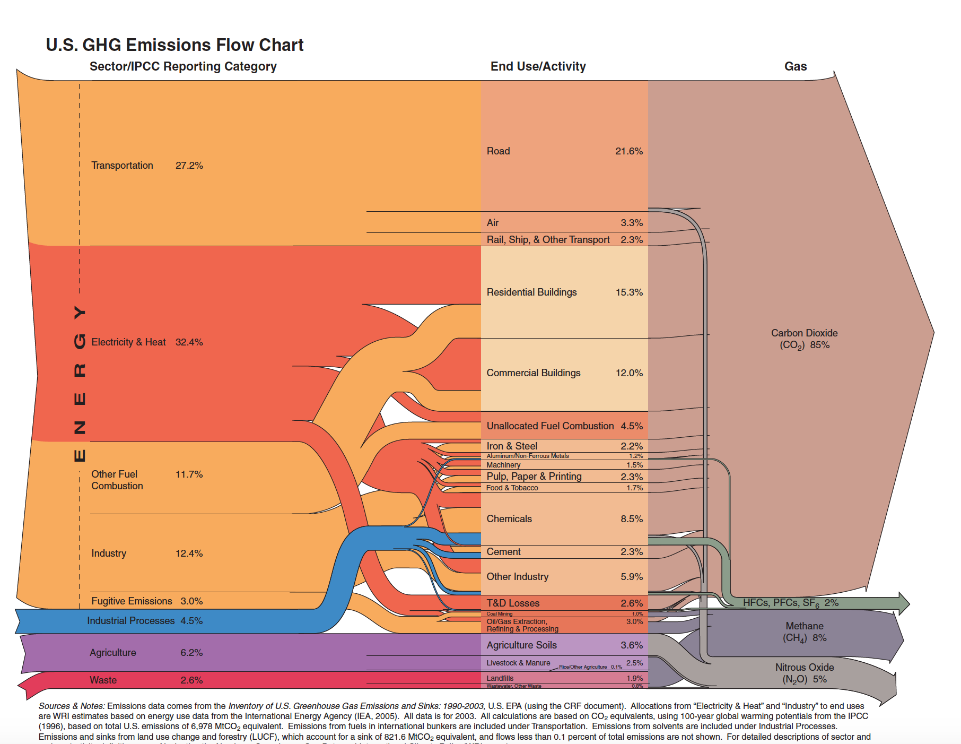
Figure 6.1
Source: http://cleanet.org/resources/47840.html

The CO₂ and the Carbon Cycle

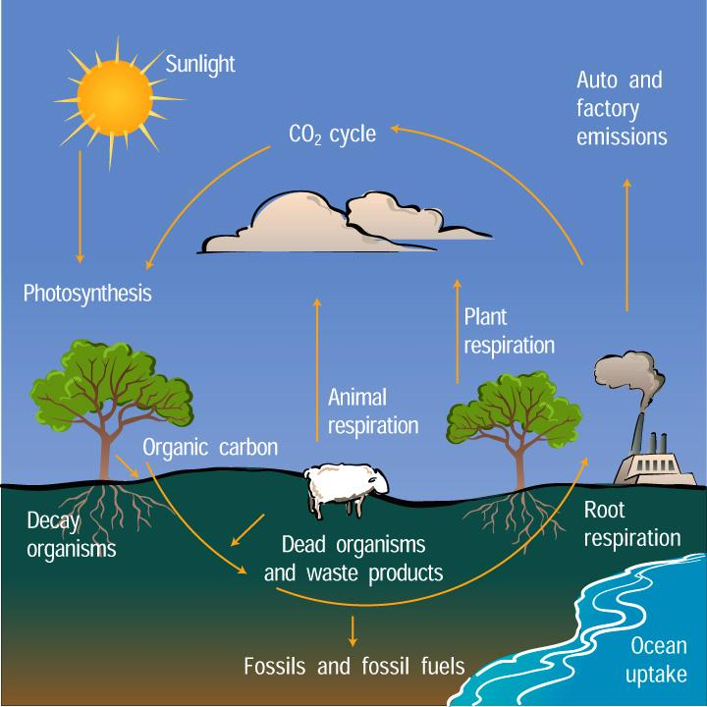
Figure 6.2
Source: https://scied.ucar.edu/carbon-cycle

The CO₂ and the Carbon Cycle

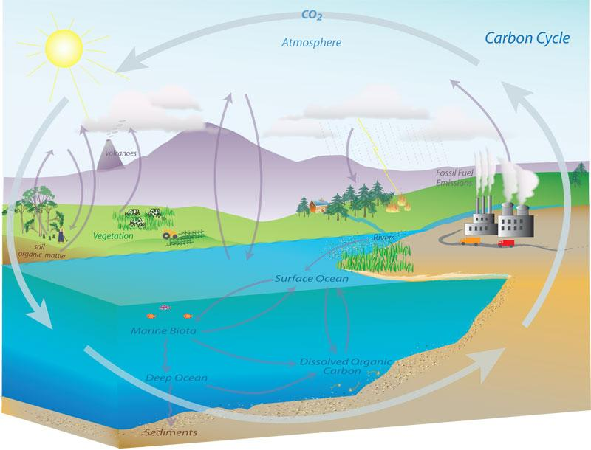
Figure 6.3
Source: https://www.esrl.noaa.gov/gmd/outreach/carbon_toolkit/basics.html

