Name ____________________________________

Lesson 6: How does human activity affect the trend of warming temperatures on Earth?

Do Now Prior Experiences:
In the last lesson, we investigated what the world’s temperature trend was in the distant past to find out if the recent increasing temperature is a trend or not. What do we now understand from the previous lesson?

___________________________________________________________________________

___________________________________________________________________________

___________________________________________________________________________

Exploring Greenhouse Gases (GHGs):

- Use the PhET The Greenhouse Effect simulation to model the relationship between greenhouse gases, especially CO₂, and the temperature:
https://phet.colorado.edu/en/simulation/greenhouse
- Complete the data table and then investigate your own scenarios using the simulation.

Time | CO2 Concentration  (ppm=parts per million) | Temperature  (in °F and °C) | Amount of Infrared photons (heat) compared to other times  Circle one: | Amount of sunlight photons compared to other times  Circle one:
Ice Age  (2.6 million to 11,760 years ago) |  |  | More  Same  Less | More  Same  Less
1750 (pre-industrial revolution) |  |  | More  Same  Less | More  Same  Less
Today  (post-industrial revolution) |  |  | More  Same  Less | More  Same  Less

Making Sense:
What patterns do you observe about the relationship between the concentration of CO₂, along with the other GHGs, and temperature?

___________________________________________________________________________

___________________________________________________________________________

___________________________________________________________________________

___________________________________________________________________________

___________________________________________________________________________

___________________________________________________________________________

___________________________________________________________________________

___________________________________________________________________________

Which time is the concentration of CO₂ in the atmosphere the highest? Where do you think the source of extra CO₂ came during this time?

___________________________________________________________________________

___________________________________________________________________________

___________________________________________________________________________

___________________________________________________________________________

___________________________________________________________________________

Which time is the concentration of CO₂ in the atmosphere the lowest? What do you think the reason is why CO₂ is not as high during this time?

___________________________________________________________________________

___________________________________________________________________________

___________________________________________________________________________

___________________________________________________________________________

___________________________________________________________________________

Understanding GHGs and the Greenhouse Effect (GHE):
Watch “The Greenhouse Effect” video to connect CO₂ and its role in the warming Earth:
https://cleanet.org/resources/42808.html

In the space below, draw a diagram or write a brief explanation describing what the GHE is and how it works. Use the following prompts, for ideas:
- Explain what the GHE is and why it’s important.
- How does the level of CO2 in the atmosphere affect the Earth’s temperature?
- Describe how human activities affect the natural GHE.

Summary:
_________________________________________________________________________

_________________________________________________________________________

_________________________________________________________________________

_________________________________________________________________________

_________________________________________________________________________

Human Activities that Emit CO₂ and Other GHGs:
Using the Data Sheet, work with a partner to analyze the U.S. GHG Emissions Flow Chart (Figure 6.1) to figure out details about the human activities that release GHGs.
http://cleanet.org/resources/47840.html

List the top three GHGs emitted the most from human activities and their percentages:
- ______________________________________________________________________
- ______________________________________________________________________
- ______________________________________________________________________

List the top three sectors that release GHGs (e.g. Industry).
- ______________________________________________________________________
- ______________________________________________________________________
- ______________________________________________________________________

Identify the top three end use/activities that release GHGs (e.g. Landfills).
- ______________________________________________________________________
- ______________________________________________________________________
- ______________________________________________________________________

Write one fact about human-caused GHG emissions that surprised you.
___________________________________________________________________________

___________________________________________________________________________

___________________________________________________________________________

___________________________________________________________________________

Brainstorm:
Think, pair, share what do you think happens after CO₂ is released into the atmosphere?
- Watch the “Following Carbon Through the Atmosphere” visualization to see where CO₂ goes after it is emitted (released) into the air:
https://www.nasa.gov/feature/goddard/2016/eye-popping-view-of-CO2-critical-step-for-carbon-cycle-science
- On the world map, sketch the pattern that you observe of how CO₂ travels:

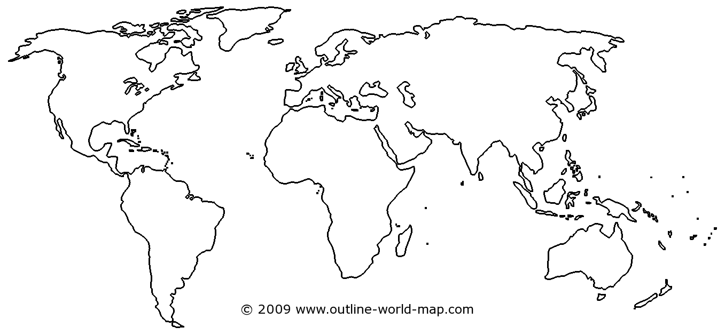
Source: http://www.outline-world-map.com/blank-thick-white-world-map-b3c

Summary:
___________________________________________________________________________

___________________________________________________________________________

___________________________________________________________________________

___________________________________________________________________________

___________________________________________________________________________

Connecting CO₂ and the Carbon Cycle:
Brainstorm:
Think, pair, share about where you think the CO₂ that is released into the atmosphere originally comes from and where it eventually goes?
- Using the Data Sheet, discuss the patterns modeled on The CO₂ and the Carbon Cycle diagrams (Figure 6.2 and Figure 6.3). Explain what you observe:

CO₂ and the Carbon Cycle Observations

Carbon Cycle Reservoirs:
- Launch and explore the online Carbon Dioxide and the Carbon Cycle interactive animation (or review the printed screenshots if computer access is unavailable):
https://rmpbs.pbslearningmedia.org/resource/pcep14.sci.ess.co2cycle/carbon-dioxide-carbon-cycle/#
- Using the interactive animation, observe each web page and read each informational link and summary to build an understanding about CO₂ and the Carbon Cycle.
- Answer the questions on the following page.

As you go through each web page, record the main areas where carbon is stored (sinks) and which processes release CO₂ (sources) into the atmosphere:
List the main reservoirs (sinks) where carbon is stored on Earth from largest to smallest:
- ______________________________________________________________________
- ______________________________________________________________________
- ______________________________________________________________________
- ______________________________________________________________________
- ______________________________________________________________________

What form is carbon stored in the atmosphere?
___________________________________________________________________________

___________________________________________________________________________

Which reservoir has the biggest direct impact on climate?
___________________________________________________________________________

___________________________________________________________________________

Which reservoir has the least impact on climate?
___________________________________________________________________________

___________________________________________________________________________

How do human activities affect the fossil fuel carbon reservoir?

___________________________________________________________________________

___________________________________________________________________________

___________________________________________________________________________

CO₂ and the Atmosphere 300 Years Ago vs. CO₂ and the Atmosphere Present Day
Use the diagram and table to compare and contrast the sources of CO₂ in the atmosphere and how their amounts have changed over time:
Past Present
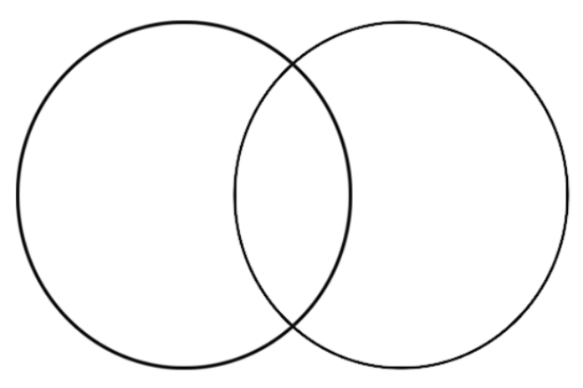
CO₂ and the Atmosphere 300 Years Ago | CO₂ and the Atmosphere Present Day

Temperature and CO₂:
Read each summary and analyze each graph about CO₂ in the atmosphere and temperature over the past 1000 years. Describe the patterns and trends you observe over time in the table:

 | Year  1000-1800 | Year  1800-Present
CO₂ Concentrations
Temperature Change
CO₂ and Temperature
Relationship

CO₂ and Climate Change Connections:
As a class, watch and then discuss the connections between GHGs, the GHE, and what adding more CO₂ to the atmosphere from burning fossil fuels does to the natural balance of Earth’s temperature.
Climate Change Basics video: http://cleanet.org/resources/45172.html

Next Steps:
What have we learned from this lesson and what should we investigate next?

Word Bank: atmosphere, carbon dioxide (CO2), Carbon Cycle, decrease, emissions, fossil fuels, greenhouse effect (GHE), greenhouse gases (GHGs), increase, sink(s), source(s), temperature.

Describe what we have learned about the connection between human activities, CO₂, and Earth’s temperature? You can use the word bank terms (above), if needed.
What should we investigate next to understand how Earth’s temperature are warming?

