Carbon Dioxide and the Carbon Cycle
https://rmpbs.pbslearningmedia.org/resource/pcep14.sci.ess.co2cycle/carbon-dioxide-carbon-cycle/#
A. Carbon Cycle Reservoirs:
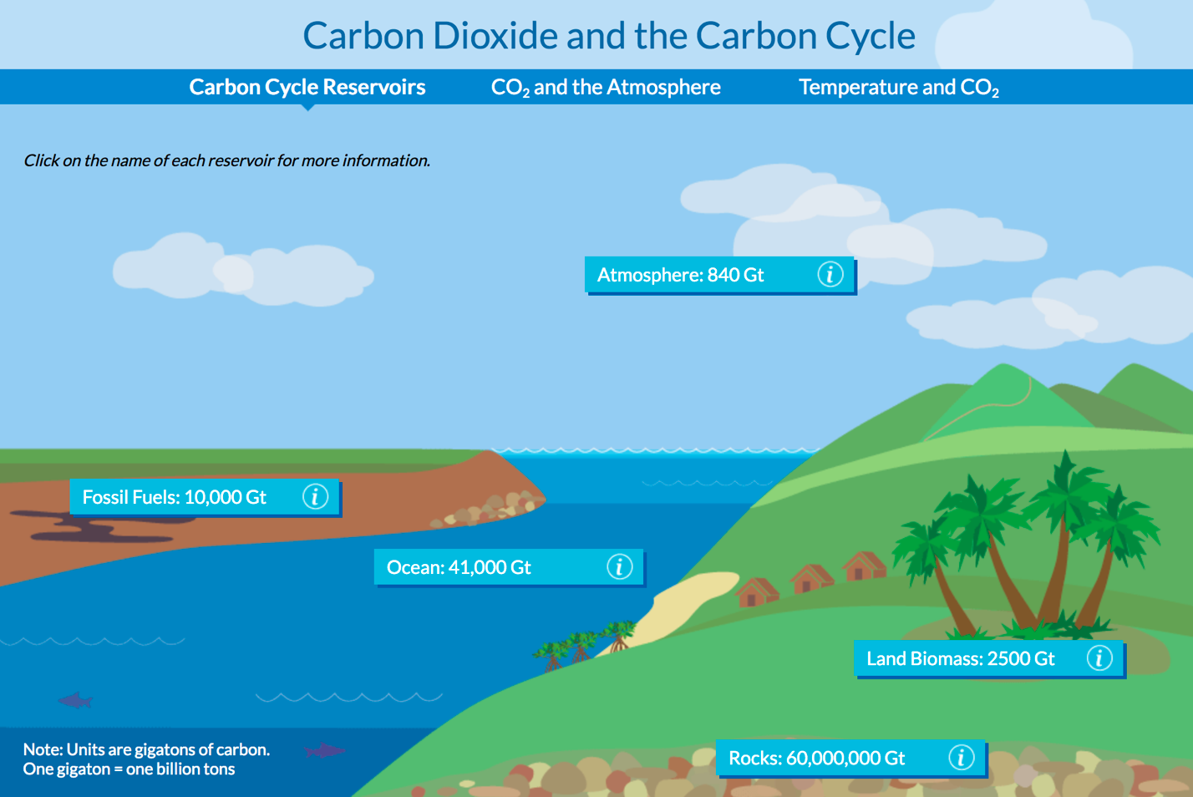

B. Carbon Cycle Reservoirs:
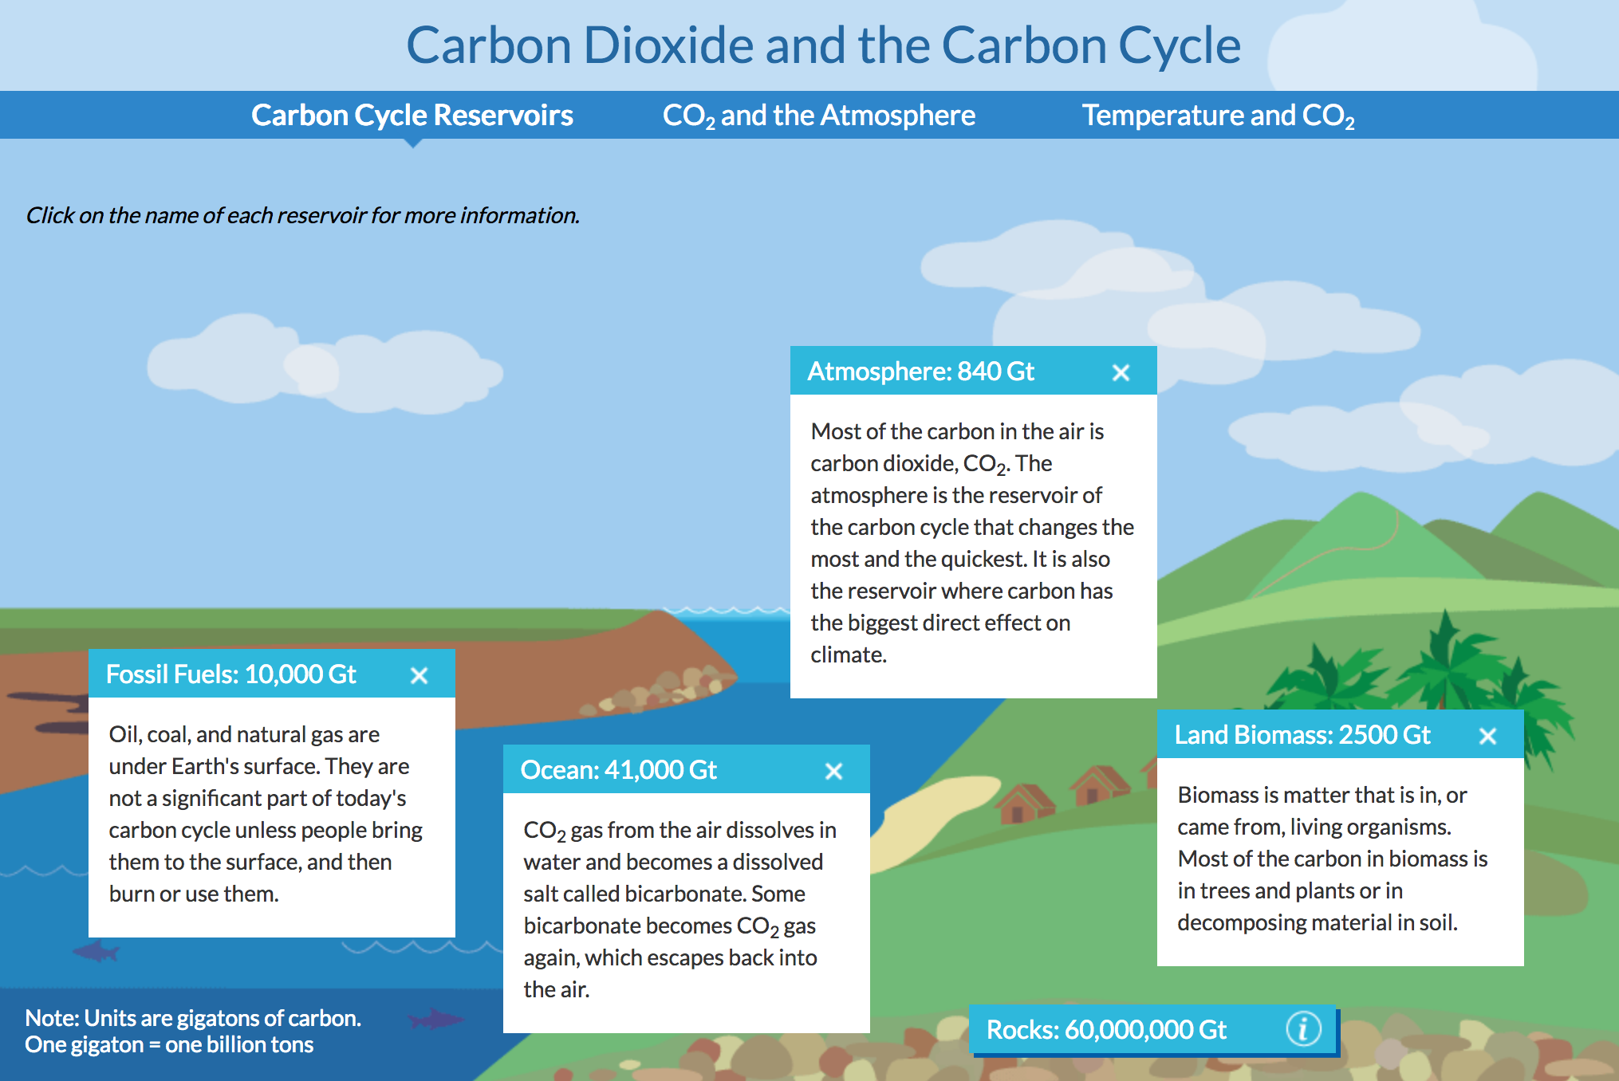

C. Carbon Cycle Reservoirs:
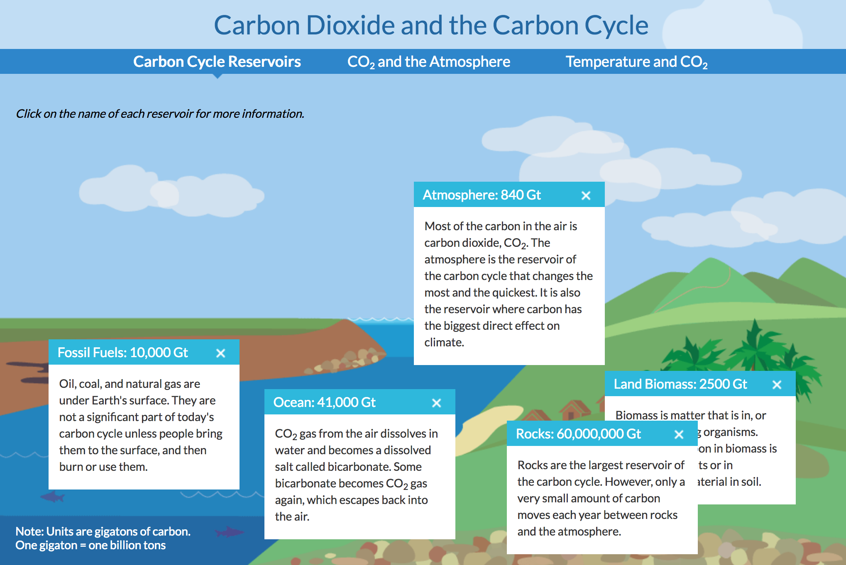

D. CO₂ and the Atmosphere 300 Years Ago:
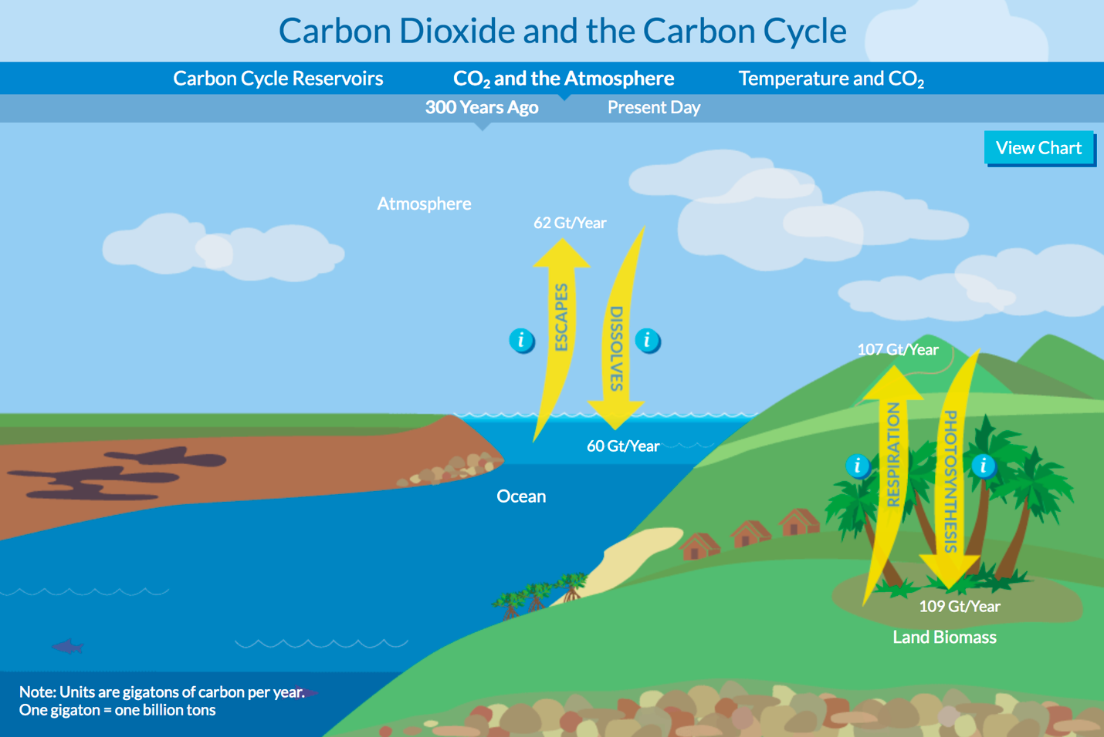

E. CO₂ and the Atmosphere 300 Years Ago:
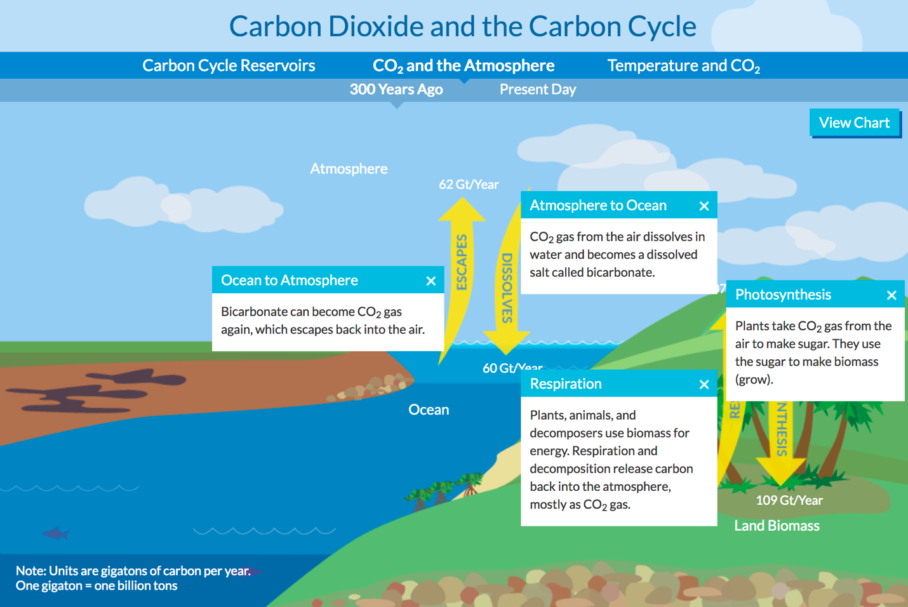

F. CO₂ and the Atmosphere Present Day:
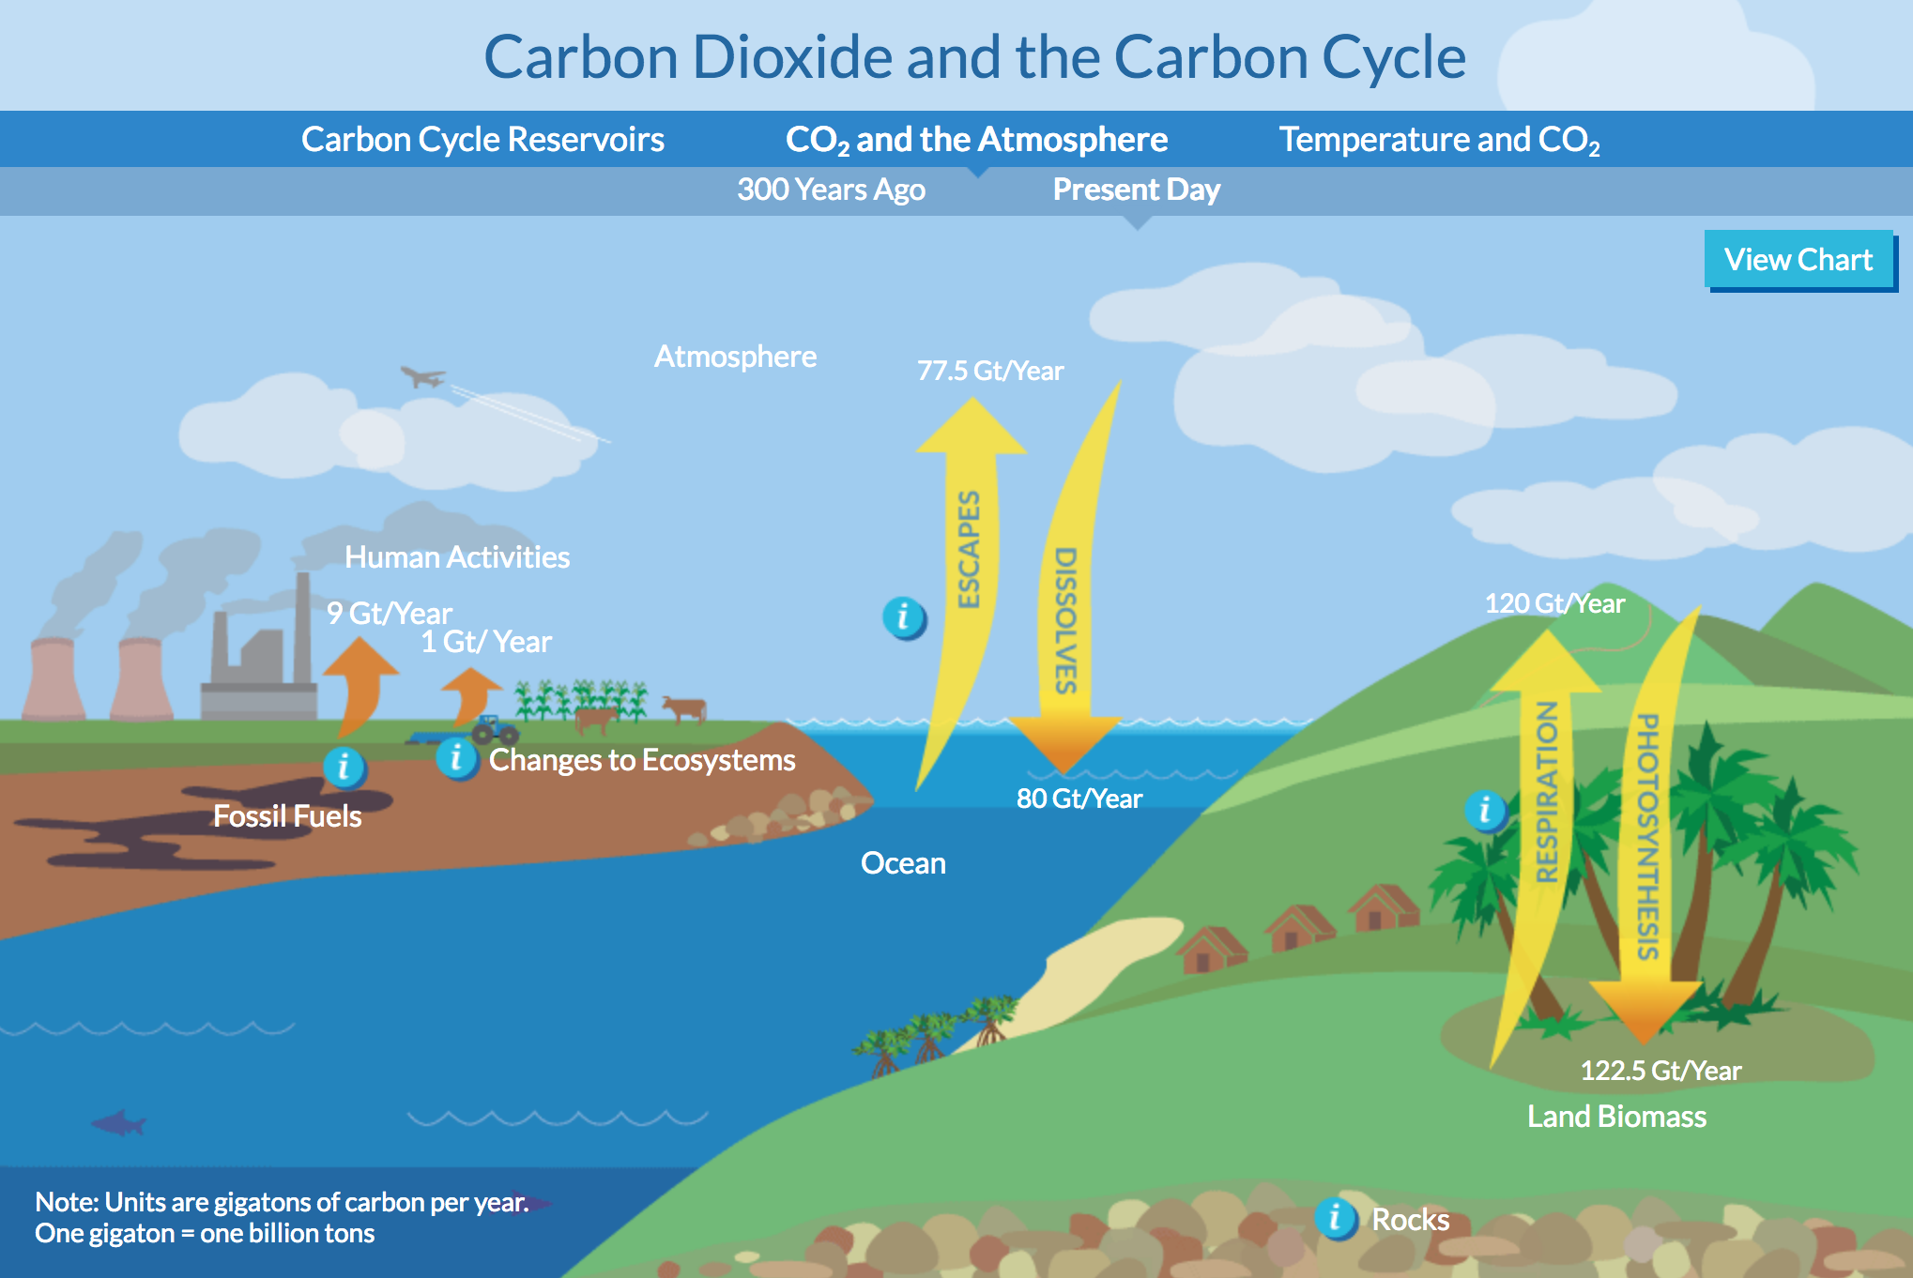

G. CO₂ and the Atmosphere Present Day:
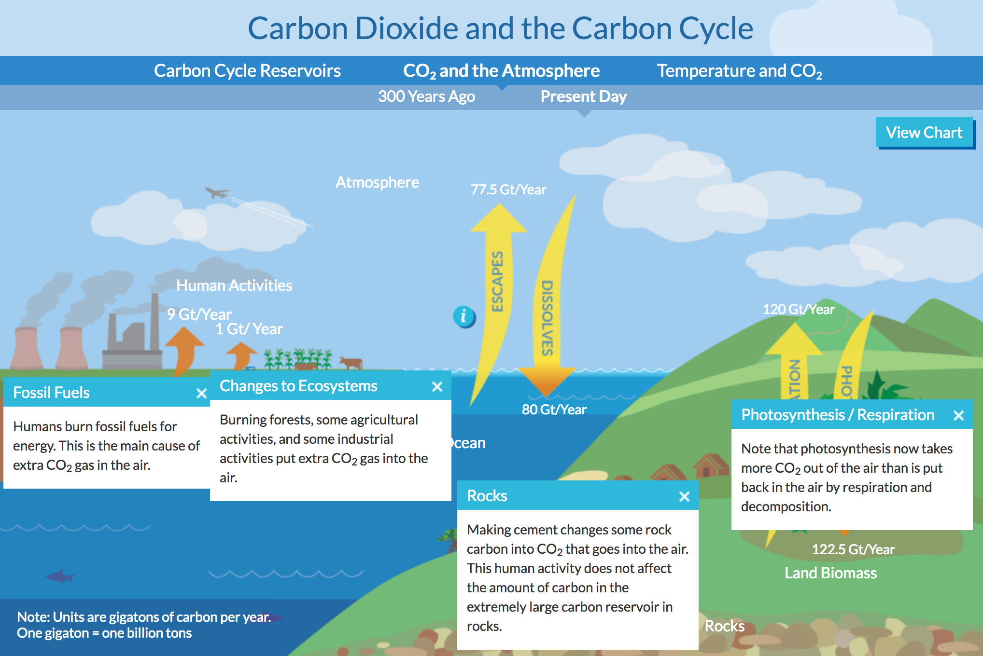

H. CO₂ and the Atmosphere Present Day:
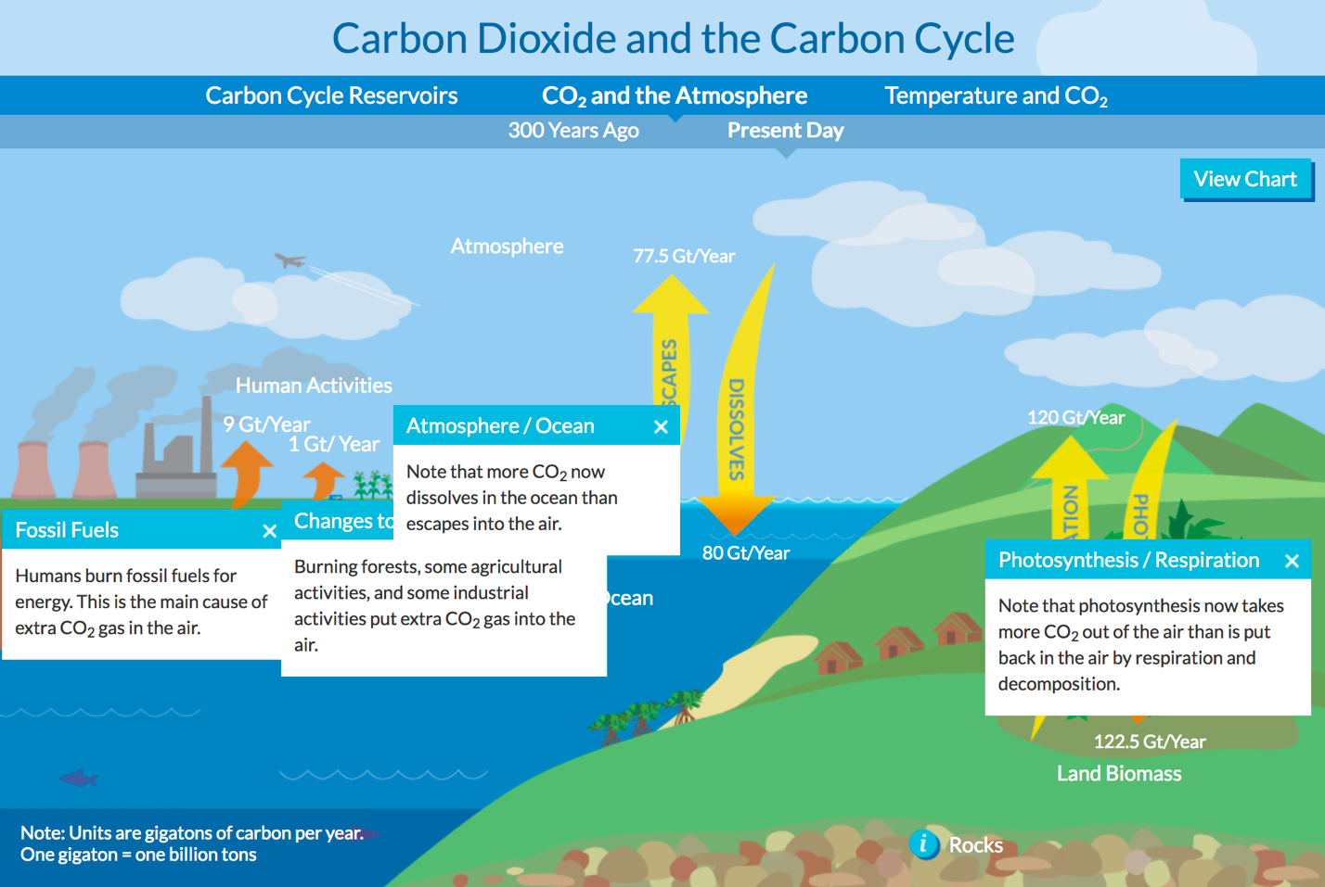

I. CO₂ and the Atmosphere 300 Years Ago:
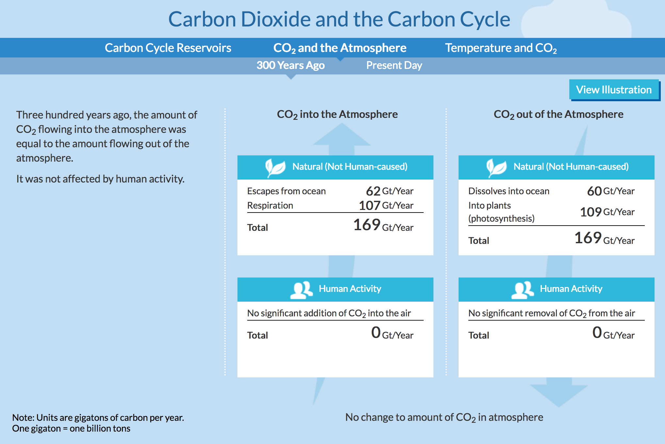

J. CO₂ and the Atmosphere Present Day:
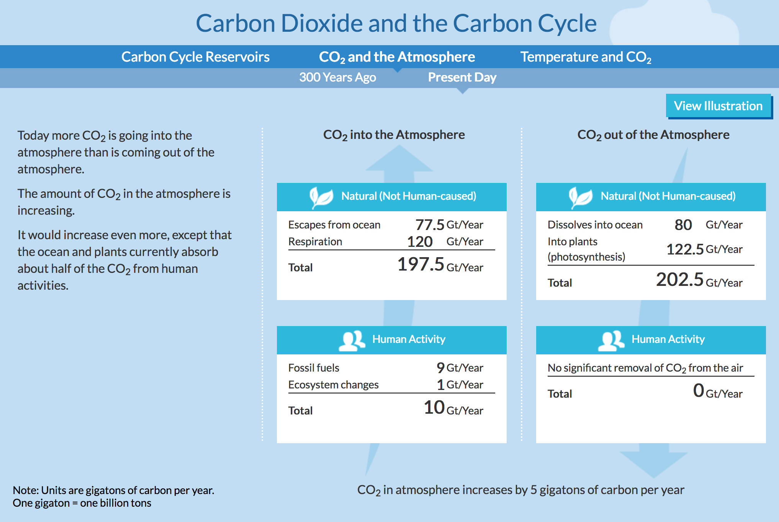

K. Temperature and CO₂:
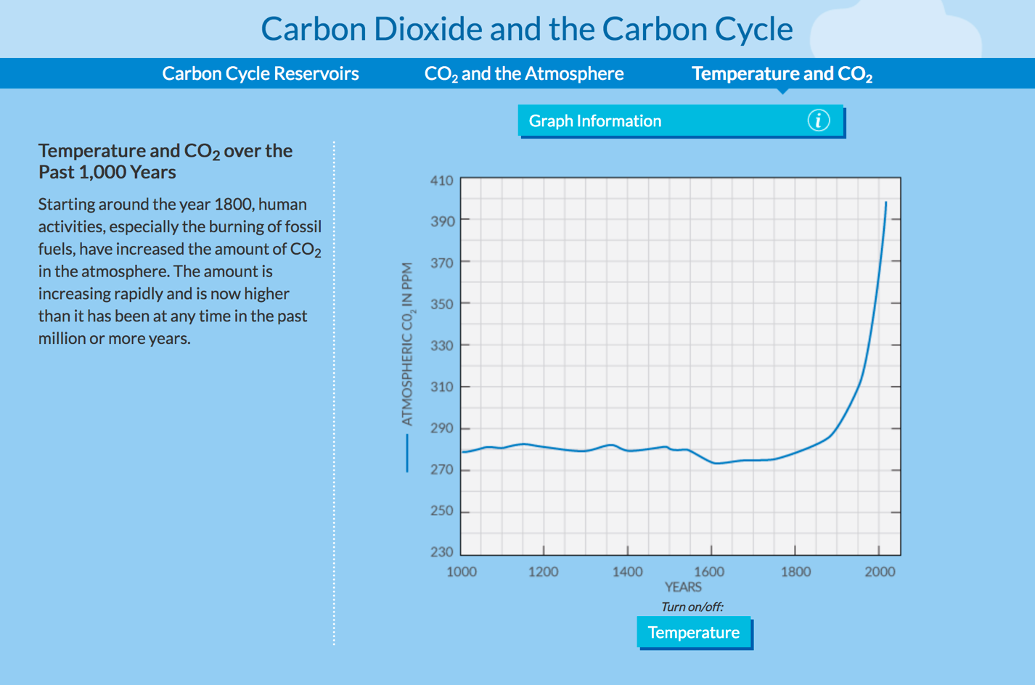

L. Temperature and CO₂:
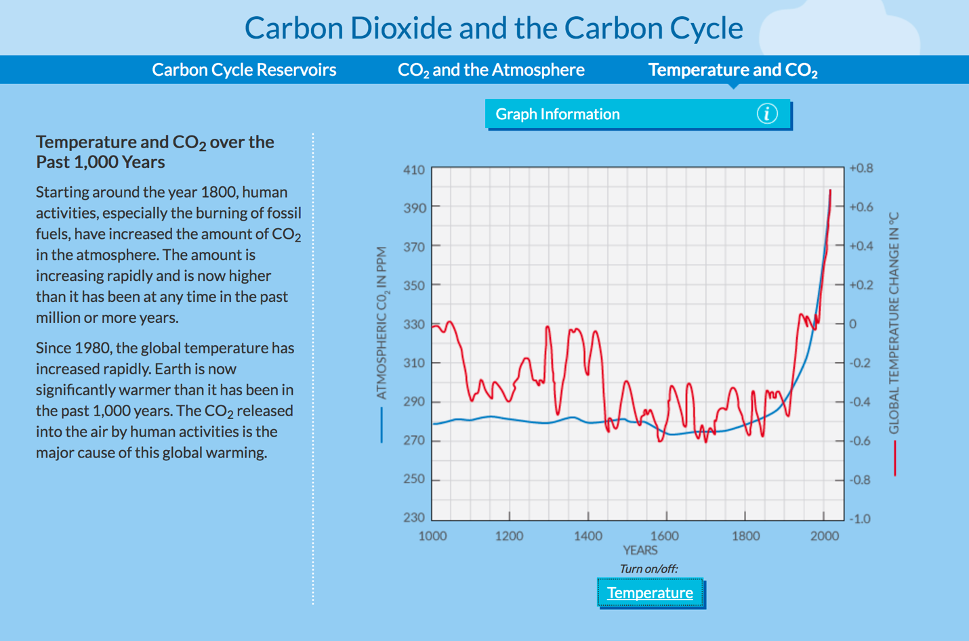
M. Temperature and CO₂:
