Lesson 7 Data Sheet:

The Increasing Number of Cars
  - At the start of the twentieth century, there were only about 8,000 cars in the United States and possibly not more than 25,000 worldwide.
  - Most cars in the early 1900s were located in either the United States or Europe. In 1908, for example, there were only about 20 cars in Tokyo, Japan.
  - There were 300 cars in the United States in 1895, 78,000 in 1905, 459,000 in 1910 and 1.7 million in 1914.
  - In 1903 just under 63,000 cars were built in the world of which about half were produced in France.
  - By 1910 there were 100,000 cars in Great Britain.
  - By 1968 the worldwide figure had increased to 170 million; a figure that had more than doubled to 375 million by 1985.
  - In 2002 there were 530 million cars worldwide, of which about 25% (130 million) were in the United States.

World Annual Car Production 2004 - 2014

Year | Total Cars Produced |  | Year | Total Cars Produced
2004 | 64,496,220 |  | 2010 | 77,583,519
2005 | 66,719,519 |  | 2011 | 79,880,920
2006 | 69,222,975 |  | 2012 | 84,236,171
2007 | 73,266,061 |  | 2013 | 87,595,998
2008 | 70,729,696 |  | 2014 | 89,776,465
2009 | 61,762,324

Figure 7.1
Source: http://www.oica.net/category/production-statistics/2014-statistics/

World Car Production 1898 - 2007
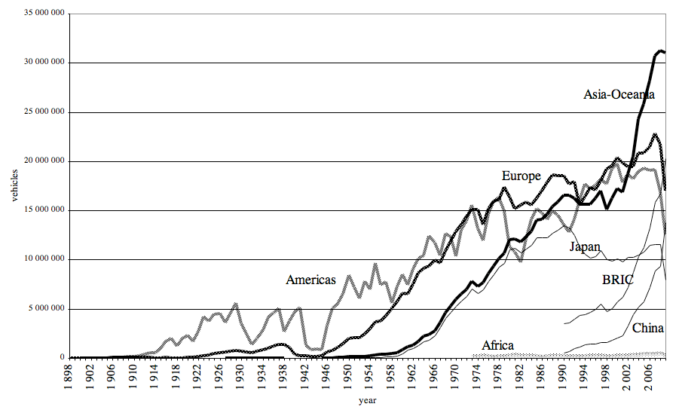
Figure 7.2
Source: http://revel.unice.fr/eriep/?id=3301

Greenhouse Gas Levels in the Atmosphere
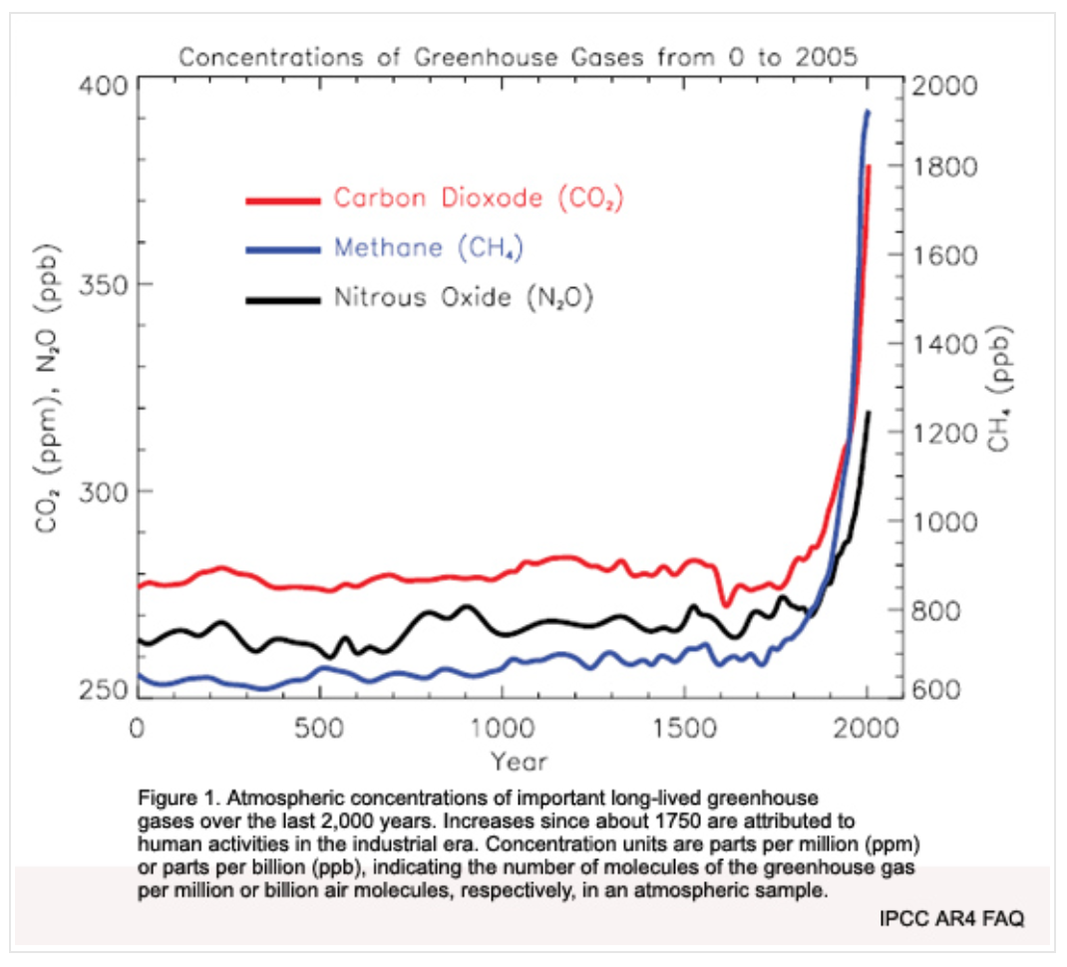
Figure 7.3
Source: http://www.global-greenhouse-warming.com/greenhouse-gas.html

Note: Double y-axis graph. CO₂ and N₂O use the scale on the left y-axis and CH₄ uses the scale on the right y-axis. The “Years” x-axis starts at year 1 AD (“year 0” does not exist) and goes through the year 2000 AD.

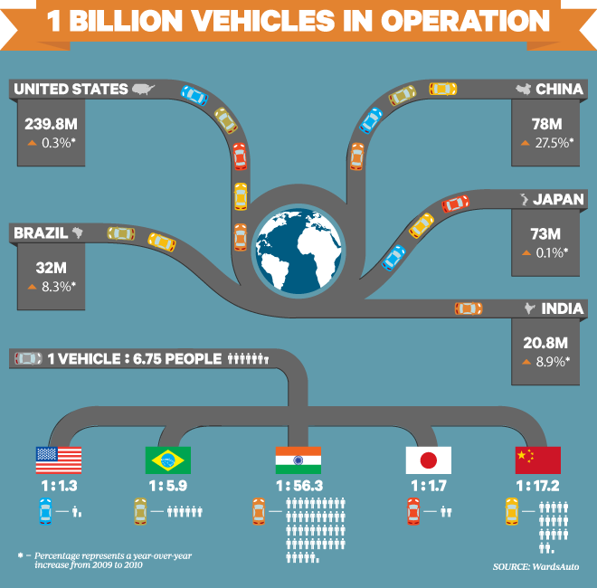

Figure 7.4
Source: https://www.wired.com/2012/07/1-billion-cars-infographic/

Transportation Greenhouse Gas (GHG) Emissions in the U.S.

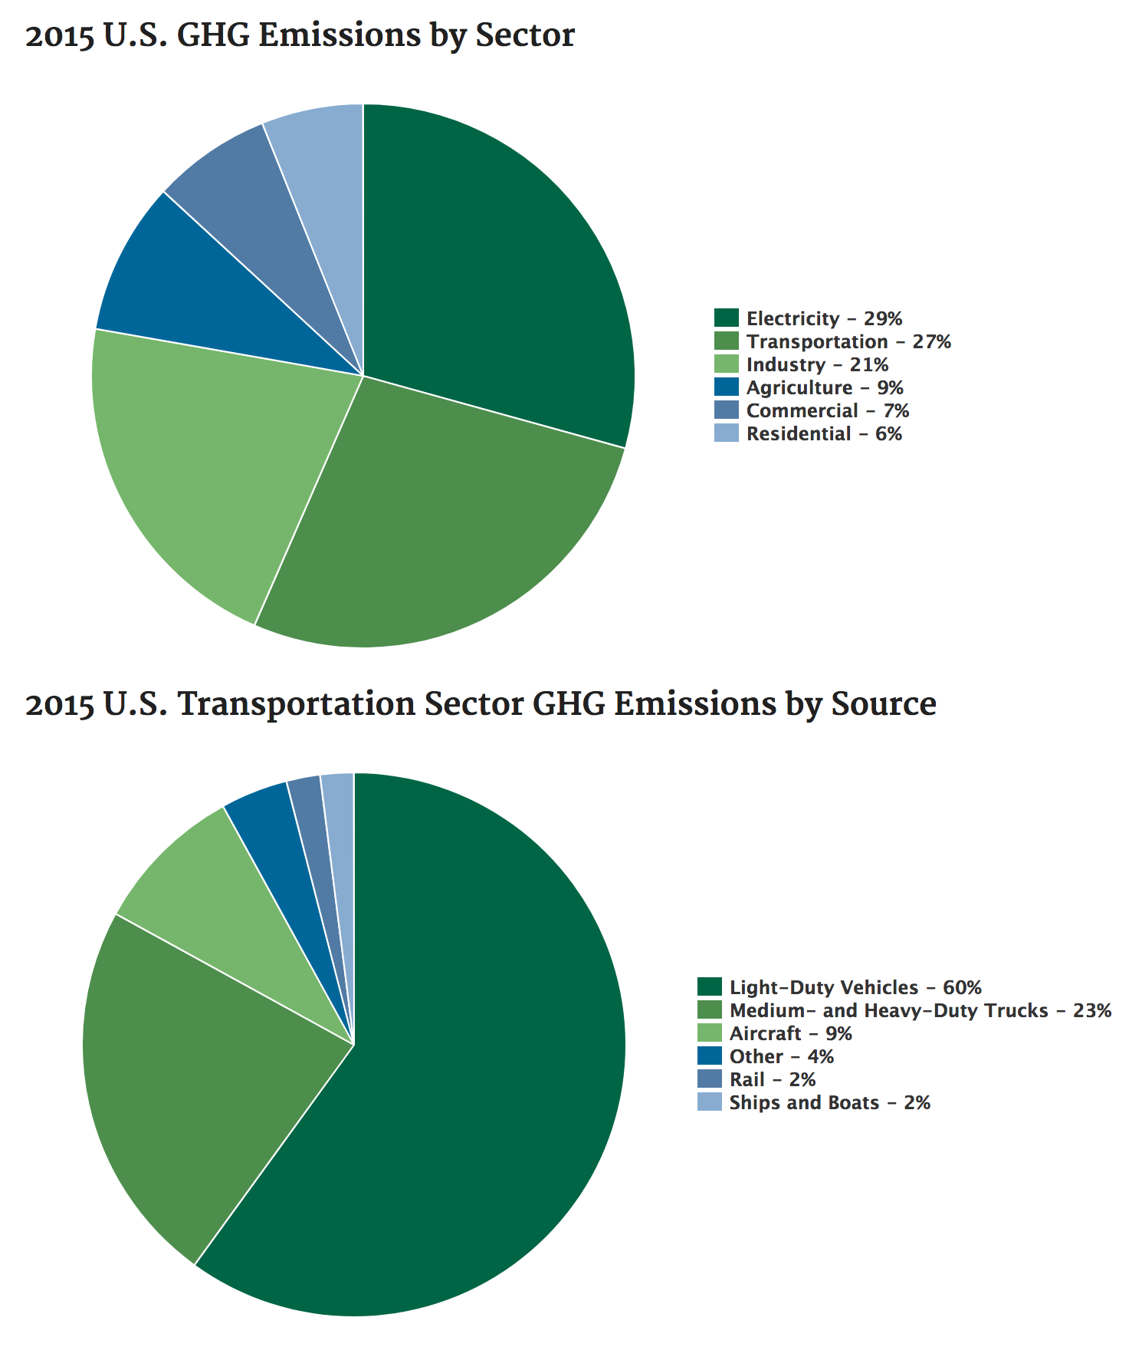
Figure 7.5
Source: https://www.epa.gov/greenvehicles/fast-facts-transportation-greenhouse-gas-emissions
Carbon Dioxide Emissions from Burning of Fossil Fuels - 2006

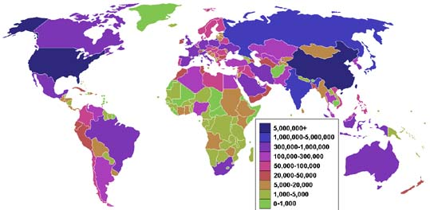

Figure 7.6

Source: https://publications.europa.eu/en/publication-detail/-/publication/41811494-f131-11e8-9982-01aa75ed71a1/language-en

