Name ____________________________________

Lesson 8: How can we show that an increase in CO₂ causes an increase in temperature?

Do Now:
- What did we wonder about last class?
- What were the most important things we figured out in our last lesson?
How did we figure those things out?
- What other evidence do we need to collect today?

Students work independently on these three questions for the first 3-4 minutes then teacher leads a whole class discussion to make sure all students know where they are at in the storyline. At this point, since this is the last main lesson, students should have a lot to share. You want students to get to the point in the share-out that they were looking at an increase in cars potentially being linked to the increased temperature, but we needed to see data about the human population and CO₂ numbers, as well as see if that was also a factor in the increased temperatures.

Initial Ideas:
What are some ways we can use these materials to design a fair test of whether CO₂ can cause temperatures to rise in the atmosphere?

Materials: 2 water bottles, modeling clay, 2 thermometers, water, light source, plastic wrap, rubber bands, a way to make CO₂ easily (4 tablets of Alka-Seltzer)

A fair test is one where we can really see if something is causing something else. So we need a control or comparison group. In our experiment, we need one where there’s more CO₂, and we also need to have a light source that represents the light from the sun. We think we can use thermometers to measure the temperature where there’s less and more CO₂. We think we can put the Alka-Seltzer in water in one of the bottles (treatment), and just water in the other (control). We might use the plastic wrap to create a seal at the top of the bottles, so that the CO₂ or air can’t escape.

Record Your Investigation Plan:

How will you use the light? Why is light important in this experiment?

We will aim it at the bottles and turn it on. Because we need a way to “warm up” the bottles that is something like the way the sun warms up the earth.

Draw a set-up for the treatment or test condition.

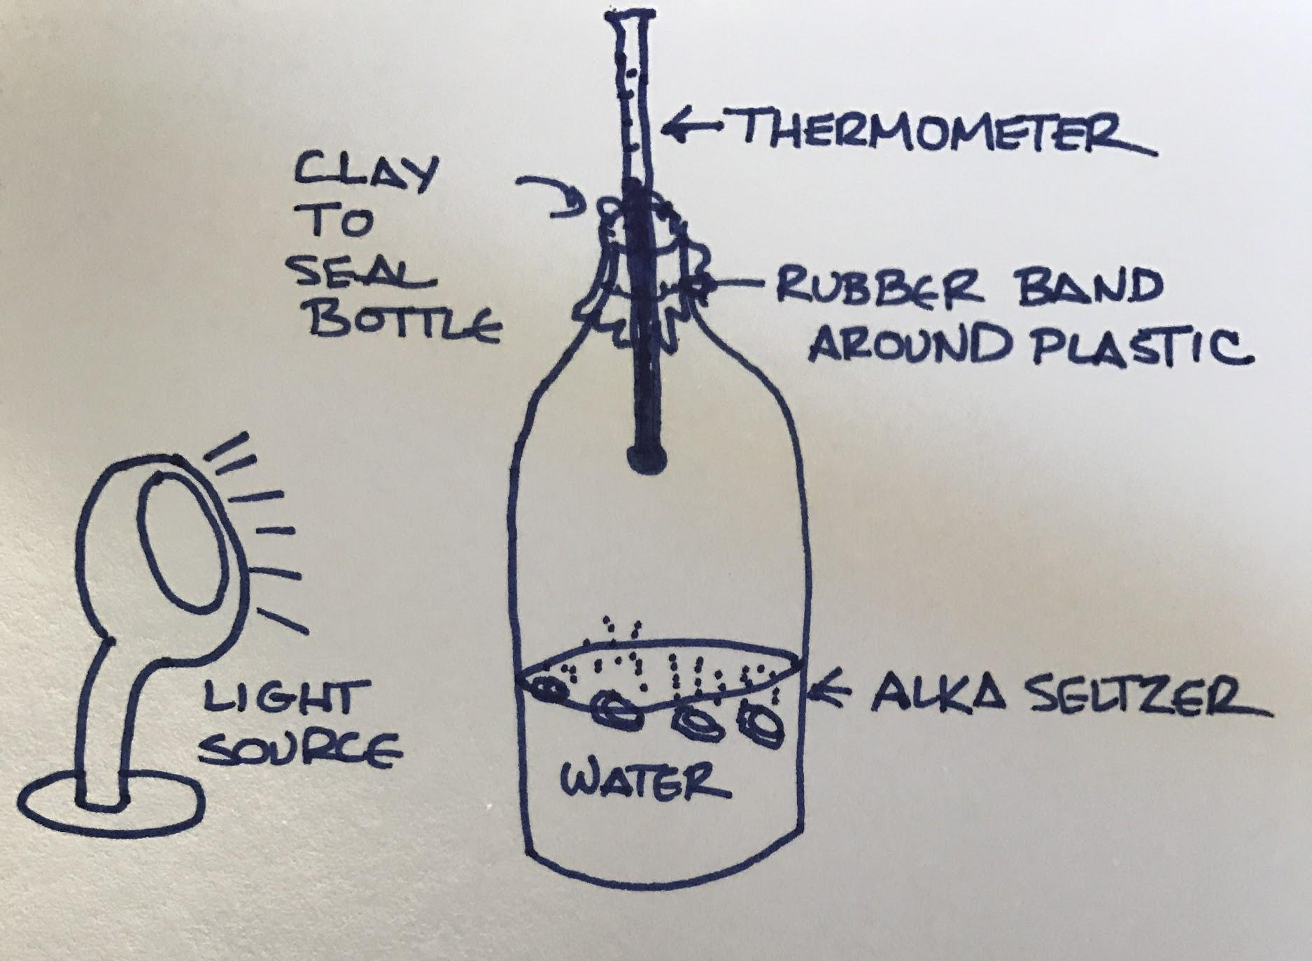

Draw the set-up for the control condition:

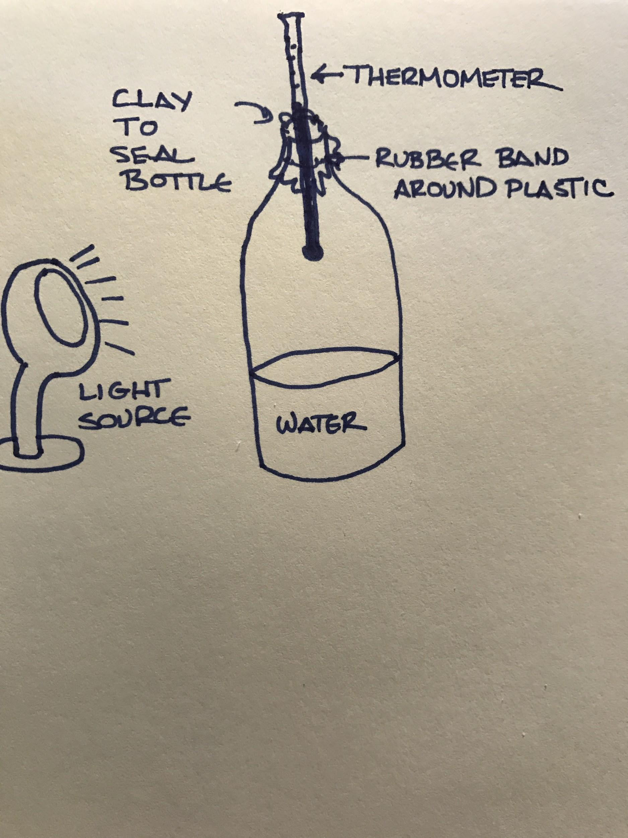

What will you do that is the same in each condition?

We will seal the top of both bottles, so that air can’t escape (this is kind of like the Earth’s atmosphere).
We will measure temperature at the same points in time in both conditions.
Both bottles will have water in the bottom, and air in the top.

What will you measure in each condition, and how often will your group take measurements? Explain your reasoning.

We need to measure the temperature at several points over time in both bottles. We will measure temperature every X minutes (where X could be every 2-5 minutes). We need to take several measurements, because it may take time for the temperature to increase in both bottles, and to see a pattern. We need to measure in both the treatment and control bottles, because we need to be able to compare the rates of increase in both bottles.

How will this experiment allow you to decide whether CO₂ can cause an increase in temperature?

We expect that because of the light, the temperature in both bottles will increase over time. But if the temperature increases at a faster rate in the bottle with CO₂ than in the control bottle, we can conclude that CO₂ caused the increase, because there were no other differences between the two bottles.

Results:
Label the table below with your treatment and control conditions, variables, and record your measurements here.

Table Title: __Temperature Change over Time in Each Condition_____

 | What we are measuring: __Temperature in Each Bottle_______
 | Measure 1 | Measure 2 | Measure 3 | Measure 4 | Measure 5 | Measure 6 | Measure 7 | Measure 8
Time
Treatment
Control

What pattern do you see or notice in the data?

The temperature starts out at “room temperature” in both bottles. Over time, the temperature in both bottles increased. But in the treatment condition, where we put the Alka-Seltzer in the water to make CO₂, the temperature increased at a faster rate.

Graph your results to help you see the patterns in your data:

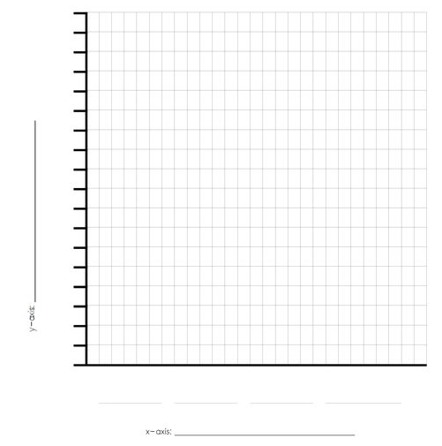

Making Sense:
Now that we have completed our activity, what can we conclude about the role of CO₂ in the temperature increase?

Our group noticed the bottles looked the same before adding the tablets, then once the tablets were added to the bottle it started to fizz and make bubbles. The temperature before adding the Alka-Seltzer was the same, but then over time with the plastic wrap on top, the bottle with the tablets became warmer than the bottle without the tablets.

We conclude that CO₂ increases in the atmosphere are not just correlated with temperature increases. It’s likely that they are causing it.

Additional Evidence:
Your experiment is a model of a closed system (particles do not enter or leave). Scientists say that the Earth is an open system (e.g. meteors can enter our atmosphere). Earth does lose some of its upper atmosphere to space but this happens in small amounts and occurs over a billion-year timescale. Gravity keeps most of Earth’s atmosphere surrounding our planet, which makes our planet habitable and protects life in many ways.

Watch:
“The Mythbusters Test the Global Warming Theory” https://www.youtube.com/watch?v=pPRd5GT0v0I

How does our experiment about figuring out if CO₂ increases temperature compare to how scientists study this question (compare & contrast materials and equipment, experimental design, data recording, etc.)?

Student answers will vary but they used more simple materials and equipment but should have the same results. There was a control (air in the bottle) and a variable (CO₂ in the bottle). Temperature was measured and increased over time. The CO₂ bottle had a higher temperature than the air bottle.

Exit Ticket:
Is there anything you are still wondering about for this unit?

We are still wondering whether the increase in human population itself might be the reason for CO₂ increases in the atmosphere, not just fossil fuel consumption.

We are not sure, because we don’t know exactly how carbon is stored and moves around in the ecosystem. (Possible connection here to MS-LS-2-3, not explored in this unit: “Develop a model to describe the cycling of matter and flow of energy among living and nonliving parts of an ecosystem.)

