Name ____________________________________

Lesson 8: How can we show that an increase in CO₂ causes an increase in temperature?

Do Now:
- What did we wonder about last class?
- What were the most important things we figured out in our last lesson?
How did we figure those things out?
- What other evidence do we need to collect today?

_________________________________________________________________________

_________________________________________________________________________

_________________________________________________________________________

_________________________________________________________________________

_________________________________________________________________________

Initial Ideas:
What are some ways we can use these materials to design a model of whether CO₂ can cause temperatures to rise in the atmosphere?

Materials: 2 water bottles, 2 thermometers, water, light source, plastic wrap, rubber bands, and a way to make CO₂ easily (4 tablets of Alka-Seltzer)

_________________________________________________________________________

_________________________________________________________________________

_________________________________________________________________________

_________________________________________________________________________

_________________________________________________________________________

_________________________________________________________________________

Record Your Investigation Plan:

How will you use the light? Why is light important in this experiment?

Draw a set-up for the treatment or test condition:

Draw the set-up for the control condition:

What will you do that is the same in each condition?

_________________________________________________________________________

_________________________________________________________________________

_________________________________________________________________________

_________________________________________________________________________

_________________________________________________________________________

What will you measure in each condition, and how often will your group take measurements? Explain your reasoning.

_________________________________________________________________________

_________________________________________________________________________

_________________________________________________________________________

_________________________________________________________________________

_________________________________________________________________________
How will this experiment allow you to decide whether CO₂ can cause an increase in temperature?

_________________________________________________________________________

_________________________________________________________________________

_________________________________________________________________________

_________________________________________________________________________

_________________________________________________________________________

_________________________________________________________________________

Results:

Label the table below with your treatment and control conditions, variables, and record your measurements here.

Table Title: __________________________________

 | What we are measuring: _______________________________________
 | Measure 1 | Measure 2 | Measure 3 | Measure 4 | Measure 5 | Measure 6 | Measure 7 | Measure 8
Time
Treatment
Control

What pattern do you see or notice in the data?

_________________________________________________________________________

_________________________________________________________________________

_________________________________________________________________________

_________________________________________________________________________

_________________________________________________________________________

_________________________________________________________________________

Graph your results to help you see the patterns in your data:

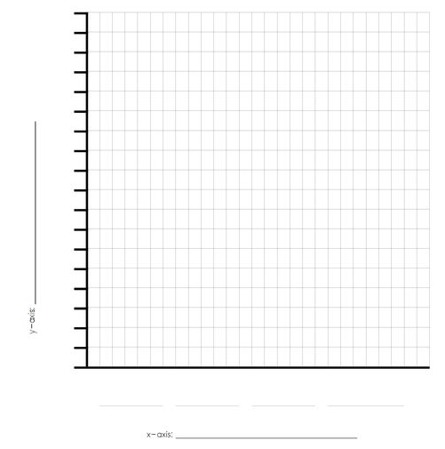

Making Sense:
Now that we have completed our activity, what can we conclude about the role of CO₂ in the temperature increase?
_________________________________________________________________________

_________________________________________________________________________

_________________________________________________________________________

_________________________________________________________________________

_________________________________________________________________________

Additional Evidence:
Your experiment is a model of a closed system (particles do not enter or leave). Scientists say that the Earth is an open system (e.g. meteors can enter our atmosphere). Earth does lose some of its upper atmosphere to space but this happens in small amounts and occurs over a billion-year timescale. Gravity keeps most of Earth’s atmosphere surrounding our planet, which makes our planet habitable and protects life in many ways.

Watch:
“The Mythbusters Test the Global Warming Theory” https://www.youtube.com/watch?v=pPRd5GT0v0I

How does our experiment about figuring out if CO₂ increases temperature compare to how scientists study this question (compare & contrast materials and equipment, experimental design, data recording, etc.)?

_________________________________________________________________________

_________________________________________________________________________

_________________________________________________________________________

_________________________________________________________________________

_________________________________________________________________________

Exit Ticket:

Is there anything you are still wondering about for this unit?

_________________________________________________________________________

_________________________________________________________________________

